Mohamed Khouyaoui Ben

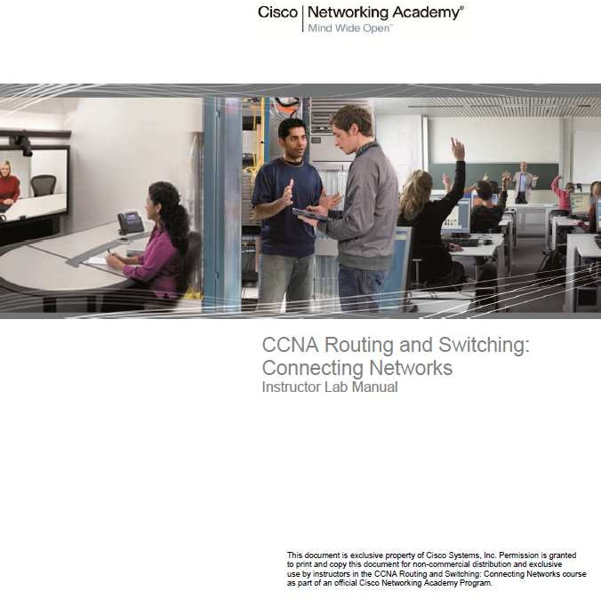

Student Lab Manual

Contenido

1.2.4.3 Lab – Researching WAN Technologies 3

Objectives 3

Required Resources 3

Part 2: Investigate a Dedicated Leased Line Service Provider in Your Area 4

2.3.2.7 Lab – Configuring Basic PPP with Authentication 1

Topology 1

Required Resources 2

Part 3: Configure PPP CHAP Authentication 15

Router Interface Summary Table 19

Required Resources 2

Part 1: Build the Network and Load Device Configurations 3

Part 3: Troubleshoot the Network Layer 8

Required Resources 1

Part 1: Investigate Broadband Distribution 1

Part 2: Research Broadband Access Options for Specific Scenarios 4

Reflection 6

3.2.2.7 Lab – Configuring a Router as a PPPoE Client for DSL Connectivity 1

Topology 1

Required Resources 2

Part 2: Configure the ISP Router 2

Part 3: Configure the Cust1 Router 3

Reflection 5

Router Interface Summary Table 5

Required Resources 1

Part 1: Build the Network 2

Part 2: Troubleshoot PPPoE on Cust1 3

Router Interface Summary Table 7

Required Resources 2

Part 1: Configure Basic Device Settings 3

Part 3: Enable Routing over the GRE Tunnel 5

Router Interface Summary Table 7

Required Resources 1

Part 1: Build the Network and Configure Basic Device Settings 2

Part 2: Configure eBGP on R2 2

Part 3: Verify eBGP Configuration 3

Router Interface Summary Table 5

Required Resources 2

Part 1: Build the Network and Load Device Configurations 2

Part 3: Configure a GRE Tunnel 5

Part 4: Configure BGP over PPPoE and BGP over a GRE Tunnel 6

Required Resources 3

Part 1: Set Up the Topology and Initialize Devices 3

Part 3: Configure and Verify Extended Numbered and Named ACLs 5

Part 4: Modify and Verify Extended ACLs 7

Router Interface Summary Table 8

Required Resources 2

Part 1: Set Up the Topology and Initialize Devices 3

Part 3: Configure and Verify IPv6 ACLs 6

Part 4: Edit IPv6 ACLs 7

Router Interface Summary Table 9

Required Resources 3

Part 1: Build the Network and Configure Basic Device Settings 4

Part 2: Troubleshoot Internal Access 6

Part 3: Troubleshoot Remote Access 8

Part 4: Troubleshoot IPv6 ACL 9

Router Interface Summary Table 11

Required Resources 1

Part 1: Survey Your Understanding of Network Monitoring 1

Part 2: Research Network Monitoring Tools 1

5.2.2.6 Lab – Configuring SNMP 1

Topology 1

Required Resources 2

Part 2: Configure SNMPv2 Manager and Agent 3

Part 3: Configure SNMPv3 Manager and Agent 6

Router Interface Summary Table 12

Required Resources 2

Part 1: Build the Network and Verify Connectivity 2

Part 2: Configure Local SPAN and Capture Copied Traffic with Wireshark 3

Router Interface Summary Table 6

Required Resources 2

Part 1: Build the Network and Verify Connectivity 2

Part 2: Configure Local SPAN and Capture Copied Traffic with Wireshark 3

Router Interface Summary Table 6

Required Resources 1

Part 1: Build the Network and Verify Connectivity 2

Part 2: Configure IP SLA ICMP Echo on R1 2

Router Interface Summary Table 4



# Lab – Researching WAN Technologies

### Objectives

##### Part 1: Investigate Dedicated WAN Technologies and Providers

**Part 2: Investigate a Dedicated Leased Line Service Provider in Your Area**

**Background / Scenario**

Today’s broadband Internet services are fast, affordable. With the use of VPN technology, the connection can also be secure. However, many companies still need a 24-hour dedicated connection to the Internet, or a dedicated point-to-point connection from one office location to another. In this lab, you will investigate the cost and availability of purchasing a dedicated T1 Internet connection for your home or business.

### Required Resources

A device with Internet access.

**Part 1: Investigate Dedicated WAN Technologies and Providers**

In Step 1, you will research basic characteristics of dedicated WAN technologies, and in Step 2, you will discover providers that offer dedicated WAN services.

#### Step 1: Research WAN technology characteristics.

Use search engines and websites to research the following WAN technologies. Put your findings in the table below.

|  |  |  |  |  |  |
| --- | --- | --- | --- | --- | --- |
| **WAN Technology** | **Dedicated Connection (yes/no)** | **Last Mile Media** | | | **Speed/Range** |
| **Copper (yes/no)** | **Fiber (yes/no)** | **Wireless (yes/no)** |
| T1/DS1 | si | si | si | si | 1.5 Mb |
| T3/DS3 | si | si | si | si | 44.7 Mb |
| OC3 (SONET) | si | no | si | no | 155.5 Mb |
| Frame Relay | si | si | si | si | 56 Kb <->1.5 Mb |
| ATM | si | si | si | si | 155.Mb <->622 Mb |
| MPLS | si | si | si | no | + 10 Gb |
| EPL (Ethernet Private Line) | si | si | si | no | +10 Gb |

#### Step 2: Discover dedicated WAN technology service providers.

Navigate to [http://www.telarus.com/carriers.html.](http://www.telarus.com/carriers.html) This webpage lists the Internet service providers (also known as carriers) that partner with Telarus to provide automated real-time telecom pricing. Click the links to the various carrier partners and search for the dedicated WAN technologies that they provide. Complete the table below by identifying each service provider’s dedicated WAN services, based on the information provided on the website. Use the extra lines provided in the table to record additional service providers.

|  |  |  |  |  |  |  |  |
| --- | --- | --- | --- | --- | --- | --- | --- |
| **Internet Service Provider** | **T1/DS1/PRI** | **T3/DS3** | **OC3 (SONET)** | **Frame Relay** | **ATM** | **MPLS** | **EPL**  **Ethernet Private Line** |
| Comcast |  |  |  |  |  |  | x |
| CenturyLink | x | x |  |  |  | x |  |
| AT&T |  |  |  |  |  |  |  |
| Earthlink |  |  |  |  |  |  |  |
| Level 3 Communications |  |  |  |  |  |  |  |
| XO  Communications |  |  |  |  |  |  |  |
| Verizon |  |  |  |  |  |  |  |
|  |  |  |  |  |  |  |  |
|  |  |  |  |  |  |  |  |
|  |  |  |  |  |  |  |  |

## Part 2: Investigate a Dedicated Leased Line Service Provider in Your Area

In Part 2, you will research a local service provider that will provide a T1 dedicated leased line to the geographical area specified. This application requires a name, address, and phone number before the search can be performed. You may wish to use your current information or research an address locally where a business might be looking for a WAN connection.

**Step 1: Navigate to** [**http://www.telarus.com/geoquote.html**](http://www.telarus.com/geoquote.html) **to try GeoQuote.**

GeoQuote is a web application that automates the search for WAN technology service providers, and provides price quotes in real-time. Complete the required fields.

* + - * 1. Click the **Service Type** drop-down list and select **Data (High Speed Internet)**.
        2. Type your **First Name** and **Last Name**, your sample **Company**, and your **Email** address.
        3. Type the **Phone Number** to connect to the WAN. This number should be a landline number.
        4. Click the button marked **Step 2**.

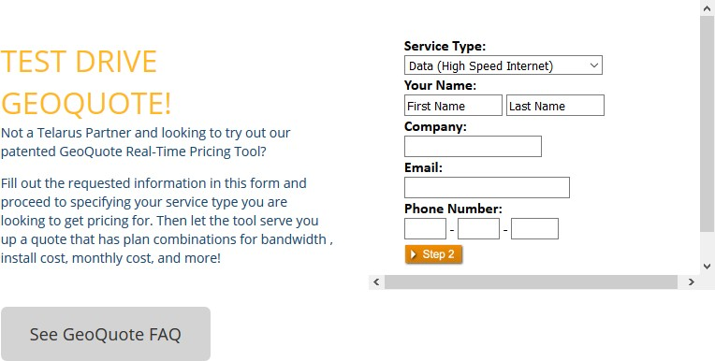

#### Step 2: Provide Information.

1. Choose **Internet T1 (1.5 MB)** in the GeoQuote Step 2 window (below).
2. In the GeoQuote Step 3 window, in the **Installation BTN** field, enter your sample business telephone number.
3. Enter your address, city, state, and zip code in the GeoQuote Step 3 window.
4. In the GeoQuote Step 4 window, click **I am just window shopping**.
5. Click **Continue** in the GeoQuote Step 4 window to display the results.

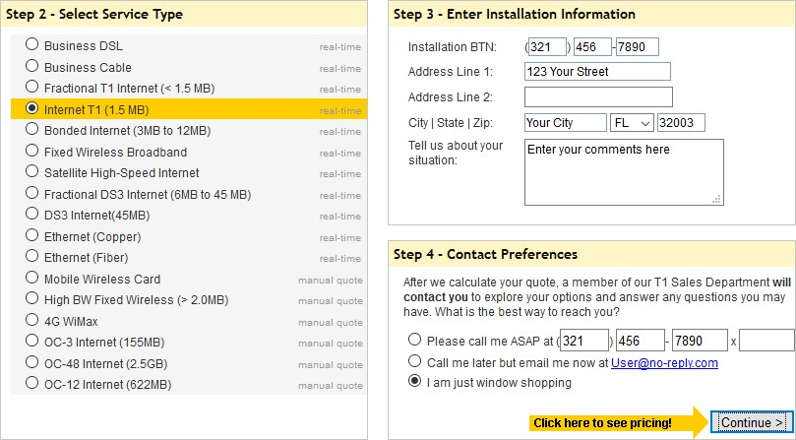

#### Step 3: Examine the results.

You should see a list of quotes showing the available pricing of a T1 connection to the location you specified. Was the pricing in the area you chose comparable to those pictured below?

El resultado es similar.

What was the range of prices from your results?

Lo podemos observar en la imagen de abajo, resultado de una dirección real: La instalación de 0$ a 500$

Coste mensual 210$ a 318$

Resultado de la ubicación:

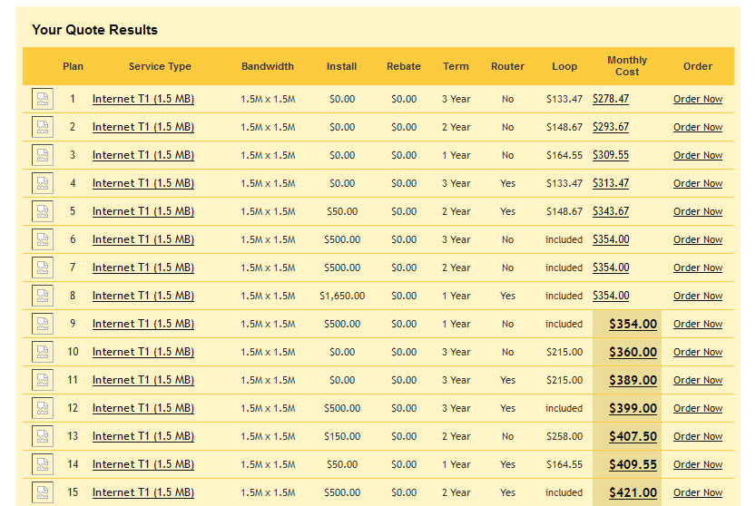

**Reflection**

1. What are the disadvantages to using a T1 leased line for personal home use? What would be a better solution?

Los precios son elevados en comparación a los servicions que dan acceso a internet dentro de una ciudad, tambien depende del uso que se le a dar.

1. When might the use of a dedicated WAN connection, of any type, be a good connectivity solution for a business?

En caso de empresas grandes, es el tipo de conexión más adecuado, son las que se benefician de su uso. Contratar uns linea dedicada para un hogar no tiene mucho sentido.

1. Describe other WAN technologies that provide high-speed, low-cost options that could be an alternative solution to a T1 connection.

Frame Relay, MPLS, and Metro Ethernet



# Lab – Configuring Basic PPP with Authentication

### Topology

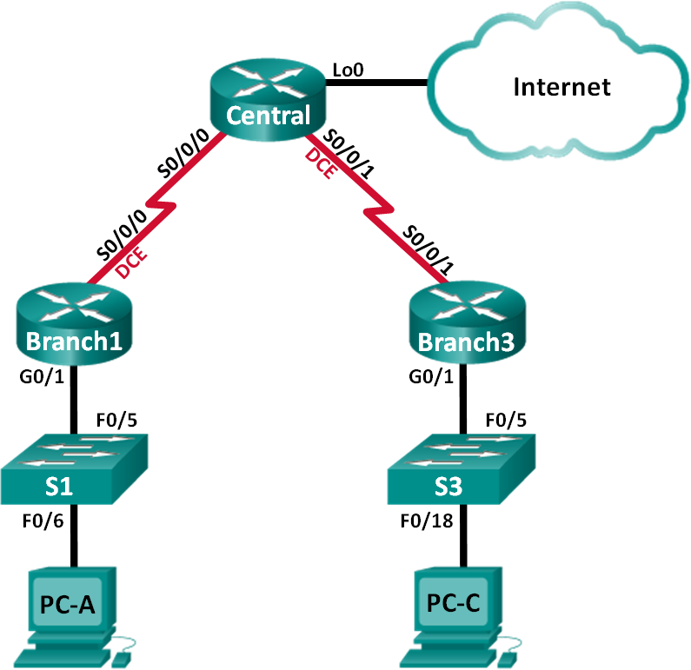

**Addressing Table**

|  |  |  |  |  |
| --- | --- | --- | --- | --- |
| **Device** | **Interface** | **IP Address** | **Subnet Mask** | **Default Gateway** |
| Branch1 | G0/1 | 192.168.1.1 | 255.255.255.0 | N/A |
| S0/0/0 (DCE) | 10.1.1.1 | 255.255.255.252 | N/A |
| Central | S0/0/0 | 10.1.1.2 | 255.255.255.252 | N/A |
| S0/0/1 (DCE) | 10.2.2.2 | 255.255.255.252 | N/A |
| Lo0 | 209.165.200.225 | 255.255.255.224 | N/A |
| Branch3 | G0/1 | 192.168.3.1 | 255.255.255.0 | N/A |
| S0/0/1 | 10.2.2.1 | 255.255.255.252 | N/A |
| PC-A | NIC | 192.168.1.3 | 255.255.255.0 | 192.168.1.1 |
| PC-C | NIC | 192.168.3.3 | 255.255.255.0 | 192.168.3.1 |

**Objectives**

##### Part 1: Configure Basic Device Settings Part 2: Configure PPP Encapsulation

**Part 3: Configure PPP CHAP Authentication**

**Background / Scenario**

The Point-to-Point Protocol (PPP) is a very common Layer 2 WAN protocol. PPP can be used to connect from LANs to service provider WANs and for connection of LAN segments within an enterprise network.

In this lab, you will configure PPP encapsulation on dedicated serial links between the branch routers and a central router. You will configure PPP Challenge Handshake Authentication Protocol (CHAP) on the PPP serial links. You will also examine the effects of the encapsulation and authentication changes on the status of the serial link.

**Note**: The routers used with CCNA hands-on labs are Cisco 1941 Integrated Services Routers (ISRs) with Cisco IOS Release 15.2(4)M3 (universalk9 image). The switches used are Cisco Catalyst 2960s with Cisco IOS Release 15.0(2) (lanbasek9 image). Other routers, switches, and Cisco IOS versions can be used.

Depending on the model and Cisco IOS version, the commands available and output produced might vary from what is shown in the labs. Refer to the Router Interface Summary Table at the end of this lab for the correct interface identifiers.

**Note**: Make sure that the routers and switches have been erased and have no startup configurations. If you are unsure, contact your instructor.

### Required Resources

* + - * + 3 Routers (Cisco 1941 with Cisco IOS Release 15.2(4)M3 universal image or comparable)
        + 2 Switches (Cisco 2960 with Cisco IOS Release 15.0(2) lanbasek9 image or comparable)
        + 2 PCs (Windows with terminal emulation program, such as Tera Term)
        + Console cables to configure the Cisco IOS devices via the console ports
        + Ethernet and serial cables as shown in the topology

**Part 1: Configure Basic Device Settings**

In Part 1, you will set up the network topology and configure basic router settings, such as the interface IP addresses, routing, device access, and passwords.

#### Step 1: Cable the network as shown in the topology.

Attach the devices as shown in the Topology, and cable as necessary.

#### Step 2: Initialize and reload the routers and switches. Step 3: Configure basic settings for each router.

1. Disable DNS lookup.
2. Configure the device name.
3. Encrypt plaintext passwords.
4. Create a message of the day (MOTD) banner warning users that unauthorized access is prohibited.
5. Assign **class** as the encrypted privileged EXEC mode password.
6. Assign **cisco** as the console and vty password and enable login.
7. Set console logging to synchronous mode.
8. Apply the IP addresses to Serial and Gigabit Ethernet interfaces according to the Addressing Table and activate the physical interfaces.
9. Set the clock rate to **128000** for DCE serial interfaces.
10. Create **Loopback0** on the Central router to simulate access to the Internet and assign an IP address according to the Addressing Table.

#### Step 4: Configure routing.

1. Enable single-area OSPF on the routers and use a process ID of 1. Add all the networks, except 209.165.200.224/27 into the OSPF process.
2. Configure a default route to the simulated Internet on the Central router using Lo0 as the exit interface and redistribute this route into the OSPF process.
3. Issue the **show ip route ospf**, **show ip ospf interface brief**, and **show ip ospf neighbor** commands on all routers to verify that OSPF is configured correctly. Take note of the router ID for each router.

Done! .PKT

#### Stepd.5: Configure the PCs.

Assign IP addresses and default gateways to the PCs according to the Addressing Table.

#### Step 6: Verify end-to-end connectivity.

All devices should be able to ping other devices in the Topology. If not, troubleshoot until you can establish end-to-end connectivity.

**Note**: It may be necessary to disable the PC firewall to ping between PCs.

#### Step 7: Save your configurations.

**Part 2: Configure PPP Encapsulation**

**Step 1: Display the default serial encapsulation.**

On the routers, issue **show interfaces serial** *interface-id* to display the current serial encapsulation.

Branch1# **show interfaces s0/0/0**

Serial0/0/0 is up, line protocol is up Hardware is WIC MBRD Serial Internet address is 10.1.1.1/30

MTU 1500 bytes, BW 1544 Kbit/sec, DLY 20000 usec, reliability 255/255, txload 1/255, rxload 1/255

Encapsulation HDLC, loopback not set Keepalive set (10 sec)

Last input 00:00:02, output 00:00:05, output hang never Last clearing of "show interface" counters never

Input queue: 0/75/0/0 (size/max/drops/flushes); Total output drops: 0 Queueing strategy: fifo

Output queue: 0/40 (size/max)

5 minute input rate 0 bits/sec, 0 packets/sec

5 minute output rate 0 bits/sec, 0 packets/sec 1003 packets input, 78348 bytes, 0 no buffer Received 527 broadcasts (0 IP multicasts)

0 runts, 0 giants, 0 throttles

0 input errors, 0 CRC, 0 frame, 0 overrun, 0 ignored, 0 abort 1090 packets output, 80262 bytes, 0 underruns

0 output errors, 0 collisions, 3 interface resets

0 unknown protocol drops

0 output buffer failures, 0 output buffers swapped out

2 carrier transitions

DCD=up DSR=up DTR=up RTS=up CTS=up

What is the default serial encapsulation for a Cisco router? _Encapsulation HDLC

#### Step 2: Change the serial encapsulation to PPP.

1. Issue the **encapsulation ppp** command on the S0/0/0 interface for the Branch1 router to change the encapsulation from HDLC to PPP.

Branch1(config)# **interface s0/0/0** Branch1(config-if)# **encapsulation ppp** Branch1(config-if)#

Jun 19 06:02:33.687: %OSPF-5-ADJCHG: Process 1, Nbr 209.165.200.225 on Serial0/0/0

from FULL to DOWN, Neighbor Down: Interface down or detached

Branch1(config-if)#

Jun 19 06:02:35.687: %LINEPROTO-5-UPDOWN: Line protocol on Interface Serial0/0/0, changed state to down

1. Issue the command to display the line status and line protocol for interface S0/0/0 on the Branch1 router. Document the command issued. What is current interface status for S0/0/0? show ip interfaces brief

----> Estado up pero el protocolo en Down

1. Issue the **encapsulation ppp** command on interface S0/0/0 for the Central router to correct the serial encapsulation mismatch.

Central(config)# **interface s0/0/0** Central(config-if)# **encapsulation ppp** Central(config-if)#

.Jun 19 06:03:41.186: %LINEPROTO-5-UPDOWN: Line protocol on Interface Serial0/0/0, changed state to up

.Jun 19 06:03:41.274: %OSPF-5-ADJCHG: Process 1, Nbr 192.168.1.1 on Serial0/0/0 from LOADING to FULL, Loading Done

1. Verify that interface S0/0/0 on both Branch1 and Central routers is up/up and is configured with PPP encapsulation.

What is the status of the PPP Link Control Protocol (LCP)? _se encuentra todo en up LCP open

Which Network Control Protocol (NCP) protocols have been negotiated? Open: IPCP, CDPCP

1. show ip interfaces serial s0/0/0

Branch1# **show interfaces s0/0/0**

Serial0/0/0 is up, line protocol is up Hardware is WIC MBRD Serial

Internet address is 10.1.1.1/30

MTU 1500 bytes, BW 1544 Kbit/sec, DLY 20000 usec, reliability 255/255, txload 1/255, rxload 1/255

Encapsulation PPP, LCP Open

Open: IPCP, CDPCP, loopback not set Keepalive set (10 sec)

Last input 00:00:00, output 00:00:00, output hang never Last clearing of "show interface" counters 00:03:58

Input queue: 0/75/0/0 (size/max/drops/flushes); Total output drops: 0 Queueing strategy: fifo

Output queue: 0/40 (size/max)

5 minute input rate 0 bits/sec, 0 packets/sec

5 minute output rate 0 bits/sec, 0 packets/sec

77 packets input, 4636 bytes, 0 no buffer Received 0 broadcasts (0 IP multicasts)

0 runts, 0 giants, 0 throttles

0 input errors, 0 CRC, 0 frame, 0 overrun, 0 ignored, 0 abort

117 packets output, 5800 bytes, 0 underruns

0 output errors, 0 collisions, 8 interface resets

22 unknown protocol drops

0 output buffer failures, 0 output buffers swapped out

18 carrier transitions

DCD=up DSR=up DTR=up RTS=up CTS=up

Central# **show interfaces s0/0/0**

Serial0/0/0 is up, line protocol is up Hardware is WIC MBRD Serial

Internet address is 10.1.1.2/30

MTU 1500 bytes, BW 1544 Kbit/sec, DLY 20000 usec, reliability 255/255, txload 1/255, rxload 1/255

Encapsulation PPP, LCP Open

Open: IPCP, CDPCP, loopback not set Keepalive set (10 sec)

Last input 00:00:02, output 00:00:03, output hang never Last clearing of "show interface" counters 00:01:20

Input queue: 0/75/0/0 (size/max/drops/flushes); Total output drops: 0 Queueing strategy: fifo

Output queue: 0/40 (size/max)

5 minute input rate 0 bits/sec, 0 packets/sec

5 minute output rate 0 bits/sec, 0 packets/sec

41 packets input, 2811 bytes, 0 no buffer Received 0 broadcasts (0 IP multicasts)

0 runts, 0 giants, 0 throttles

0 input errors, 0 CRC, 0 frame, 0 overrun, 0 ignored, 0 abort

40 packets output, 2739 bytes, 0 underruns

0 output errors, 0 collisions, 0 interface resets

0 unknown protocol drops

0 output buffer failures, 0 output buffers swapped out

0 carrier transitions

DCD=up DSR=up DTR=up RTS=up CTS=up

#### Step 3: Intentionally break the serial connection.

1. Issue the **debug ppp** commands to observe the effects of changing the PPP configuration on the Branch1 router and the Central router.

Branch1# **debug ppp negotiation**

PPP protocol negotiation debugging is on Branch1# **debug ppp packet**

PPP packet display debugging is on

Central# **debug ppp negotiation**

PPP protocol negotiation debugging is on Central# **debug ppp packet**

PPP packet display debugging is on

1. Observe the debug PPP messages when traffic is flowing on the serial link between the Branch1 and Central routers.

Branch1#

Jun 20 02:20:45.795: Se0/0/0 PPP: O pkt type 0x0021, datagramsize 84

Jun 20 02:20:49.639: Se0/0/0 PPP: I pkt type 0x0021, datagramsize 84 link[ip]

Jun 20 02:20:50.147: Se0/0/0 LCP-FS: I ECHOREQ [Open] id 45 len 12 magic 0x73885AF2 Jun 20 02:20:50.147: Se0/0/0 LCP-FS: O ECHOREP [Open] id 45 len 12 magic 0x8CE1F65F Jun 20 02:20:50.159: Se0/0/0 LCP: O ECHOREQ [Open] id 45 len 12 magic 0x8CE1F65F Jun 20 02:20:50.159: Se0/0/0 LCP-FS: I ECHOREP [Open] id 45 len 12 magic 0x73885AF2

Jun 20 02:20:50.159: Se0/0/0 LCP-FS: Received id 45, sent id 45, line up

Central#

Jun 20 02:20:49.636: Se0/0/0 PPP: O pkt type 0x0021, datagramsize 84

Jun 20 02:20:50.148: Se0/0/0 LCP: O ECHOREQ [Open] id 45 len 12 magic 0x73885AF2

Jun 20 02:20:50.148: Se0/0/0 LCP-FS: I ECHOREP [Open] id 45 len 12 magic 0x8CE1F65F

Jun 20 02:20:50.148: Se0/0/0 LCP-FS: Received id 45, sent id 45, line up

Jun 20 02:20:50.160: Se0/0/0 LCP-FS: I ECHOREQ [Open] id 45 len 12 magic 0x8CE1F65F Jun 20 02:20:50.160: Se0/0/0 LCP-FS: O ECHOREP [Open] id 45 len 12 magic 0x73885AF2

Jun 20 02:20:55.552: Se0/0/0 PPP: I pkt type 0x0021, datagramsize 84 link[ip]

1. Break the serial connection by returning the serial encapsulation to HDLC for interface S0/0/0 on the Branch1 router. Record the command used to change the encapsulation to HDLC.

encapsulation hdlc

1. Observe the debug PPP messages on the Branch1 router. The serial connection has terminated, and the line protocol is down. The route to 10.1.1.2 (Central) has been removed from the routing table.

Jun 20 02:29:50.295: Se0/0/0 PPP DISC: Lower Layer disconnected Jun 20 02:29:50.295: PPP: NET STOP send to AAA.

Jun 20 02:29:50.299: Se0/0/0 IPCP: Event[DOWN] State[Open to Starting] Jun 20 02:29:50.299: Se0/0/0 IPCP: Event[CLOSE] State[Starting to Initial] Jun 20 02:29:50.299: Se0/0/0 CDPCP: Event[DOWN] State[Open to Starting]

Jun 20 02:29:50.299: Se0/0/0 CDPCP: Event[CLOSE] State[Starting to Initial] Jun 20 02:29:50.29

Branch1(config-if)#9: Se0/0/0 LCP: O TERMREQ [Open] id 7 len 4

Jun 20 02:29:50.299: Se0/0/0 LCP: Event[CLOSE] State[Open to Closing] Jun 20 02:29:50.299: Se0/0/0 PPP: Phase is TERMINATING

Jun 20 02:29:50.299: Se0/0/0 Deleted neighbor route from AVL tree: topoid 0, address 10.1.1.2

Jun 20 02:29:50.299: Se0/0/0 IPCP: Remove route to 10.1.1.2

Jun 20 02:29:50.299: Se0/0/0 LCP: Event[DOWN] State[Closing to Initial] Jun 20 02:29:50.299: Se0/0/0 PPP: Phase is DOWN

Branch1(config-if)#

Jun 20 02:30:17.083: %LINEPROTO-5-UPDOWN: Line protocol on Interface Serial0/0/0, changed state to down

Jun 20 02:30:17.083: %OSPF-5-ADJCHG: Process 1, Nbr 209.165.200.225 on Serial0/0/0

from FULL to DOWN, Neighbor Down: Interface down or detached

1. Observe the debug PPP messages on the Central router. The Central router continues to attempt to establish a connection with Branch1 as indicated by the debug messages. When the interfaces are unable to establish a connection, the interfaces go back down again. Furthermore, OSPF cannot establish an adjacency with its neighbor due to the mismatched serial encapsulation.

|  |  |  |  |
| --- | --- | --- | --- |
| Jun | 20 | 02:29:50.296: | Se0/0/0 PPP: Sending cstate DOWN notification |
| Jun | 20 | 02:29:50.296: | Se0/0/0 PPP: Processing CstateDown message |
| Jun | 20 | 02:29:50.296: | Se0/0/0 PPP DISC: Lower Layer disconnected |
| Jun | 20 | 02:29:50.296: | PPP: NET STOP send to AAA. |
| Jun | 20 | 02:29:50.296: | Se0/0/0 IPCP: Event[DOWN] State[Open to Starting] |
| Jun | 20 | 02:29:50.296: | Se0/0/0 IPCP: Event[CLOSE] State[Starting to Initial] |
| Jun | 20 | 02:29:50.296: | Se0/0/0 CDPCP: Event[DOWN] State[Open to Starting] |
| Jun | 20 | 02:29:50.296: | Se0/0/0 CDPCP: Event[CLOSE] State[Starting to Initial] |
| Jun | 20 | 02:29:50.296: | Se0/0/0 LCP: O TERMREQ [Open] id 2 len 4 |
| Jun | 20 | 02:29:50.296: | Se0/0/0 LCP: Event[CLOSE] State[Open to Closing] |
| Jun | 20 | 02:29:50.296: | Se0/0/0 PPP: Phase is TERMINATING |
| Jun | 20 | 02:29:50.296: | Se0/0/0 Deleted neighbor route from AVL tree: topoid 0, address |

10.1.1.1

Jun 20 02:29:50.296: Se0/0/0 IPCP: Remove route to 10.1.1.1

Jun 20 02:29:50.296: %OSPF-5-ADJCHG: Process 1, Nbr 192.168.1.1 on Serial0/0/0 from FULL to DOWN, Neighbor Down: Interface down or detached

Jun 20 02:29:50.296: Se0/0/0 LCP: Event[DOWN] State[Closing to Initial] Jun 20 02:29:50.296: Se0/0/0 PPP: Phase is DOWN

Jun 20 02:29:52.296: %LINEPROTO-5-UPDOWN: Line protocol on Interface Serial0/0/0, changed state to down

.Jun 20 02:29:52.296: Se0/0/0 PPP: Sending cstate UP notification

.Jun 20 02:29:52.296: Se0/0/0 PPP: Processing CstateUp message

.Jun 20 02:29:52.296: PPP: Alloc Context [29F9F32C]

.Jun 20 02:29:52.296: ppp3 PPP: Phase is ESTABLISHING

.Jun 20 02:29:52.296: Se0/0/0 PPP: Using default call direction

.Jun 20 02:29:52.296: Se0/0/0 PPP: Treating connection as a dedicated line

.Jun 20 02:29:52.296: Se0/0/0 PPP: Session handle[60000003] Session id[3]

.Jun 20 02:29:52.296: Se0/0/0 LCP: Event[OPEN] State[Initial to Starting]

.Jun 20 02:29:52.296: Se0/0/0 LCP: O CONFREQ [Starting] id 1 len 10

.Jun 20 02:29:52.296: Se0/0/0 LCP: MagicNumber 0x7397843B (0x05067397843B)

.Jun 20 02:29:52.296: Se0/0/0 LCP:Event[UP] State[Starting to REQsent]

.Jun 20 02:29:54.308: Se0/0/0 LCP: O CONFREQ [REQsent] id 2 len 10

.Jun 20 02:29:54.308: Se0/0/0 LCP: MagicNumber 0x7397843B (0x05067397843B)

.Jun 20 02:29:54.308: Se0/0/0 LCP: Event[Timeout+] State[REQsent to REQsent]

.Jun 20 02:29:56.080: Se0/0/0 PPP: I pkt type 0x008F, datagramsize 24 link[illegal]

.Jun 20 02:29:56.080: Se0/0/0 UNKNOWN(0x008F): Non-NCP packet, discarding

<output omitted>

.Jun 20 02:30:10.436: Se0/0/0 LCP: O CONFREQ [REQsent] id 10 len 10

.Jun 20 02:30:10.436: Se0/0/0 LCP: MagicNumber 0x7397843B (0x05067397843B)

.Jun 20 02:30:10.436: Se0/0/0 LCP: Event[Timeout+] State[REQsent to REQsent]

.Jun 20 02:30:12.452: Se0/0/0 PPP DISC: LCP failed to negotiate

.Jun 20 02:30:12.452: PPP: NET STOP send to AAA.

.Jun 20 02:30:12.452: Se0/0/0 LCP: Event[Timeout-] State[REQsent to Stopped]

.Jun 20 02:30:12.452: Se0/0/0 LCP: Event[DOWN] State[Stopped to Starting]

.Jun 20 02:30:12.452: Se0/0/0 PPP: Phase is DOWN

.Jun 20 02:30:14.452: PPP: Alloc Context [29F9F32C]

.Jun 20 02:30:14.452: ppp4 PPP: Phase is ESTABLISHING

.Jun 20 02:30:14.452: Se0/0/0 PPP: Using default call direction

.Jun 20 02:30:14.452: Se0/0/0 PPP: Treating connection as a dedicated line

.Jun 20 02:30:14.452: Se0/0/0 PPP: Session handle[6E000004] Session id[4]

.Jun 20 02:30:14.452: Se0/0/0 LCP: Event[OPEN] State[Initial to Starting]

.Jun 20 02:30:14.452: Se0/0/0 LCP: O CONFREQ [Starting] id 1 len 10

.Jun 20 02:30:14.452: Se0/0/0 LCP: MagicNumber 0x7397DADA (0x05067397DADA)

.Jun 20 02:30:14.452: Se0/0/0 LCP: Event[UP] State[Starting to REQsent]

.Jun 20 02:30:16.080: Se0/0/0 PPP: I pkt type 0x008F, datagramsize 24 link[illegal]

.Jun 20 02:30:16.080: Se0/0/0 UNKNOWN(0x008F): Non-NCP packet, discarding

<output omitted>

.Jun 20 02:30:32.580: Se0/0/0 LCP: O CONFREQ [REQsent] id 10 len 10

.Jun 20 02:30:32.580: Se0/0/0 LCP: MagicNumber 0x7397DADA (0x05067397DADA)

.Jun 20 02:30:32.580: Se0/0/0 LCP: Event[Timeout+] State[REQsent to REQsent]

.Jun 20 02:30:34.596: Se0/0/0 PPP DISC: LCP failed to negotiate

.Jun 20 02:30:34.596: PPP: NET STOP send to AAA.

.Jun 20 02:30:34.596: Se0/0/0 LCP: Event[Timeout-] State[REQsent to Stopped]

.Jun 20 02:30:34.596: Se0/0/0 LCP: Event[DOWN] State[Stopped to Starting]

.Jun 20 02:30:34.596: Se0/0/0 PPP: Phase is DOWN

.Jun 20 02:30:36.080: Se0/0/0 PPP: I pkt type 0x008F, discarded, PPP not running

.Jun 20 02:30:36.596: PPP: Alloc Context [29F9F32C]

.Jun 20 02:30:36.596: ppp5 PPP: Phase is ESTABLISHING

.Jun 20 02:30:36.596: Se0/0/0 PPP: Using default call direction

.Jun 20 02:30:36.596: Se0/0/0 PPP: Treating connection as a dedicated line

.Jun 20 02:30:36.596: Se0/0/0 PPP: Session handle[34000005] Session id[5]

.Jun 20 02:30:36.596: Se0/0/0 LCP: Event[OPEN] State[Initial to Starting]

What happens when one end of the serial link is encapsulated with PPP and the other end of the link is encapsulated with HDLC?

El protocolo ppp sigue intentando establecer la conexión con el punto contrario pero sin respuesta, ya que hemos cambiado el protocolo en el dispositivo branch1, además pierde la adyacencia del protocolo ospf.

1. Issue the **encapsulation ppp** command on the S0/0/0 interface for the Branch1 router to correct mismatched encapsulation.

Branch1(config)# **interface s0/0/0**

Branch1(config-if)# **encapsulation ppp**

1. Observe the debug PPP messages from the Branch1 router as the Branch1 and Central routers establish a connection.

Branch1(config-if)#

Jun 20 03:01:57.399: %OSPF-5-ADJCHG: Process 1, Nbr 209.165.200.225 on Serial0/0/0

from FULL to DOWN, Neighbor Down: Interface down or detached

Jun 20 03:01:59.399: %LINEPROTO-5-UPDOWN: Line protocol on Interface Serial0/0/0, changed state to down

|  |  |  |  |
| --- | --- | --- | --- |
| Jun | 20 | 03:01:59.399: | Se0/0/0 PPP: Sending cstate UP notification |
| Jun | 20 | 03:01:59.399: | Se0/0/0 PPP: Processing CstateUp message |
| Jun | 20 | 03:01:59.399: | PPP: Alloc Context [30F8D4F0] |
| Jun | 20 | 03:01:59.399: | ppp9 PPP: Phase is ESTABLISHING |
| Jun | 20 | 03:01:59.399: | Se0/0/0 PPP: Using default call direction |
| Jun | 20 | 03:01:59.399: | Se0/0/0 PPP: Treating connection as a dedicated line |
| Jun | 20 | 03:01:59.399: | Se0/0/0 PPP: Session handle[BA000009] Session id[9] |
| Jun | 20 | 03:01:59.399: | Se0/0/0 LCP: Event[OPEN] State[Initial to Starting] |
| Jun | 20 | 03:01:59.399: | Se0/0/0 LCP: O CONFREQ [Starting] id 1 len 10 |
| Jun | 20 | 03:01:59.399: | Se0/0/0 LCP: MagicNumber 0x8D0EAC44 (0x05068D0EAC44) |
| Jun | 20 | 03:01:59.399: | Se0/0/0 LCP: Event[UP] State[Starting to REQsent] |
| Jun | 20 | 03:01:59.407: | Se0/0/0 PPP: I pkt type 0xC021, datagramsize 14 link[ppp] |
| Jun | 20 | 03:01:59.407: | Se0/0/0 LCP: I CONFREQ [REQsent] id 1 len 10 |
| Jun | 20 | 03:01:59.407: | Se0/0/0 LCP: MagicNumber 0x73B4F1AF (0x050673B4F1AF) |
| Jun | 20 | 03:01:59.407: | Se0/0/0 LCP: O CONFACK [REQsent] id 1 len 10 |
| Jun | 20 | 03:01:59.407: | Se0/0/0 LCP: MagicNumber 0x73B4F1AF (0x050673B4F1AF) |
| Jun | 20 | 03:01:59.407: | Se0/0/0 LCP: Event[Receive ConfReq+] State[REQsent to ACKsent] |
| Jun | 20 | 03:01:59.407: | Se0/0/0 PPP: I pkt type 0xC021, datagramsize 14 link[ppp] |
| Jun | 20 | 03:01:59.407: | Se0/0/0 LCP: I CONFACK [ACKsent] id 1 len 10 |
| Jun | 20 | 03:01:59.407: | Se0/0/0 LCP: MagicNumber 0x8D0EAC44 (0x05068D0EAC44) |
| Jun | 20 | 03:01:59.407: | Se0/0/0 LCP: Event[Receive ConfAck] State[ACKsent to Open] |

Jun 20 03:01:59.439: Se0/0/0 PPP: Phase is FORWARDING, Attempting Forward Jun 20 03:01:59.439: Se0/0/0 LCP: State is Open

Jun 20 03:01:59.439: Se0/0/0 PPP: Phase is ESTABLISHING, Finish LCP

Jun 20 03:01:59.439: %LINEPROTO-5-UPDOWN: Line protocol on Interface Serial0/0/0, changed state to up

Jun 20 03:01:59.439: Se0/0/0 PPP: Outbound cdp packet dropped, line protocol not up Jun 20 03:01:59.439: Se0/0/0 PPP: Phase is UP

Jun 20 03:01:59.439: Se0/0/0 IPCP: Protocol configured, start CP. state[Initial] Jun 20 03:01:59.439: Se0/0/0 IPCP: Event[OPEN] State[Initial to Starting]

Jun 20 03:01:59.439: Se0/0/0 IPCP: O CONFREQ [Starting] id 1 len 10

Jun 20 03:01:59.439: Se0/0/0 IPCP: Address 10.1.1.1 (0x03060A010101)

Jun 20 03:01:59.439: Se0/0/0 IPCP: Event[UP] State[Starting to REQsent]

Jun 20 03:01:59.439: Se0/0/0 CDPCP: Protocol configured, start CP. state[Initial]

<output omitted>

Jun 20 03:01:59.471: Se0/0/0 Added to neighbor route AVL tree: topoid 0, address 10.1.1.2

Jun 20 03:01:59.471: Se0/0/0 IPCP: Install route to 10.1.1.2

|  |  |  |  |  |  |  |  |  |  |  |  |
| --- | --- | --- | --- | --- | --- | --- | --- | --- | --- | --- | --- |
| Jun | 20 | 03:01:59.471: | Se0/0/0 | PPP: | O | pkt | type | 0x0021, | datagramsize | 80 |  |
| Jun | 20 | 03:01:59.479: | Se0/0/0 | PPP: | I | pkt | type | 0x0021, | datagramsize | 80 | link[ip] |
| Jun | 20 | 03:01:59.479: | Se0/0/0 | PPP: | O | pkt | type | 0x0021, | datagramsize | 84 |  |
| Jun | 20 | 03:01:59.483: | Se0/0/0 | PPP: | I | pkt | type | 0x0021, | datagramsize | 84 | link[ip] |
| Jun | 20 | 03:01:59.483: | Se0/0/0 | PPP: | O | pkt | type | 0x0021, | datagramsize | 68 |  |
| Jun | 20 | 03:01:59.491: | Se0/0/0 | PPP: | I | pkt | type | 0x0021, | datagramsize | 68 | link[ip] |

Jun 20 03:01:59.491: Se0/0/0 PPP: O pkt type 0x0021, datagramsize 148

Jun 20 03:01:59.511: Se0/0/0 PPP: I pkt type 0x0021, datagramsize 148 link[ip]

Jun 20 03:01:59.511: %OSPF-5-ADJCHG:Process 1, Nbr 209.165.200.225 on Serial0/0/0 from

LOADING to FULL, Loading Done

Jun 20 03:01:59.511: Se0/0/0 PPP: O pkt type 0x0021, datagramsize 68

Jun 20 03:01:59.519: Se0/0/0 PPP: I pkt type 0x0021, datagramsize 60 link[ip]

1. Observe the debug PPP messages from the Central router as the Branch1 and Central routers establish a connection.

|  |  |  |  |
| --- | --- | --- | --- |
| Jun | 20 | 03:01:59.393: | Se0/0/0 PPP: I pkt type 0xC021, datagramsize 14 link[ppp] |
| Jun | 20 | 03:01:59.393: | Se0/0/0 LCP: I CONFREQ [Open] id 1 len 10 |
| Jun | 20 | 03:01:59.393: | Se0/0/0 LCP: MagicNumber 0x8D0EAC44 (0x05068D0EAC44) |
| Jun | 20 | 03:01:59.393: | Se0/0/0 PPP DISC: PPP Renegotiating |
| Jun | 20 | 03:01:59.393: | PPP: NET STOP send to AAA. |
| Jun | 20 | 03:01:59.393: | Se0/0/0 LCP: Event[LCP Reneg] State[Open to Open] |
| Jun | 20 | 03:01:59.393: | Se0/0/0 IPCP: Event[DOWN] State[Open to Starting] |
| Jun | 20 | 03:01:59.393: | Se0/0/0 IPCP: Event[CLOSE] State[Starting to Initial] |
| Jun | 20 | 03:01:59.393: | Se0/0/0 CDPCP: Event[DOWN] State[Open to Starting] |
| Jun | 20 | 03:01:59.393: | Se0/0/0 CDPCP: Event[CLOSE] State[Starting to Initial] |
| Jun | 20 | 03:01:59.393: | Se0/0/0 LCP: Event[DOWN] State[Open to Starting] |

Jun 20 03:01:59.393: %LINEPROTO-5-UPDOWN: Line protocol on Interface Serial0/0/0, changed state to down

Jun 20 03:01:59.393: Se0/0/0 PPP: Outbound cdp packet dropped, NCP not negotiated

.Jun 20 03:01:59.393: Se0/0/0 PPP: Phase is DOWN

.Jun 20 03:01:59.393: Se0/0/0 Deleted neighbor route from AVL tree: topoid 0, address 10.1.1.1

.Jun 20 03:01:59.393: Se0/0/0 IPCP: Remove route to 10.1.1.1

.Jun 20 03:01:59.393: %OSPF-5-ADJCHG: Process 1, Nbr 192.168.1.1 on Serial0/0/0 from FULL to DOWN, Neighbor Down: Interface down or detached

.Jun 20 03:01:59.397: PPP: Alloc Context [29F9F32C]

.Jun 20 03:01:59.397: ppp38 PPP: Phase is ESTABLISHING

.Jun 20 03:01:59.397: Se0/0/0 PPP: Using default call direction

.Jun 20 03:01:59.397: Se0/0/0 PPP: Treating connection as a dedicated line

<output omitted>

.Jun 20 03:01:59.401: Se0/0/0 LCP: MagicNumber 0x73B4F1AF (0x050673B4F1AF)

.Jun 20 03:01:59.401: Se0/0/0 LCP: Event[Receive ConfAck] State[ACKsent to Open]

.Jun 20 03:01:59.433: Se0/0/0 PPP: Phase is FORWARDING, Attempting Forward

.Jun 20 03:01:59.433: Se0/0/0 LCP: State is Open

.Jun 20 03:01:59.433: Se0/0/0 PPP: I pkt type 0x8021, datagramsize 14 link[ip]

.Jun 20 03:01:59.433: Se0/0/0 PPP: Queue IPCP code[1] id[1]

.Jun 20 03:01:59.433: Se0/0/0 PPP: I pkt type 0x8207, datagramsize 8 link[cdp]

.Jun 20 03:01:59.433: Se0/0/0 PPP: Discarded CDPCP code[1] id[1]

.Jun 20 03:01:59.433: Se0/0/0 PPP: Phase is ESTABLISHING, Finish LCP

.Jun 20 03:01:59.433: %LINEPROTO-5-UPDOWN: Line protocol on Interface Serial0/0/0, changed state to up

|  |  |  |  |
| --- | --- | --- | --- |
| .Jun | 20 | 03:01:59.433: | Se0/0/0 PPP: Outbound cdp packet dropped, line protocol not up |
| .Jun | 20 | 03:01:59.433: | Se0/0/0 PPP: Phase is UP |
| .Jun | 20 | 03:01:59.433: | Se0/0/0 IPCP: Protocol configured, start CP. state[Initial] |
| .Jun | 20 | 03:01:59.433: | Se0/0/0 IPCP: Event[OPEN] State[Initial to Starting] |
| .Jun | 20 | 03:01:59.433: | Se0/0/0 IPCP: O CONFREQ [Starting] id 1 len 10 |
| .Jun | 20 | 03:01:59.433: | Se0/0/0 IPCP: Address 10.1.1.2 (0x03060A010102) |
| .Jun | 20 | 03:01:59.433: | Se0/0/0 IPCP: Event[UP] State[Starting to REQsent] |
| .Jun | 20 | 03:01:59.433: | Se0/0/0 CDPCP: Protocol configured, start CP. state[Initial] |
| .Jun | 20 | 03:01:59.433: | Se0/0/0 CDPCP: Event[OPEN] State[Initial to Starting] |
| .Jun | 20 | 03:01:59.433: | Se0/0/0 CDPCP: O CONFREQ [Starting] id 1 len 4 |
| .Jun | 20 | 03:01:59.433: | Se0/0/0 CDPCP: Event[UP] State[Starting to REQsent] |

<output omitted>

.Jun 20 03:01:59.465: Se0/0/0 IPCP: State is Open

.Jun 20 03:01:59.465: Se0/0/0 Added to neighbor route AVL tree: topoid 0, address 10.1.1.1

.Jun 20 03:01:59.465: Se0/0/0 IPCP: Install route to 10.1.1.1

|  |  |  |  |  |  |  |  |  |  |  |  |
| --- | --- | --- | --- | --- | --- | --- | --- | --- | --- | --- | --- |
| .Jun | 20 | 03:01:59.465: | Se0/0/0 | PPP: | O | pkt | type | 0x0021, | datagramsize | 80 |  |
| .Jun | 20 | 03:01:59.465: | Se0/0/0 | PPP: | I | pkt | type | 0x0021, | datagramsize | 80 | link[ip] |
| .Jun | 20 | 03:01:59.469: | Se0/0/0 | PPP: | O | pkt | type | 0x0021, | datagramsize | 84 |  |
| .Jun | 20 | 03:01:59.477: | Se0/0/0 | PPP: | I | pkt | type | 0x0021, | datagramsize | 84 | link[ip] |
| .Jun | 20 | 03:01:59.477: | Se0/0/0 | PPP: | O | pkt | type | 0x0021, | datagramsize | 68 |  |
| .Jun | 20 | 03:01:59.481: | Se0/0/0 | PPP: | I | pkt | type | 0x0021, | datagramsize | 68 | link[ip] |
| .Jun | 20 | 03:01:59.489: | Se0/0/0 | PPP: | I | pkt | type | 0x0021, | datagramsize | 148 link[ip] | |
| .Jun | 20 | 03:01:59.493: | Se0/0/0 | PPP: | O | pkt | type | 0x0021, | datagramsize | 148 | |
| .Jun | 20 | 03:01:59.505: | Se0/0/0 | PPP: | I | pkt | type | 0x0021, | datagramsize | 68 link[ip] | |
| .Jun | 20 | 03:01:59.505: | Se0/0/0 | PPP: | O | pkt | type | 0x0021, | datagramsize | 60 | |
| .Jun | 20 | 03:01:59.517: | Se0/0/0 | PPP: | I | pkt | type | 0x0021, | datagramsize | 88 link[ip] | |

.Jun 20 03:01:59.517: %OSPF-5-ADJCHG: Process 1, Nbr 192.168.1.1 on Serial0/0/0 from LOADING to FULL, Loading Done

.Jun 20 03:01:59.561: Se0/0/0 PPP: O pkt type 0x0021, datagramsize 80

.Jun 20 03:01:59.569: Se0/0/0 PPP: I pkt type 0x0021, datagramsize 80 link[ip] Jun 20 03:02:01.445: Se0/0/0 PPP: I pkt type 0x8207, datagramsize 8 link[cdp]

Jun 20 03:02:01.445: Se0/0/0 CDPCP: I CONFREQ [ACKrcvd] id 2 len 4

Jun 20 03:02:01.445: Se0/0/0 CDPCP: O CONFACK [ACKrcvd] id 2 len 4

Jun 20 03:02:01.445: Se0/0/0 CDPCP: Event[Receive ConfReq+] State[ACKrcvd to Open] Jun 20 03:02:01.449: Se0/0/0 CDPCP: State is Open

|  |  |  |  |  |  |  |  |  |  |  |
| --- | --- | --- | --- | --- | --- | --- | --- | --- | --- | --- |
| Jun | 20 | 03:02:01.561: | Se0/0/0 | PPP: | O | pkt | type | 0x0021, | datagramsize | 80 |
| Jun | 20 | 03:02:01.569: | Se0/0/0 | PPP: | I | pkt | type | 0x0021, | datagramsize | 80 link[ip] |
| Jun | 20 | 03:02:02.017: | Se0/0/0 | PPP: | O | pkt | type | 0x0021, | datagramsize | 68 |
| Jun | 20 | 03:02:02.897: | Se0/0/0 | PPP: | I | pkt | type | 0x0021, | datagramsize | 112 link[ip] |
| Jun | 20 | 03:02:03.561: | Se0/0/0 | PPP: | O | pkt | type | 0x0021, | datagramsize | 80 |

From the debug message, what phases does PPP go through when the other end of the serial link on the Central router is configured with PPP encapsulation?

Observamos en debug: DOWN, ESTABLISHING, and UP

What happens when PPP encapsulation is configured on each end of the serial link?

Vuelve a establecer la conexión mediante protocolo de encapsulación ppp, además establece la adyacencia de protocolo de enrutamiento.

1. Issue the **undebug all** (or **u all**) command on the Branch1 and Central routers to turn off all debugging on both routers.

No debug all

1. Issue the **show ip interface brief** command on the Branch1 and Central routers after the network converges. What is the status for interface S0/0/0 on both routers?

branch1#show ip interface brief

Interface IP-Address OK? Method Status Protocol

GigabitEthernet0/0 192.168.1.1 YES manual up up

GigabitEthernet0/1 unassigned YES unset administratively down down

Serial0/0/0 10.1.1.1 YES manual up up

Serial0/0/1 unassigned YES unset administratively down down

Serial0/1/0 unassigned YES unset administratively down down

Serial0/1/1 unassigned YES unset administratively down down

central#show ip interface brief

Interface IP-Address OK? Method Status Protocol

GigabitEthernet0/0 unassigned YES unset administratively down down

GigabitEthernet0/1 unassigned YES unset administratively down down

Serial0/0/0 10.1.1.2 YES manual up up

Serial0/0/1 10.2.2.2 YES manual up up

Serial0/1/0 unassigned YES unset administratively down down

Serial0/1/1 unassigned YES unset administratively down down

Loopback0 209.165.200.225 YES manual up up

Vlan1 unassigned YES unset administratively down down

1. Verify that the interface S0/0/0 on both Branch1 and Central routers are configured for PPP encapsulation.

Record the command to verify the PPP encapsulation in the space provided below.

show interfaces s0/0/0

show interfaces s0/0/0

1. Change the serial encapsulation for the link between the Central and Branch3 routers to PPP encapsulation.

Central(config)# **interface s0/0/1** Central(config-if)# **encapsulation ppp** Central(config-if)#

Jun 20 03:17:15.933: %OSPF-5-ADJCHG: Process 1, Nbr 192.168.3.1 on Serial0/0/1 from FULL to DOWN, Neighbor Down: Interface down or detached

Jun 20 03:17:17.933: %LINEPROTO-5-UPDOWN: Line protocol on Interface Serial0/0/1, changed state to down

Jun 20 03:17:23.741: %LINEPROTO-5-UPDOWN: Line protocol on Interface Serial0/0/1, changed state to up

Jun 20 03:17:23.825: %OSPF-5-ADJCHG: Process 1, Nbr 192.168.3.1 on Serial0/0/1 from LOADING to FULL, Loading Done

Branch3(config)# **interface s0/0/1** Branch3(config-if)# **encapsulation ppp** Branch3(config-if)#

Jun 20 03:17:21.744: %OSPF-5-ADJCHG: Process 1, Nbr 209.165.200.225 on Serial0/0/1

from FULL to DOWN, Neighbor Down: Interface down or detached

Jun 20 03:17:21.948: %LINEPROTO-5-UPDOWN: Line protocol on Interface Serial0/0/1, changed state to down

.Jun 20 03:17:21.964: %LINEPROTO-5-UPDOWN: Line protocol on Interface Serial0/0/1, changed state to up

.Jun 20 03:17:23.812: %OSPF-5-ADJCHG: Process 1, Nbr 209.165.200.225 on Serial0/0/1

from LOADING to FULL, Loading Done

1. Verify that end-to-end connectivity is restored before continuing to Part 3.

## Part 3: Configure PPP CHAP Authentication

#### Step 1: Verify that PPP encapsulation is configured on all serial interfaces.

Record the command used to verify that PPP encapsulation is configured.

show interfaces interface-id/ por ejemplo show interfaces s0/0/0

#### Step 2: Configure PPP CHAP authentication for the link between the Central router and the Branch3 router.

1. Configure a username for CHAP authentication.

Central(config)# **username Branch3 password cisco**

Branch3(config)# **username Central password cisco**

1. Issue the **debug ppp** commands on the Branch3 router to observe the process, which is associated with authentication.

Branch3# **debug ppp negotiation**

PPP protocol negotiation debugging is on

Branch3# **debug ppp packet**

PPP packet display debugging is on

1. Configure the interface S0/0/1 on Branch3 for CHAP authentication.

Branch3(config)# **interface s0/0/1**

Branch3(config-if)# **ppp authentication chap**

1. Examine the debug PPP messages on the Branch3 router during the negotiation with the Central router.

Branch3(config-if)#

Jun 20 04:25:02.079: Se0/0/1 PPP DISC: Authentication configuration changed Jun 20 04:25:02.079: PPP: NET STOP send to AAA.

Jun 20 04:25:02.079: Se0/0/1 IPCP: Event[DOWN] State[Open to Starting] Jun 20 04:25:02.079: Se0/0/1 IPCP: Event[CLOSE] State[Starting to Initial] Jun 20 04:25:02.079: Se0/0/1 CDPCP: Event[DOWN] State[Open to Starting]

Jun 20 04:25:02.079: Se0/0/1 CDPCP: Event[CLOSE] State[Starting to Initial] Jun 20 04:25:02.079: Se0/0/1 LCP: Event[DOWN] State[Open to Starting]

Jun 20 04:25:02.079: %LINEPROTO-5-UPDOWN: Line protocol on Interface Serial0/0/1, changed state to down

Jun 20 04:25:02.079: Se0/0/1 PPP: Outbound cdp packet dropped, NCP not negotiated

.Jun 20 04:25:02.079: Se0/0/1 PPP: Phase is DOWN

.Jun 20 04:25:02.079: Se0/0/1 Deleted neighbor route from AVL tree: topoid 0, address 10.2.2.2

.Jun 20 04:25:02.079: Se0/0/1 IPCP: Remove route to 10.2.2.2

.Jun 20 04:25:02.079: %OSPF-5-ADJCHG: Process 1, Nbr 209.165.200.225 on Serial0/0/1

from FULL to DOWN, Neighbor Down: Interface down or detached

.Jun 20 04:25:02.083: PPP: Alloc Context [29F4DA8C]

.Jun 20 04:25:02.083: ppp73 PPP: Phase is ESTABLISHING

.Jun 20 04:25:02.083: Se0/0/1 PPP: Using default call direction

.Jun 20 04:25:02.083: Se0/0/1 PPP: Treating connection as a dedicated line

.Jun 20 04:25:02.083: Se0/0/1 PPP: Session handle[2700004D] Session id[73]

<output omitted>

.Jun 20 04:25:02.091: Se0/0/1 PPP: I pkt type 0xC021, datagramsize 19 link[ppp]

.Jun 20 04:25:02.091: Se0/0/1 LCP: I CONFACK [ACKsent] id 1 len 15

.Jun 20 04:25:02.091: Se0/0/1 LCP: AuthProto CHAP (0x0305C22305)

.Jun 20 04:25:02.091: Se0/0/1 LCP: MagicNumber 0xF7B20F10 (0x0506F7B20F10)

.Jun 20 04:25:02.091: Se0/0/1 LCP: Event[Receive ConfAck] State[ACKsent to Open]

.Jun 20 04:25:02.123: Se0/0/1 PPP: Phase is AUTHENTICATING, by this end

.Jun 20 04:25:02.123: Se0/0/1 CHAP: O CHALLENGE id 1 len 28 from "Branch3"

.Jun 20 04:25:02.123: Se0/0/1 LCP: State is Open

.Jun 20 04:25:02.127: Se0/0/1 PPP: I pkt type 0xC223, datagramsize 32 link[ppp]

.Jun 20 04:25:02.127: Se0/0/1 CHAP: I RESPONSE id 1 len 28 from "Central"

.Jun 20 04:25:02.127: Se0/0/1 PPP: Phase is FORWARDING, Attempting Forward

.Jun 20 04:25:02.127: Se0/0/1 PPP: Phase is AUTHENTICATING, Unauthenticated User

.Jun 20 04:25:02.127: Se0/0/1 PPP: Sent CHAP LOGIN Request

.Jun 20 04:25:02.127: Se0/0/1 PPP: Received LOGIN Response PASS

.Jun 20 04:25:02.127: Se0/0/1 IPCP: Authorizing CP

.Jun 20 04:25:02.127: Se0/0/1 IPCP: CP stalled on event[Authorize CP]

.Jun 20 04:25:02.127: Se0/0/1 IPCP: CP unstall

.Jun 20 04:25:02.127: Se0/0/1 PPP: Phase is FORWARDING, Attempting Forward

.Jun 20 04:25:02.135: Se0/0/1 PPP: Phase is AUTHENTICATING, Authenticated User

.Jun 20 04:25:02.135: Se0/0/1 CHAP: O SUCCESS id 1 len 4

.Jun 20 04:25:02.135: %LINEPROTO-5-UPDOWN: Line protocol on Interface Serial0/0/1, changed state to up

.Jun 20 04:25:02.135: Se0/0/1 PPP: Outbound cdp packet dropped, line protocol not up

.Jun 20 04:25:02.135: Se0/0/1 PPP: Phase is UP

.Jun 20 04:25:02.135: Se0/0/1 IPCP: Protocol configured, start CP. state[Initial]

.Jun 20 04:25:02.135: Se0/0/1 IPCP: Event[OPEN] State[Initial to Starting]

.Jun 20 04:25:02.135: Se0/0/1 IPCP: O CONFREQ [Starting] id 1 len 10

<output omitted>

.Jun 20 04:25:02.143: Se0/0/1 CDPCP: I CONFACK [ACKsent] id 1 len 4

.Jun 20 04:25:02.143: Se0/0/1 CDPCP: Event[Receive ConfAck] State[ACKsent to Open]

.Jun 20 04:25:02.155: Se0/0/1 IPCP: State is Open

.Jun 20 04:25:02.155: Se0/0/1 CDPCP: State is Open

.Jun 20 04:25:02.155: Se0/0/1 Added to neighbor route AVL tree: topoid 0, address 10.2.2.2

.Jun 20 04:25:02.155: Se0/0/1 IPCP: Install route to 10.2.2.2

|  |  |  |  |  |  |  |  |  |  |  |  |
| --- | --- | --- | --- | --- | --- | --- | --- | --- | --- | --- | --- |
| .Jun | 20 | 04:25:02.155: | Se0/0/1 | PPP: | O | pkt | type | 0x0021, | datagramsize | 80 |  |
| .Jun | 20 | 04:25:02.155: | Se0/0/1 | PPP: | I | pkt | type | 0x0021, | datagramsize | 80 | link[ip] |
| .Jun | 20 | 04:25:02.155: | Se0/0/1 | PPP: | O | pkt | type | 0x0021, | datagramsize | 84 |  |
| .Jun | 20 | 04:25:02.167: | Se0/0/1 | PPP: | I | pkt | type | 0x0021, | datagramsize | 84 | link[ip] |
| .Jun | 20 | 04:25:02.167: | Se0/0/1 | PPP: | O | pkt | type | 0x0021, | datagramsize | 68 |  |
| .Jun | 20 | 04:25:02.171: | Se0/0/1 | PPP: | I | pkt | type | 0x0021, | datagramsize | 68 | link[ip] |

.Jun 20 04:25:02.171: Se0/0/1 PPP: O pkt type 0x0021, datagramsize 148

.Jun 20 04:25:02.191: Se0/0/1 PPP: I pkt type 0x0021, datagramsize 148 link[ip]

.Jun 20 04:25:02.191: %OSPF-5-ADJCHG: Process 1, Nbr 209.165.200.225 on Serial0/0/1

from LOADING to FULL, Loading Done

.Jun 20 04:25:02.191: Se0/0/1 PPP: O pkt type 0x0021, datagramsize 68

|  |  |  |  |  |  |  |  |  |  |  |
| --- | --- | --- | --- | --- | --- | --- | --- | --- | --- | --- |
| .Jun | 20 | 04:25:02.571: | Se0/0/1 | PPP: | O | pkt | type | 0x0021, | datagramsize | 80 |
| .Jun | 20 | 04:25:03.155: | Se0/0/1 | PPP: | I | pkt | type | 0x0207, | datagramsize | 333 link[cdp] |
| .Jun | 20 | 04:25:03.155: | Se0/0/1 | PPP: | O | pkt | type | 0x0207, | datagramsize | 339 |
| .Jun | 20 | 04:25:04.155: | Se0/0/1 | PPP: | O | pkt | type | 0x0207, | datagramsize | 339 |

From the PPP debug messages, what phases did the Branch3 router go through before the link is up with the Central router?

PPP muestra estos estados: DOWN, ESTABLISHING, AUTHENTICATING.

1. Issue the **debug ppp authentication** command to observe the CHAP authentication messages on the Central router.

Central# **debug ppp authentication**

PPP authentication debugging is on

1. Configure CHAP authentication on S0/0/1 on the Central router.

Central(config)# **interface s0/0/1**

Central(config-if)# **ppp authentication chap**

1. Observe the debug PPP messages relating to CHAP authentication on the Central router.

Central(config-if)#

.Jun 20 05:05:16.057: %LINEPROTO-5-UPDOWN: Line protocol on Interface Serial0/0/1, changed state to down

.Jun 20 05:05:16.061: %OSPF-5-ADJCHG: Process 1, Nbr 192.168.3.1 on Serial0/0/1 from FULL to DOWN, Neighbor Down: Interface down or detached

|  |  |  |  |  |
| --- | --- | --- | --- | --- |
| .Jun | 20 | 05:05:16.061: | Se0/0/1 | PPP: Using default call direction |
| .Jun | 20 | 05:05:16.061: | Se0/0/1 | PPP: Treating connection as a dedicated line |
| .Jun | 20 | 05:05:16.061: | Se0/0/1 | PPP: Session handle[12000078] Session id[112] |
| .Jun | 20 | 05:05:16.081: | Se0/0/1 | CHAP: O CHALLENGE id 1 len 28 from "Central" |
| .Jun | 20 | 05:05:16.089: | Se0/0/1 | CHAP: I CHALLENGE id 1 len 28 from "Branch3" |
| .Jun | 20 | 05:05:16.089: | Se0/0/1 | PPP: Sent CHAP SENDAUTH Request |
| .Jun | 20 | 05:05:16.089: | Se0/0/1 | PPP: Received SENDAUTH Response PASS |
| .Jun | 20 | 05:05:16.089: | Se0/0/1 | CHAP: Using hostname from configured hostname |
| .Jun | 20 | 05:05:16.089: | Se0/0/1 | CHAP: Using password from AAA |
| .Jun | 20 | 05:05:16.089: | Se0/0/1 | CHAP: O RESPONSE id 1 len 28 from "Central" |
| .Jun | 20 | 05:05:16.093: | Se0/0/1 | CHAP: I RESPONSE id 1 len 28 from "Branch3" |
| .Jun | 20 | 05:05:16.093: | Se0/0/1 | PPP: Sent CHAP LOGIN Request |
| .Jun | 20 | 05:05:16.093: | Se0/0/1 | PPP: Received LOGIN Response PASS |
| .Jun | 20 | 05:05:16.093: | Se0/0/1 | CHAP: O SUCCESS id 1 len 4 |
| .Jun | 20 | 05:05:16.097: | Se0/0/1 | CHAP: I SUCCESS id 1 len 4 |

.Jun 20 05:05:16.097: %LINEPROTO-5-UPDOWN: Line protocol on Interface Serial0/0/1, changed state to up

.Jun 20 05:05:16.165: %OSPF-5-ADJCHG: Process 1, Nbr 192.168.3.1 on Serial0/0/1 from LOADING to FULL, Loading Done

1. Issue the **undebug all** (or **u all**) command on the Central and Branch3 routers to turn off all debugging.

Central# **undebug all**

All possible debugging has been turned off

#### Step 3: Intentionally break the serial link configured with authentication.

1. On the Central router, configure a username for use with Branch1. Assign **cisco** as the password.

Central(config)# **username Branch1 password cisco**

1. On the Central and Branch1 routers, configure CHAP authentication on interface S0/0/0. What is happening with the interface?

En el debug observamos que intenta volver a establecer la conexión.

**Note**: To speed up the process, shut down the interface and enable it again.

1. Use a **debug ppp negotiation** command to examine what is happening.

Central# **debug ppp negotiation**

PPP protocol negotiation debugging is on Central(config-if)#

.Jun 20 05:25:26.229: Se0/0/0 PPP: Missed a Link-Up transition, starting PPP

.Jun 20 05:25:26.229: Se0/0/0 PPP: Processing FastStart message

|  |  |  |  |
| --- | --- | --- | --- |
| .Jun | 20 | 05:25:26.229: | PPP: Alloc Context [29F9F32C] |
| .Jun | 20 | 05:25:26.229: | ppp145 PPP: Phase is ESTABLISHING |
| .Jun | 20 | 05:25:26.229: | Se0/0/0 PPP: Using default call direction |
| .Jun | 20 | 05:25:26.229: | Se0/0/0 PPP: Treating connection as a dedicated line |
| .Jun | 20 | 05:25:26.229: | Se0/0/0 PPP: Session handle[6000009C] Session id[145] |
| .Jun | 20 | 05:25:26.229: | Se0/0/0 LCP: Event[OPEN] State[Initial to Starting] |
| .Jun | 20 | 05:25:26.229: | Se0/0/0 LCP: O CONFREQ [Starting] id 1 len 15 |
| .Jun | 20 | 05:25:26.229: | Se0/0/0 LCP: AuthProto CHAP (0x0305C22305) |
| .Jun | 20 | 05:25:26.229: | Se0/0/0 LCP: MagicNumber 0x74385C31 (0x050674385C31) |
| .Jun | 20 | 05:25:26.229: | Se0/0/0 LCP: Event[UP] State[Starting to REQsent] |
| .Jun | 20 | 05:25:26.229: | Se0/0/0 LCP: I CONFREQ [REQsent] id 1 len 10 |
| .Jun | 20 | 05:25:26.229: | Se0/0/0 LCP: MagicNumber 0x8D920101 (0x05068D920101) |
| .Jun | 20 | 05:25:26.229: | Se0/0/0 LCP: O CONFACK [REQsent] id 1 len 10 |
| .Jun | 20 | 05:25:26.229: | Se0/0/0 LCP: MagicNumber 0x8D920101 (0x05068D920101) |
| .Jun | 20 | 05:25:26.229: | Se0/0/0 LCP: Event[Receive ConfReq+] State[REQsent to ACKsent] |
| .Jun | 20 | 05:25:26.233: | Se0/0/0 LCP: I CONFACK [ACKsent] id 1 len 15 |
| .Jun | 20 | 05:25:26.233: | Se0/0/0 LCP: AuthProto CHAP (0x0305C22305) |
| .Jun | 20 | 05:25:26.233: | Se0/0/0 LCP: MagicNumber 0x74385C31 (0x050674385C31) |
| .Jun | 20 | 05:25:26.233: | Se0/0/0 LCP: Event[Receive ConfAck] State[ACKsent to Open] |
| .Jun | 20 | 05:25:26.261: | Se0/0/0 PPP: Phase is AUTHENTICATING, by this end |
| .Jun | 20 | 05:25:26.261: | Se0/0/0 CHAP: O CHALLENGE id 1 len 28 from "Central" |
| .Jun | 20 | 05:25:26.261: | Se0/0/0 LCP: State is Open |
| .Jun | 20 | 05:25:26.265: | Se0/0/0 LCP: I TERMREQ [Open] id 2 len 4 |
| .Jun | 20 | 05:25:26.265: | Se0/0/0 PPP DISC: Received LCP TERMREQ from peer |
| .Jun | 20 | 05:25:26.265: | PPP: NET STOP send to AAA. |
| .Jun | 20 | 05:25:26.265: | Se0/0/0 PPP: Phase is TERMINATING |
| .Jun | 20 | 05:25:26.265: | Se0/0/0 LCP: O TERMACK [Open] id 2 len 4 |
| .Jun | 20 | 05:25:26.265: | Se0/0/0 LCP: Event[Receive TermReq] State[Open to Stopping] |
| .Jun | 20 | 05:25:26.265: | Se0/0/0 PPP: Sending cstate DOWN notification |
| .Jun | 20 | 05:25:26.265: | Se0/0/0 PPP: Processing CstateDown message |
| .Jun | 20 | 05:25:26.265: | Se0/0/0 LCP: Event[CLOSE] State[Stopping to Closing] |
| .Jun | 20 | 05:25:26.265: | Se0/0/0 LCP: Event[DOWN] State[Closing to Initial] |
| .Jun | 20 | 05:25:26.265: | Se0/0/0 PPP: Phase is DOWN |

Explain what is causing the link to terminate. Correct the issue and document the command issued to correct the issue in the space provided below.

no consigue reanudar la conexión porque en router branch1 no esta configurado el usuario correcto, al final la interfaz acaba siendo Down.

1. Issue the **undebug all** command on all routers to turn off debugging.
2. Verify end-to-end connectivity.

**Reflection**

1. What are the indicators that you may have a serial encapsulation mismatch on a serial link?

Indica la perdida de la adyacencia entre dos enlaces de serie, cuando uno no consigue la conexión con el otro punto.

1. What are the indicators that you may have an authentication mismatch on a serial link?

uno de los indicadores que se observan al caer uno de los enlaces es la perdida de adyacencia del protocolo de enrutamiento y se borra el vecino de la tabla.

### Router Interface Summary Table

|  |  |  |  |  |
| --- | --- | --- | --- | --- |
| **Router Interface Summary** | | | | |
| **Router Model** | **Ethernet Interface #1** | **Ethernet Interface #2** | **Serial Interface #1** | **Serial Interface #2** |
| 1800 | Fast Ethernet 0/0 (F0/0) | Fast Ethernet 0/1 (F0/1) | Serial 0/0/0 (S0/0/0) | Serial 0/0/1 (S0/0/1) |
| 1900 | Gigabit Ethernet 0/0 (G0/0) | Gigabit Ethernet 0/1 (G0/1) | Serial 0/0/0 (S0/0/0) | Serial 0/0/1 (S0/0/1) |
| 2801 | Fast Ethernet 0/0 (F0/0) | Fast Ethernet 0/1 (F0/1) | Serial 0/1/0 (S0/1/0) | Serial 0/1/1 (S0/1/1) |
| 2811 | Fast Ethernet 0/0 (F0/0) | Fast Ethernet 0/1 (F0/1) | Serial 0/0/0 (S0/0/0) | Serial 0/0/1 (S0/0/1) |
| 2900 | Gigabit Ethernet 0/0 (G0/0) | Gigabit Ethernet 0/1 (G0/1) | Serial 0/0/0 (S0/0/0) | Serial 0/0/1 (S0/0/1) |
| **Note**: To find out how the router is configured, look at the interfaces to identify the type of router and how many interfaces the router has. There is no way to effectively list all the combinations of configurations for each router class. This table includes identifiers for the possible combinations of Ethernet and Serial interfaces in the device. The table does not include any other type of interface, even though a specific router may contain one. An example of this might be an ISDN BRI interface. The string in parenthesis is the legal abbreviation that can be used in Cisco IOS commands to represent the interface. | | | | |



* + - 1. **Lab – Troubleshooting Basic PPP with Authentication**

**Topology**

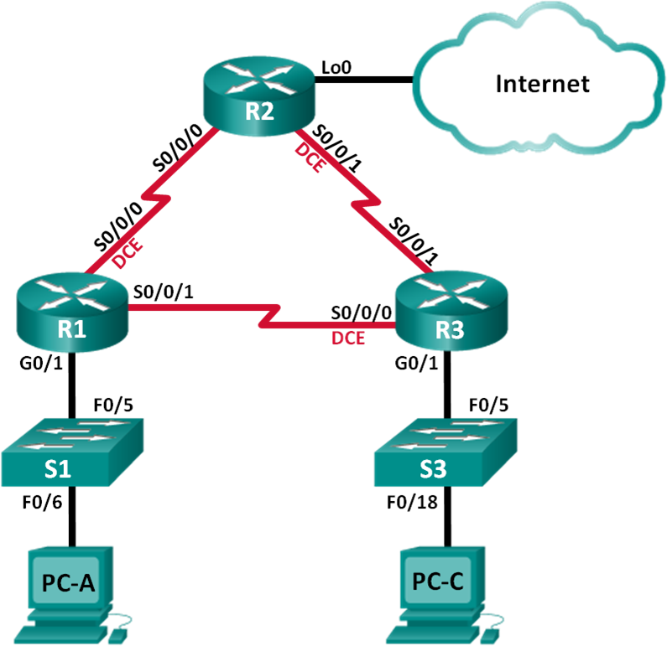

**Addressing Table**

|  |  |  |  |  |
| --- | --- | --- | --- | --- |
| **Device** | **Interface** | **IP Address** | **Subnet Mask** | **Default Gateway** |
| R1 | G0/1 | 192.168.1.1 | 255.255.255.0 | N/A |
| S0/0/0 (DCE) | 192.168.12.1 | 255.255.255.252 | N/A |
| S0/0/1 | 192.168.13.1 | 255.255.255.252 | N/A |
| R2 | Lo0 | 209.165.200.225 | 255.255.255.252 | N/A |
| S0/0/0 | 192.168.12.2 | 255.255.255.252 | N/A |
| S0/0/1 (DCE) | 192.168.23.1 | 255.255.255.252 | N/A |
| R3 | G0/1 | 192.168.3.1 | 255.255.255.0 | N/A |
| S0/0/0 (DCE) | 192.168.13.2 | 255.255.255.252 | N/A |
| S0/0/1 | 192.168.23.2 | 255.255.255.252 | N/A |
| PC-A | NIC | 192.168.1.3 | 255.255.255.0 | 192.168.1.1 |
| PC-C | NIC | 192.168.3.3 | 255.255.255.0 | 192.168.3.1 |

**Objectives**

##### Part 1: Build the Network and Load Device Configurations Part 2: Troubleshoot the Data Link Layer

**Part 3: Troubleshoot the Network Layer**

**Background / Scenario**

The routers at your company were configured by an inexperienced network engineer. Several errors in the configuration have resulted in connectivity issues. Your manager has asked you to troubleshoot and correct the configuration errors and document your work. Using your knowledge of PPP and standard testing methods, find and correct the errors. Ensure that all of the serial links use PPP CHAP authentication, and that all of the networks are reachable.

**Note**: The routers used with CCNA hands-on labs are Cisco 1941 Integrated Services Routers (ISRs) with Cisco IOS Release 15.2(4)M3 (universalk9 image). The switches used are Cisco Catalyst 2960s with Cisco IOS Release 15.0(2) (lanbasek9 image). Other routers, switches, and Cisco IOS versions can be used.

Depending on the model and Cisco IOS version, the commands available and output produced might vary from what is shown in the labs. Refer to the Router Interface Summary Table at the end of this lab for the correct interface identifiers.

**Note**: Make sure that the routers and switches have been erased and have no startup configurations. If you are unsure, contact your instructor.

### Required Resources

* + - * + 3 Routers (Cisco 1941 with Cisco IOS Release 15.2(4)M3 universal image or comparable)
        + 2 Switches (Cisco 2960 with Cisco IOS Release 15.0(2) lanbasek9 image or comparable)
        + 2 PCs (Windows with a terminal emulation program, such as Tera Term)
        + Console cables to configure the Cisco IOS devices via the console ports
        + Ethernet and serial cables as shown in the topology

## Part 1: Build the Network and Load Device Configurations

In Part 1, you will set up the network topology, configure basic settings on the PC hosts, and load configurations on the routers.

#### Step 1: Cable the network as shown in the topology. Step 2: Configure the PC hosts.

**Step 3: Load router configurations.**

Load the following configurations into the appropriate router. All routers have the same passwords. The privileged EXEC mode password is **class**. The password for console and vty access is **cisco**. All serial interfaces should be configured with PPP encapsulation and authenticated with CHAP using the password of **chap123**.

##### Router R1 Configuration:

hostname R1

enable secret class no ip domain lookup

banner motd #Unauthorized Access is Prohibited!# username R2 password chap123

username R3 password chap123 interface g0/1

ip address 192.168.1.1 255.255.255.0

no shutdown interface s0/0/0

ip address 192.168.12.1 255.255.255.252

clock rate 128000 encapsulation ppp

ppp authentication chap interface s0/0/1

ip address 192.168.31.1 255.255.255.252

encapsulation ppp

ppp authentication pap exit

router ospf 1

router-id 1.1.1.1

network 192.168.1.0 0.0.0.255 area 0

network 192.168.12.0 0.0.0.3 area 0

network 192.168.13.0 0.0.0.3 area 0 passive-interface g0/1

exit line con 0

password cisco logging synchronous login

line vty 0 4

password cisco login

##### Router R2 Configuration:

hostname R2

enable secret class no ip domain lookup

banner motd #Unauthorized Access is Prohibited!#

username R1 password chap123

username r3 password chap123

interface lo0

ip address 209.165.200.225 255.255.255.252

interface s0/0/0

ip address 192.168.12.2 255.255.255.252

encapsulation ppp

ppp authentication chap

no shutdown

interface s0/0/1

ip address 192.168.23.1 255.255.255.252

clock rate 128000

no shutdown

exit

router ospf 1

router-id 2.2.2.2

network 192.168.12.0 0.0.0.3 area 0

network 192.168.23.0 0.0.0.3 area 0

default-information originate

exit

ip route 0.0.0.0 0.0.0.0 loopback0

line con 0

password cisco

logging synchronous

login

line vty 0 4 password cisco

login

##### Router R3 Configuration:

hostname R3

enable secret class

no ip domain lookup

banner motd #Unauthorized Access is Prohibited!#

username R2 password chap123

username R3 password chap123

interface g0/1

ip address 192.168.3.1 255.255.255.0

no shutdown

interface s0/0/0

ip address 192.168.13.2 255.255.255.252

clock rate 128000

encapsulation ppp

ppp authentication chap

no shutdown

interface s0/0/1

ip address 192.168.23.2 255.255.255.252

encapsulation ppp

ppp authentication chap

no shutdown

exit

router ospf 1

router-id 3.3.3.3

network 192.168.13.0 0.0.0.3 area 0

network 192.168.23.0 0.0.0.3 area 0

passive-interface g0/1

line con 0 password cisco

logging synchronous

login

line vty 0 4 password cisco

login

#### Step 4: Save your running configuration.

**Part 2: Troubleshoot the Data Link Layer**

In Part 2, you will use **show** commands to troubleshoot data link layer issues. Be sure to verify settings, such as clock rate, encapsulation, CHAP, and usernames/passwords.

#### Step 1: Examine the R1 configuration.

1. Use the **show interfaces** command to determine whether PPP has been established on both serial links. From the **show interfaces** results for S0/0/0 and S0/0/1, what are possible issues with the PPP links?

Los problemas que se presentan en R1:

Serial0/0/0 is administratively down, line protocol is down

Encapsulation PPP, LCP Closed, loopback not set

Serial0/0/1 is administratively down, line protocol is down

Encapsulation PPP, LCP Closed, loopback not set

1. Use the **debug ppp authentication** command to view real-time PPP authentication output during troubleshooting.

##### R1# debug ppp authentication

PPP authentication debugging is on

1. Use the **show run interface s0/0/0** command to examine the settings on S0/0/0.

Resolve all problems found for S0/0/0. Record the commands used to correct the configuration.

Lo primero procedemos a levantar la interfaz:

No shutdown

After correcting the issue, what information does the debug output provide?

Se0/0/0 CHAP: O SUCCESS id 1 len 4

Se0/0/0 CHAP: I SUCCESS id 1 len 4

Al final del log vemos que se ha establecido la conexión

1. Use the **show run interface s0/0/1** command to examine the settings on S0/0/1.

Resolve all problems found for S0/0/1. Record the commands used to correct the configuration.

interface s0/0/1

ppp authentication chap

no shutdown

interface Serial0/0/1

ip address 192.168.31.1 255.255.255.252

encapsulation ppp

shutdown

ppp authentication pap

end

After correcting the issue, what information does the debug output provide?

Se0/0/1 PPP: Sending AAA radius abort

No consigue reanudar la conexión debido a que pueden haber más fallos en el otro punto del enlace serial

1. Use the **no debug ppp authentication** or **undebug all** command to turn off the debug PPP output.

No debug all

1. Use the **show running-config | include username** command to verify the correct username and password configurations.

username R2 password 0 chap123

username R3 password 0 chap123

Resolve all problems found. Record the commands used to correct the configuration.

Username “nombre de host/usuario” “password de chap”

#### Step 2: Examine the R2 configuration.

1. Use the **show interfaces** command to determine if PPP has been established on both serial links.

Serial0/0/1 is up, line protocol is down

Encapsulation HDLC, loopback not set

1. Have all links been established? no

If the answer is no, which links need to be examined? What are the possible issues?

el enlace serial que conecta a R2 y R3 no esta estanlecido, la encapsulación esta configurada con un protocolo destinto al esperado “HDLC”

1. Use the **show run interface** command to examine links that have not been established.

Resolve all problems found for the interfaces. Record the commands used to correct the configuration

1. Use the **show running-config | include username** command to verify the correct username and password configurations.

Resolve all problems found. Record the commands used to correct the configuration.

Establecimos el Puerto de encapsulamiento correcto y indicamos el método de autenticación configurado.

R2(config)# interface s0/0/1

R2(config-if)# encapsulation ppp

R2(config-if)# ppp authentication chap

R2(config)# username R3 password chap123

1. Use the **show ppp interface serial** command for the serial interface that you are troubleshooting. Has the link been established? Sí

Serial0/0/1 is up, line protocol is up

Encapsulation PPP, LCP Open

Open: IPCP, CDPCP, loopback not set

#### Step 3: Examine the R3 configuration.

1. Use the **show interfaces** command to determine whether PPP has been established on both serial links. Have all links been established? No

If the answer is no, which links need to be examined? What are the possible issues?

Esta fallando la conexión entre R1 y R3, las interfaz tiene el encapsulamiendo ppp, por tanto el que estará fallando será la autenticación.

1. Using the **show run interface** command to examine on any serial link that has not been established. Resolve all problems found on the interfaces. Record the commands used to correct the configuration.
2. Use the **show running-config | include username** command to verify the correct username and password configurations.

R3#show running-config | include username

username R2 password 0 chap123

username R3 password 0 chap123

R3#

Resolve all problems found. Record the commands used to correct the configuration.

no username R3 password chap123

username R1 password chap123

1. Use the **show interface** command to verify that serial links have been established.

Encapsulation PPP, LCP Open

Open: IPCP, CDPCP, loopback not set

1. Have all PPP links been established? Si
2. Can PC-A ping Lo0? Si
3. Can PC-A ping PC-C? No

**Note**: It may be necessary to disable the PC firewall for pings between the PCs to succeed.

## Part 3: Troubleshoot the Network Layer

In Part 3, you will verify that Layer 3 connectivity is established on all interfaces by examining IPv4 and OSPF configurations.

#### Step 1: Verify that the interfaces listed in the Addressing Table are active and configured with the correct IP address information.

Issue the **show ip interface brief** command on all routers to verify that the interfaces are in an up/up state. Resolve all problems found. Record the commands used to correct the configuration.

La ip de la interfaz incorrecta

R1(config)# interface s0/0/1

R1(config-if)# ip address 192.168.13.1 255.255.255.252

#### Step 2: Verify OSPF Routing

Issue the **show ip protocols** command to verify that OSPF is running and that all networks are advertised. Resolve all problems found. Record the commands used to correct the configuration.

Por tanto en la tabla de enrutamiento estará incorrecta también, actualizamos:

R3(config)# router ospf 1

R3(config-router)# network 192.168.3.0 0.0.0.255 area 0

Can PC-A ping PC-C? Sí

If connectivity does not exist between all hosts, then continue troubleshooting to resolve any remaining issues.

**Note**: It may be necessary to disable the PC firewall for pings between the PCs to succeed.

**Router Interface Summary Table**

|  |  |  |  |  |
| --- | --- | --- | --- | --- |
| **Router Interface Summary** | | | | |
| **Router Model** | **Ethernet Interface #1** | **Ethernet Interface #2** | **Serial Interface #1** | **Serial Interface #2** |
| 1800 | Fast Ethernet 0/0 (F0/0) | Fast Ethernet 0/1 (F0/1) | Serial 0/0/0 (S0/0/0) | Serial 0/0/1 (S0/0/1) |
| 1900 | Gigabit Ethernet 0/0 (G0/0) | Gigabit Ethernet 0/1 (G0/1) | Serial 0/0/0 (S0/0/0) | Serial 0/0/1 (S0/0/1) |
| 2801 | Fast Ethernet 0/0 (F0/0) | Fast Ethernet 0/1 (F0/1) | Serial 0/1/0 (S0/1/0) | Serial 0/1/1 (S0/1/1) |
| 2811 | Fast Ethernet 0/0 (F0/0) | Fast Ethernet 0/1 (F0/1) | Serial 0/0/0 (S0/0/0) | Serial 0/0/1 (S0/0/1) |
| 2900 | Gigabit Ethernet 0/0 (G0/0) | Gigabit Ethernet 0/1 (G0/1) | Serial 0/0/0 (S0/0/0) | Serial 0/0/1 (S0/0/1) |
| **Note**: To find out how the router is configured, look at the interfaces to identify the type of router and how many interfaces the router has. There is no way to effectively list all the combinations of configurations for each router class. This table includes identifiers for the possible combinations of Ethernet and Serial interfaces in the device. The table does not include any other type of interface, even though a specific router may contain one. An example of this might be an ISDN BRI interface. The string in parenthesis is the legal abbreviation that can be used in Cisco IOS commands to represent the interface. | | | | |



* + - 1. **Lab – Researching Broadband Internet Access Technologies**

**Objectives**

##### Part 1: Investigate Broadband Distribution

**Part 2: Research Broadband Access Options for Specific Scenarios**

**Background / Scenario**

Although broadband Internet access options have increased dramatically in recent years, broadband access varies greatly depending on location. In this lab, you will investigate current broadband distribution and research broadband access options for specific scenarios.

### Required Resources

Device with Internet access

## Part 1: Investigate Broadband Distribution

In Part 1, you will research broadband distribution in a geographical location.

#### Step 1: Research broadband distribution.

Use the Internet to research the following questions:

* + - * 1. For the country in which you reside, what percentage of the population has broadband Internet subscriptions? España
        2. What percentage of the population is without broadband Internet options? Pocos, entre 10% y 20%

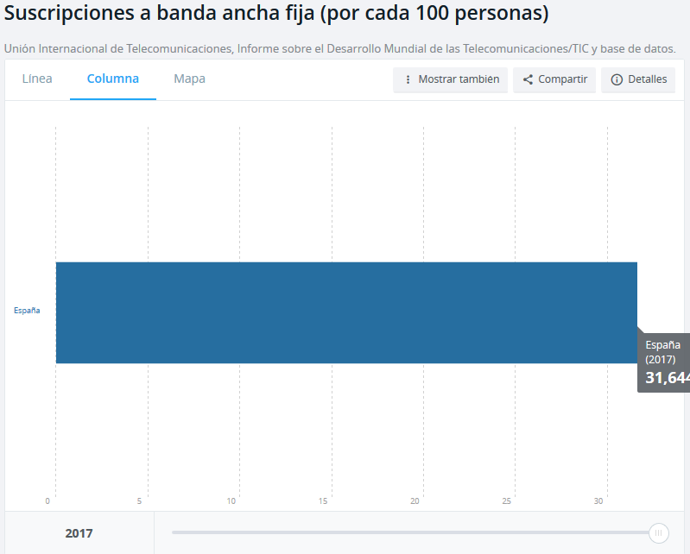

#### Step 2: Research broadband distribution in the United States.

Navigate to the website [www.broadbandmap.gov.](http://www.broadbandmap.gov/) The National Broadband Map allows users to search and map broadband availability across the United States.

**Note**: For access options and ISPs for locations outside the United States, perform an Internet search using the keywords “broadband access XYZ, where XYZ is the name of the country.

1. Enter your zip code, city and country that you would like to explore and click **Find Broadband**. List the zip code or city in the space provided. Yo me basaré en esta dirección: The Lobby Lounge at Mandarin Oriental, 80 Columbus Cir, New York, New York 10019, United States
2. Click **Show Wired** and **Expand All**. What, if any, wired broadband Internet connections are available at this location? Complete the table below.

|  |  |  |
| --- | --- | --- |
| **ISP** | **Connection Type** | **Download Speed** |
| Radiate Holdings LP | Cable | 1000Mbps |
| Verizon | ADSL | 10Mbps |
| Verizon | Fiber | 940Mbps |

1. Click **Show Wireless** and **Expand All**. What, if any, wireless broadband Internet connections are available in this location? Complete the table below.

|  |  |  |
| --- | --- | --- |
| **ISP** | **Connection Type** | **Download Speed** |
| Xcharge | Fixed Wireless | 1000Mbps |
| VSAT Systems | Satellite | 15Mbps |
| Barrier communications | Fixed Wireless | 2 Mbps |

1. Return to the home page and click **Explore the Maps**. The interactive map allows you to explore the geographical availability of a number of broadband Internet options.
2. 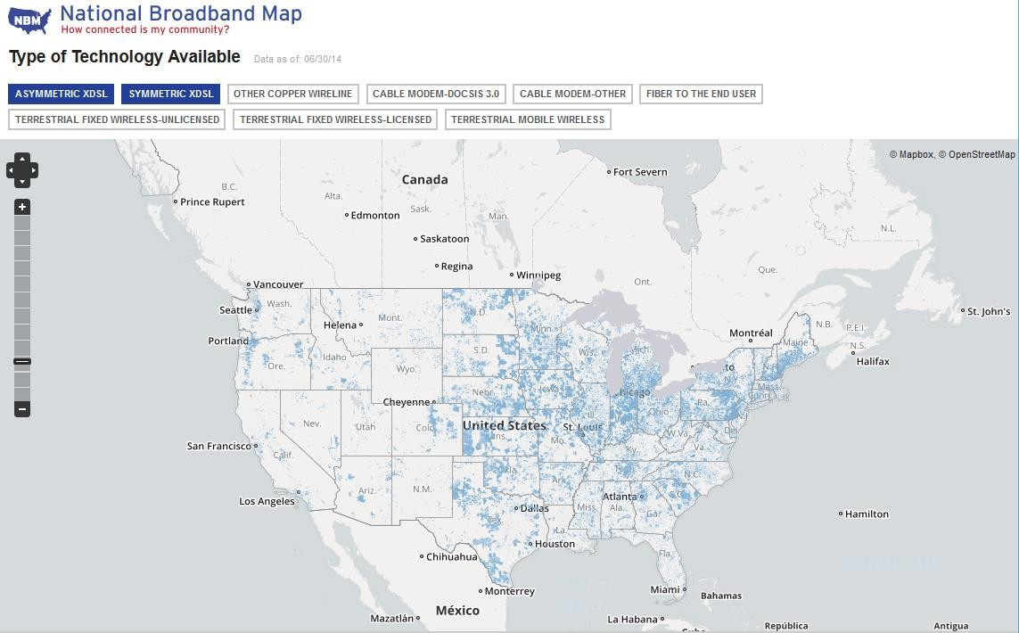Highlight each of the wired connections independently (DSL, cable, and fiber). Selections are highlighted in dark blue.

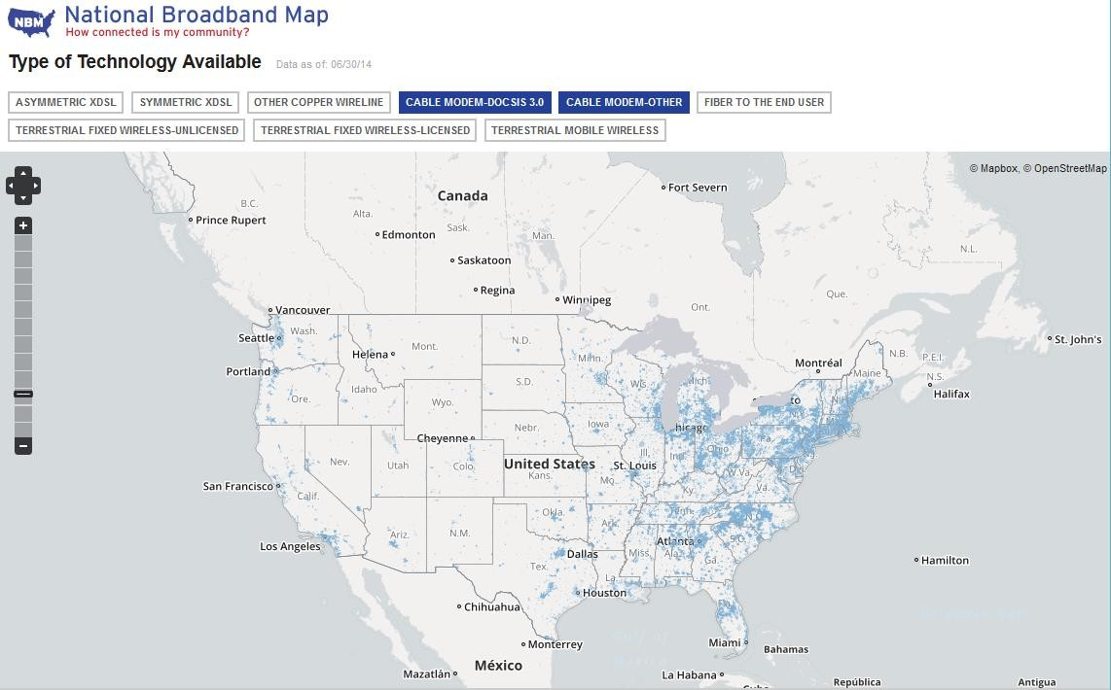

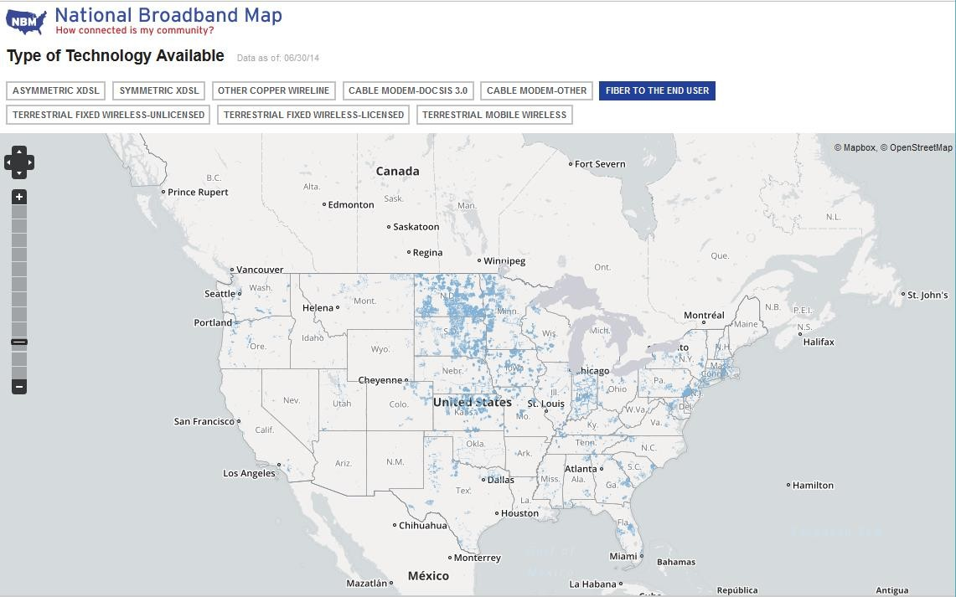

For wired connections, order the wired broadband connections from least to greatest in terms of geographical area covered. List your answer in the space provided.

Fiber y cable

1. 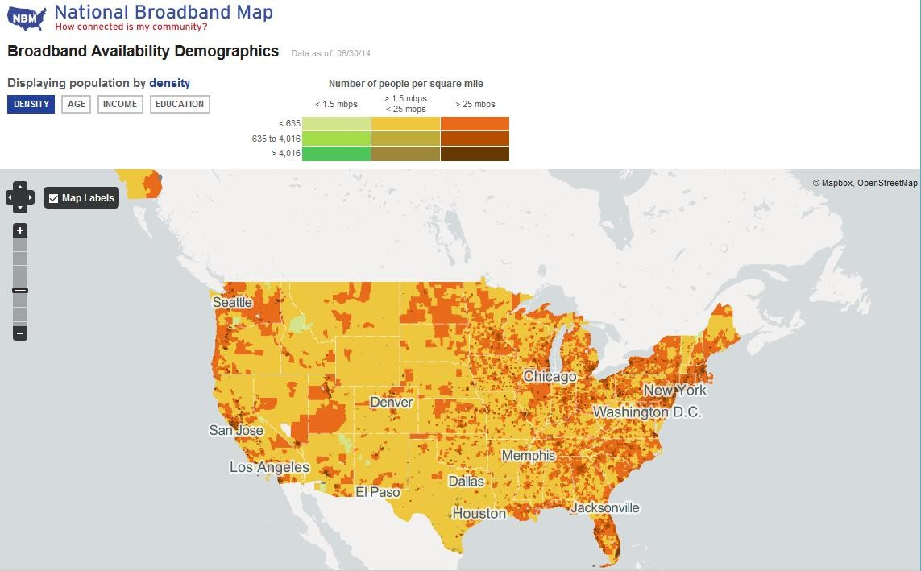In the gallery of maps at the bottom of the web page, select **Broadband Availability Demographics**. Display the population by **density** and compare the broadband connection to the population distribution of the United States. What correlations can be drawn?

Según la cantidad de gente y deniedad de acceso puede afectar la velocidad.

## Part 2: Research Broadband Access Options for Specific Scenarios

In Part 2, you will research and detail broadband options for the following scenarios and select the best last- mile technology to meet the needs of the consumer. You can use the [http://www.broadbandmap.gov](http://www.broadbandmap.gov/) site as a starting point for your research.

**Scenario 1**: You are moving to Kansas City, Missouri and are exploring home Internet connections. Research and detail two Internet connections from which you can select in this metropolitan area.

|  |  |  |  |
| --- | --- | --- | --- |
| **ISP** | **Connection Type** | **Cost per Month** | **Download Speed** |
| Google Fiber inlc | Fiber | $70 | 1000 Mbps |
| Packet layer | Cable | $79 | 50 Mbps |

Choose one from the list of local ISPs that you selected. Give the reasons why you chose that particular ISP.

El de google, ya que la velocidad esta bien, en comparación con el resto y el precio no hay mucha diferencia

**Scenario 2**: You are moving to an area outside of Billings, Montana and are exploring home Internet connections. You will be beyond the reach of cable or DSL connections. Research and detail two Internet connections from which you can select in this area.

|  |  |  |  |
| --- | --- | --- | --- |
| **ISP** | **Connection Type** | **Cost per Month** | **Download Speed** |
| VSAT Systems, LLC | Satellite | 60$ | 2 Mbps |
| USA Holdings | Fixed wireless | 40$ | 5 Mbps |

Choose one from the list of local ISPs that you selected. Give the reasons why you chose that particular ISP.

Usa Holdings, es más económico y no ofrece mejor conexión

**Scenario 3**: You are moving to New York City and your job requires you to have 24 hours anytime/anywhere access. Research and detail two Internet connections from which you can select in this area.

|  |  |  |  |
| --- | --- | --- | --- |
| **ISP** | **Connection Type** | **Cost per Month** | **Download Speed** |
| Clear | Mobile Wireless | 50$ | 6 Mbps |
| Sprint | Mobile Wireless | 80$ | 6 Mbps |

Choose one from the list of local ISPs that you selected. Give the reasons why you chose that particular ISP.

Clear ya que es más económico y ofrece una conexión comparable con el resto de proveedores

**Scenario 4**: You are small business owner with 10 employees who telecommute in the Fargo, North Dakota area. The teleworkers live beyond the reach of cable Internet connections. Research and detail two Internet connections from which you can select in this area.

|  |  |  |  |
| --- | --- | --- | --- |
| **ISP** | **Connection Type** | **Cost per Month** | **Download Speed** |
| Century Link | DSL | 29$ | 12 Mbps |
| VAL-ED | Fixed wifi | 43$ | 3 Mbps |

Choose one from the list of local ISPs that you selected. Give the reasons why you chose that particular ISP.

VAL-ED ya que facilita acceso a los teletrabajadores, más comodidad a la empresa

**Scenario 5**: Your business in Washington, D.C. is expanding to 25 employees and will need to upgrade your broadband access to include equipment colocation and web hosting. Research and detail two Internet connections from which you can select in this area.

|  |  |  |  |
| --- | --- | --- | --- |
| **ISP** | **Connection Type** | **Cost per Month** | **Download Speed** |
| Charler | Cable | 500$ | 400 Mbps |
| Frontier | ADSL | 123$ | 6Mbps |

Choose one from the list of local ISPs that you selected. Give the reasons why you chose that particular ISP.

Aque depende de la necesidad de la velocidad que necesitrá la empresa, Frontier si es suficiente ya la otra alternativa es más cara.

### Reflection

How do you think broadband Internet access will change in the future?

Yo pienso que siempre habrán área sin acceso o con poco acceso ya que el desarrollo de las infraestructuras es caro y a no ser por una gran necesidad no se implementa.

Aun así cada vez un mundo esta interconectado con tecnologías más punteras que dan acceso a unas velocidades impresionantes. se si llega a desarrollar una tecnología inalámbrica que velocidades altas quirás es la que menos gastos necesita por ejemplo el 5g



# Lab – Configuring a Router as a PPPoE Client for DSL Connectivity

### Topology

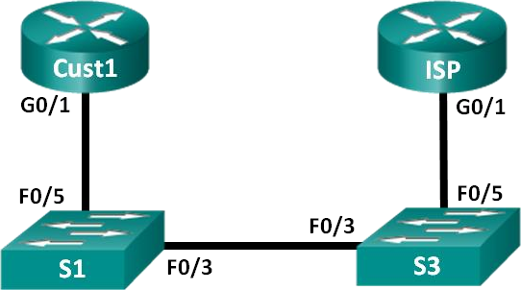

**Addressing Table**

|  |  |  |  |  |
| --- | --- | --- | --- | --- |
| **Device** | **Interface** | **IP Address** | **Subnet Mask** | **Default Gateway** |
| Cust1 | G0/1 | Learned via PPP | Learned via PPP | Learned via PPP |
| ISP | G0/1 | N/A | N/A | N/A |

**Objectives**

##### Part 1: Build the Network

**Part 2: Configure the ISP Router Part 3: Configure the Cust1 Router**

**Background / Scenario**

ISPs often use Point-to-Point Protocol over Ethernet (PPPoE) on DSL links to their customers. PPP supports the assignment of IP address information to a device at the remote end of a PPP link. More importantly, PPP supports CHAP authentication. ISPs can check accounting records to see if a customer’s bill has been paid, before letting them connect to the Internet.

In this lab, you will configure both the client and ISP side of the connection to set up PPPoE. Typically, you would only configure the client end.

**Note**: The routers used with CCNA hands-on labs are Cisco 1941 Integrated Services Routers (ISRs) with Cisco IOS Release 15.2(4)M3 (universalk9 image). The switches used are Cisco Catalyst 2960s with Cisco IOS Release 15.0(2) (lanbasek9 image). Other routers, switches, and Cisco IOS versions can be used.

Depending on the model and Cisco IOS version, the commands available and output produced might vary from what is shown in the labs. Refer to the Router Interface Summary Table at the end of this lab for the correct interface identifiers.

**Note**: Ensure that the routers and switches have been erased and have no startup configurations. If you are unsure, contact your instructor.

### Required Resources

* + - * + 2 Routers (Cisco 1941 with Cisco IOS Release 15.2(4)M3 universal image or comparable)
        + 2 Switches (Cisco 2960 with Cisco IOS Release 15.0(2) lanbasek9 image or comparable)
        + Console cables to configure the Cisco IOS devices via the console ports
        + Ethernet cables as shown in the topology

**Part 1: Build the Network**

#### Step 1: Cable the network as shown in the topology. Step 2: Initialize and reload the routers and switches.

**Step 3: Configure basic settings for each router.**

1. Disable DNS lookup.
2. Configure device name as shown in the topology.
3. Encrypt plaintext passwords.
4. Create a message of the day (MOTD) banner warning users that unauthorized access is prohibited.
5. Assign **class** as the encrypted privileged EXEC mode password.
6. Assign **cisco** as the console and vty password and enable login.
7. Set console logging to synchronous mode.
8. Save your configuration.

## Part 2: Configure the ISP Router

In Part 2, you configure the ISP router with PPPoE parameters for connection from the Cust1 router.

**Note**: Many of the ISP router PPPoE configuration commands are beyond the scope of the course; however, they are necessary for completion of the lab. They can be copied and pasted into the ISP router at the global configuration mode prompt.

1. Create a local database username **Cust1** with a password of **ciscopppoe**.

ISP(config)# **username Cust1 password ciscopppoe**

1. Create a pool of addresses that will be assigned to customers.

ISP(config)# **ip local pool PPPoEPOOL 10.0.0.1 10.0.0.10**

1. Create the Virtual Template and associate the IP address of G0/1 with it. Associate the Virtual Template with the pool of addresses. Configure CHAP to authenticate customers.

ISP(config)# **interface virtual-template 1**

ISP(config-if)# **ip address 10.0.0.254 255.255.255.0**

ISP(config-if)# **mtu 1492**

ISP(config-if)# **peer default ip address pool PPPoEPOOL** ISP(config-if)# **ppp authentication chap callin** ISP(config-if)# **exit**

1. Assign the template to the PPPoE group.

ISP(config)# **bba-group pppoe global**

ISP(config-bba-group)# **virtual-template 1**

ISP(config-bba-group)# **exit**

1. Associate the bba-group with the G0/1 physical interface.

ISP(config)# **interface g0/1**

ISP(config-if# **pppoe enable group global**

ISP(config-if)# **no shutdown**

## Part 3: Configure the Cust1 Router

In Part 3, you will configure the Cust1 router with PPPoE parameters.

1. Configure G0/1 interface for PPPoE connectivity.

Cust1(config)# **interface g0/1**

Cust1(config-if)# **pppoe enable**

Cust1(config-if)# **pppoe-client dial-pool-number 1**

Cust1(config-if)# **exit**

1. Associate the G0/1 interface with a dialer interface. Use the username **Cust1** and password **ciscopppoe**

configured in Part 2.

Cust1(config)# **interface dialer 1** Cust1(config-if)# **mtu 1492** Cust1(config-if)# **ip address negotiated** Cust1(config-if)# **encapsulation ppp** Cust1(config-if)# **dialer pool 1**

Cust1(config-if)# **ppp authentication chap callin** Cust1(config-if)# **ppp chap hostname Cust1** Cust1(config-if)# **ppp chap password ciscopppoe** Cust1(config-if)# **exit**

1. Set up a static default route pointing to the Dialer interface.

Cust1(config)# **ip route 0.0.0.0 0.0.0.0 dialer 1**

1. Set up debugging on the Cust1 router to display PPP and PPPoE negotiation.

Cust1# **debug ppp authentication**

Cust1# **debug pppoe events**

1. Enable the G0/1 interface on the Cust1 router and observe the debug output as the PPPoE dialer session is established and CHAP authentication takes place.

*Jul 30 19:28:42.427: %LINK-3-UPDOWN: Interface GigabitEthernet0/1, changed state to down

*Jul 30 19:28:46.175: %LINK-3-UPDOWN: Interface GigabitEthernet0/1, changed state to up

*Jul 30 19:28:47.175: %LINEPROTO-5-UPDOWN: Line protocol on Interface GigabitEthernet0/1, changed state to up

*Jul 30 19:29:03.839: padi timer expired

*Jul 30 19:29:03.839: Sending PADI: Interface = GigabitEthernet0/1

*Jul 30 19:29:03.839: PPPoE 0: I PADO R:30f7.0da3.0b01 L:30f7.0da3.0bc1 Gi0/1

*Jul 30 19:29:05.887: PPPOE: we've got our pado and the pado timer went off

*Jul 30 19:29:05.887: OUT PADR from PPPoE Session

*Jul 30 19:29:05.895: PPPoE 1: I PADS R:30f7.0da3.0b01 L:30f7.0da3.0bc1 Gi0/1

|  |  |  |  |
| --- | --- | --- | --- |
| *Jul | 30 | 19:29:05.895: | IN PADS from PPPoE Session |
| *Jul | 30 | 19:29:05.899: | %DIALER-6-BIND: Interface Vi2 bound to profile Di1 |
| *Jul | 30 | 19:29:05.899: | PPPoE: Virtual Access interface obtained. |
| *Jul | 30 | 19:29:05.899: | PPPoE : encap string prepared |
| *Jul | 30 | 19:29:05.899: | [0]PPPoE 1: data path set to PPPoE Client |
| *Jul | 30 | 19:29:05.903: | %LINK-3-UPDOWN: Interface Virtual-Access2, changed state to up |
| *Jul | 30 | 19:29:05.911: | Vi2 PPP: Using dialer call direction |
| *Jul | 30 | 19:29:05.911: | Vi2 PPP: Treating connection as a callout |
| *Jul | 30 | 19:29:05.911: | Vi2 PPP: Session handle[C6000001] Session id[1] |
| *Jul | 30 | 19:29:05.919: | Vi2 PPP: No authorization without authentication |
| *Jul | 30 | 19:29:05.939: | Vi2 CHAP: I CHALLENGE id 1 len 24 from "ISP" |
| *Jul | 30 | 19:29:05.939: | Vi2 PPP: Sent CHAP SENDAUTH Request |
| *Jul | 30 | 19:29:05.939: | Vi2 PPP: Received SENDAUTH Response FAIL |
| *Jul | 30 | 19:29:05.939: | Vi2 CHAP: Using hostname from interface CHAP |
| *Jul | 30 | 19:29:05.939: | Vi2 CHAP: Using password from interface CHAP |
| *Jul | 30 | 19:29:05.939: | Vi2 CHAP: O RESPONSE id 1 len 26 from "Cust1" |
| *Jul | 30 | 19:29:05.955: | Vi2 CHAP: I SUCCESS id 1 len 4 |
| *Jul | 30 | 19:29:05.955: | %LINEPROTO-5-UPDOWN: Line protocol on Interface Virtual-Access2, |

changed state to up

*Jul 30 19:29:05.983: PPPoE : ipfib_encapstr prepared

*Jul 30 19:29:05.983: PPPoE : ipfib_encapstr prepared

1. Issue a **show ip interface brief** command on the Cust1 router to display the IP address assigned by the ISP router. Sample output is shown below. By what method was the IP address obtained? La ip se obtenido mediante el ISP, método IPCP.

Cust1# **show ip interface brief**

Interface IP-Address OK? Method Status Protocol Embedded-Service-Engine0/0 unassigned YES unset administratively down down GigabitEthernet0/0 unassigned YES unset administratively down down GigabitEthernet0/1 unassigned YES unset up up Serial0/0/0 unassigned YES unset administratively down down

Serial0/0/1 unassigned YES unset administratively down down

Dialer1 10.0.0.1 YES IPCP up up

Virtual-Access1 unassigned YES unset up up

Virtual-Access2 unassigned YES unset up up

1. Issue a **show ip route** command on the Cust1 router. Sample output is shown below.

Cust1# **show ip route**

Codes: L - local, C - connected, S - static, R - RIP, M - mobile, B - BGP D - EIGRP, EX - EIGRP external, O - OSPF, IA - OSPF inter area

N1 - OSPF NSSA external type 1, N2 - OSPF NSSA external type 2 E1 - OSPF external type 1, E2 - OSPF external type 2

i - IS-IS, su - IS-IS summary, L1 - IS-IS level-1, L2 - IS-IS level-2 ia - IS-IS inter area, * - candidate default, U - per-user static route o - ODR, P - periodic downloaded static route, H - NHRP, l - LISP

+ - replicated route, % - next hop override Gateway of last resort is 0.0.0.0 to network 0.0.0.0

S* 0.0.0.0/0 is directly connected, Dialer1 10.0.0.0/32 is subnetted, 2 subnets

C 10.0.0.1 is directly connected, Dialer1 C 10.0.0.254 is directly connected, Dialer1

1. Issue a **show pppoe session** on Cust1 router. Sample output is shown below.

Cust1# **show pppoe session**

1 client session

|  |  |  |  |  |  |
| --- | --- | --- | --- | --- | --- |
| Uniq ID PPPoE  SID | RemMAC  LocMAC | Port | VT | VA  VA-st | State  Type |
| N/A 1 | 30f7.0da3.0b01 | Gi0/1 | Di1 | Vi2 | UP |
|  | 30f7.0da3.0bc1 |  |  | UP |  |

i. Issue a ping to 10.0.0.254 from the Cust1 router. The ping should be successful. If not, troubleshoot until you have connectivity.

Cust1# **ping 10.0.0.254**

Type escape sequence to abort.

Sending 5, 100-byte ICMP Echos to 10.0.0.254, timeout is 2 seconds:

!!!!!

Success rate is 100 percent (5/5), round-trip min/avg/max = 1/1/4 ms

### Reflection

Why do ISPs who use DSL, primarily use PPPoE with their customers?

Para facilitar la asignación de ip a sus clientes.

### Router Interface Summary Table

|  |  |  |  |  |
| --- | --- | --- | --- | --- |
| **Router Interface Summary** | | | | |
| **Router Model** | **Ethernet Interface #1** | **Ethernet Interface #2** | **Serial Interface #1** | **Serial Interface #2** |
| 1800 | Fast Ethernet 0/0 (F0/0) | Fast Ethernet 0/1 (F0/1) | Serial 0/0/0 (S0/0/0) | Serial 0/0/1 (S0/0/1) |
| 1900 | Gigabit Ethernet 0/0 (G0/0) | Gigabit Ethernet 0/1 (G0/1) | Serial 0/0/0 (S0/0/0) | Serial 0/0/1 (S0/0/1) |
| 2801 | Fast Ethernet 0/0 (F0/0) | Fast Ethernet 0/1 (F0/1) | Serial 0/1/0 (S0/1/0) | Serial 0/1/1 (S0/1/1) |
| 2811 | Fast Ethernet 0/0 (F0/0) | Fast Ethernet 0/1 (F0/1) | Serial 0/0/0 (S0/0/0) | Serial 0/0/1 (S0/0/1) |
| 2900 | Gigabit Ethernet 0/0 (G0/0) | Gigabit Ethernet 0/1 (G0/1) | Serial 0/0/0 (S0/0/0) | Serial 0/0/1 (S0/0/1) |
| **Note**: To find out how the router is configured, look at the interfaces to identify the type of router and how many interfaces the router has. There is no way to effectively list all the combinations of configurations for each router class. This table includes identifiers for the possible combinations of Ethernet and Serial interfaces in the device. The table does not include any other type of interface, even though a specific router may contain one. An example of this might be an ISDN BRI interface. The string in parenthesis is the legal abbreviation that can be used in Cisco IOS commands to represent the interface. | | | | |



* + - 1. **Lab – Troubleshoot PPPoE**

**Topology**



**Addressing Table**

|  |  |  |  |  |
| --- | --- | --- | --- | --- |
| **Device** | **Interface** | **IP Address** | **Subnet Mask** | **Default Gateway** |
| Cust1 | G0/1 | Learned via PPP | Learned via PPP | Learned via PPP |
| ISP | G0/1 | N/A | N/A | N/A |

**Objectives**

##### Part 1: Build the Network

**Part 2: Troubleshoot PPPoE on Cust1**

**Background / Scenario**

ISPs sometimes use Point-to-Point Protocol over Ethernet (PPPoE) on DSL links to their customers. PPP supports the assignment of IP address information to a device at the remote end of a PPP link. More

importantly, PPP supports CHAP authentication. ISPs can check accounting records to see if a customer’s bill has been paid, before letting them connect to the Internet.

In this lab, you will troubleshoot the Cust1 router for PPPoE configuration problems.

**Note**: The routers used with CCNA hands-on labs are Cisco 1941 Integrated Services Routers (ISRs) with Cisco IOS Release 15.2(4)M3 (universalk9 image). The switches used are Cisco Catalyst 2960s with Cisco IOS Release 15.0(2) (lanbasek9 image). Other routers, switches, and Cisco IOS versions can be used.

Depending on the model and Cisco IOS version, the commands available and output produced might vary from what is shown in the labs. Refer to the Router Interface Summary Table at the end of this lab for the correct interface identifiers.

**Note**: Ensure that the routers and switches have been erased and have no startup configurations. If you are unsure, contact your instructor.

### Required Resources

* + - * + 2 Routers (Cisco 1941 with Cisco IOS Release 15.2(4)M3 universal image or comparable)
        + 2 Switches (Cisco 2960 with Cisco IOS Release 15.0(2) lanbasek9 image or comparable)
        + Console cables to configure the Cisco IOS devices via the console ports
        + Ethernet cables as shown in the topology

## Part 1: Build the Network

#### Step 1: Cable the network as shown in the topology. Step 2: Initialize and reload the routers and switches.

**Step 3: Copy the configurations on to routers.**

1. Copy and paste the Cust1 configuration to the Cust1 router.

hostname Cust1 enable secret class no aaa new-model

no ip domain lookup interface GigabitEthernet0/1

no ip address duplex auto speed auto

pppoe enable group global

pppoe-client dial-pool-number 1 no shut

interface Dialer1 mtu 1492

ip address negotiated encapsulation ppp dialer pool 1

ppp authentication chap callin ppp chap hostname Cust1

ppp chap password 0 ciscoppp ip route 0.0.0.0 0.0.0.0 Dialer1 banner motd ^C

Unauthorized Access Prohibited.

^C

line con 0 password cisco

logging synchronous login

line aux 0

line vty 0 4 password cisco login

end

1. Copy and paste the ISP configuration to the ISP router.

hostname ISP

enable secret class

username Cust1 password 0 ciscopppoe bba-group pppoe global

virtual-template 1 interface GigabitEthernet0/1

no ip address duplex auto speed auto

pppoe enable group global no shut

interface Virtual-Template1

ip address 10.0.0.254 255.255.255.0

mtu 1492

peer default ip address pool PPPoEPOOL ppp authentication chap callin

ip local pool PPPoEPOOL 10.0.0.1 10.0.0.10 ip forward-protocol nd

banner motd ^C

Unauthorized Access Prohibited.

^C

line con 0 password cisco

logging synchronous login

line vty 0 4 password cisco login

end

**Note**: Many of the ISP router PPPoE configuration commands are beyond the scope of the course.

1. Save the router configurations.

## Part 2: Troubleshoot PPPoE on Cust1

In Part 2, you will troubleshoot PPPoE on the Cust 1 router. The privileged EXEC mode password is **class**, and console and vty passwords are **cisco**. The ISP has provided a username of **Cust1** and a password of **ciscopppoe** for PPPoE CHAP authentication.

The following log messages should be appearing on your console session to Cust1:

Cust1#

*Nov 5 22:53:46.999: %DIALER-6-BIND: Interface Vi2 bound to profile Di1

*Nov 5 22:53:47.003: %LINK-3-UPDOWN: Interface Virtual-Access2, changed state to up

*Nov 5 22:53:47.035: %DIALER-6-UNBIND: Interface Vi2 unbound from profile Di1

*Nov 5 22:53:47.039: %LINK-3-UPDOWN: Interface Virtual-Access2, changed state to down Cust1#

#### Step 1: Verify that IPv4 Address is assigned to the Cust1 Dialer interface.

The Dialer virtual interface did not receive an IP address.

Cust1# **show ip interface brief**

Interface IP-Address OK? Method Status Protocol Embedded-Service-Engine0/0 unassigned YES unset administratively down down GigabitEthernet0/0 unassigned YES unset administratively down down GigabitEthernet0/1 unassigned YES unset up up Serial0/0/0 unassigned YES unset administratively down down Serial0/0/1 unassigned YES unset administratively down down

Dialer1 unassigned YES manual up up

Virtual-Access1 unassigned YES unset up up

Virtual-Access2 unassigned YES unset down down

#### Step 2: Debug PPP to determine if the problem is with authentication.

1. Turn on debug for PPP authentication.

Cust1# **debug ppp authentication** PPP authentication debugging is on Cust1#

*Nov 5 23:09:00.283: %DIALER-6-BIND: Interface Vi2 bound to profile Di1

*Nov 5 23:09:00.287: %LINK-3-UPDOWN: Interface Virtual-Access2, changed state to up

*Nov 5 23:09:00.287: Vi2 PPP: Using dialer call direction

*Nov 5 23:09:00.287: Vi2 PPP: Treating connection as a callout

*Nov 5 23:09:00.287: Vi2 PPP: Session handle[8A000036] Session id[54]

*Nov 5 23:09:00.315: Vi2 PPP: No authorization without authentication

*Nov 5 23:09:00.315: Vi2 CHAP: I CHALLENGE id 1 len 24 from "ISP"

*Nov 5 23:0

Cust1#9:00.315: Vi2 PPP: Sent CHAP SENDAUTH Request

*Nov 5 23:09:00.315: Vi2 PPP: Received SENDAUTH Response FAIL

*Nov 5 23:09:00.315: Vi2 CHAP: Using hostname from interface CHAP

*Nov 5 23:09:00.315: Vi2 CHAP: Using password from interface CHAP

*Nov 5 23:09:00.315: Vi2 CHAP: O RESPONSE id 1 len 26 from "Cust1"

*Nov 5 23:09:00.315: Vi2 CHAP: I FAILURE id 1 len 25 msg is "Authentication failed"

*Nov 5 23:09:00.315: %DIALER-6-UNBIND: Interface Vi2 unbound from profile Di1

*Nov 5 23:09:00.319: %LINK-3

Cust1#-UPDOWN: Interface Virtual-Access2, changed state to down Cust1#

1. End debug mode.

Cust1# **u all**

All possible debugging has been turned off

Cust1#

#### Step 3: Verify that the PPPoE username and password matches what was given by the ISP.

1. Display the running configuration; apply a filter to display only the Dialer section. Verify that the username and password matches what was provided by the ISP.

Cust1# **show run | section Dialer**

interface Dialer1 mtu 1492

ip address negotiated encapsulation ppp

dialer pool 1

ppp authentication chap callin ppp chap hostname Cust1

ppp chap password 0 ciscoppp ip route 0.0.0.0 0.0.0.0 Dialer1

1. The problem appears to be with the password. Enter Global configuration mode and fix the ppp password.

Cust1# **conf t**

Enter configuration commands, one per line. End with CNTL/Z. Cust1(config)# **interface Dialer1**

Cust1(config-if)# **ppp chap password ciscopppoe**

Cust1(config-if)# **end**

Cust1#

*Nov 5 23:42:07.343: %SYS-5-CONFIG_I: Configured from console by console Cust1#

*Nov 5 23:42:25.039: %DIALER-6-BIND: Interface Vi2 bound to profile Di1

*Nov 5 23:42:25.043: %LINK-3-UPDOWN: Interface Virtual-Access2, changed state to up Cust1#

*Nov 5 23:42:25.063: %LINEPROTO-5-UPDOWN: Line protocol on Interface Virtual-Access2, changed state to up

#### Step 4: Verify PPPoE connectivity.

1. Verify that this change resolved the problem and that an IP address has been assigned to the Dialer1 interface.

Cust1# **show ip interface brief**

Interface IP-Address OK? Method Status Protocol Embedded-Service-Engine0/0 unassigned YES unset administratively down down GigabitEthernet0/0 unassigned YES unset administratively down down GigabitEthernet0/1 unassigned YES unset up up Serial0/0/0 unassigned YES unset administratively down down

Serial0/0/1 unassigned YES unset administratively down down

Dialer1 10.0.0.1 YES IPCP up up

Virtual-Access1 unassigned YES unset up up

Virtual-Access2 unassigned YES unset up up

1. Display the routing table to verify a route to the ISP router.

Cust1# **show ip route**

Codes: L - local, C - connected, S - static, R - RIP, M - mobile, B - BGP D - EIGRP, EX - EIGRP external, O - OSPF, IA - OSPF inter area

N1 - OSPF NSSA external type 1, N2 - OSPF NSSA external type 2 E1 - OSPF external type 1, E2 - OSPF external type 2

i - IS-IS, su - IS-IS summary, L1 - IS-IS level-1, L2 - IS-IS level-2 ia - IS-IS inter area, * - candidate default, U - per-user static route o - ODR, P - periodic downloaded static route, H - NHRP, l - LISP

a - application route

+ - replicated route, % - next hop override Gateway of last resort is 0.0.0.0 to network 0.0.0.0

S* 0.0.0.0/0 is directly connected, Dialer1 10.0.0.0/32 is subnetted, 2 subnets

C 10.0.0.1 is directly connected, Dialer1 C 10.0.0.254 is directly connected, Dialer1

1. Display information about the active PPPoE sessions.

Cust1# **show pppoe session**

1 client session

|  |  |  |  |  |  |
| --- | --- | --- | --- | --- | --- |
| Uniq ID PPPoE  SID | RemMAC  LocMAC | Port | VT | VA  VA-st | State  Type |
| N/A 1 | 30f7.0da3.1641 | Gi0/1 | Di1 | Vi2 | UP |
|  | 30f7.0da3.0da1 |  |  | UP |  |

#### Step 5: Adjust the maximum segment size on the physical interface.

The PPPoE header adds an additional 8 bytes to each segment. To prevent TCP sessions from being dropped, the maximum segment size (MSS) needs to be adjusted to its optimum value on the physical interface.

1. Display G0/1s configuration setting to see if the MSS has been adjusted.

Cust1# **show run interface g0/1**

Building configuration...

Current configuration : 136 bytes

!

interface GigabitEthernet0/1 no ip address

duplex auto speed auto

pppoe enable group global

pppoe-client dial-pool-number 1 end

1. Adjust the MSS to its optimum value of 1452 bytes.

Cust1(config)# **interface g0/1** Cust1(config-if)# **ip tcp adjust-mss 1452** Cust1(config-if)# **end**

**Reflection**

Explain why the TCP segment size needs to be adjusted for PPPoE.

### Router Interface Summary Table

|  |  |  |  |  |
| --- | --- | --- | --- | --- |
| **Router Interface Summary** | | | | |
| **Router Model** | **Ethernet Interface #1** | **Ethernet Interface #2** | **Serial Interface #1** | **Serial Interface #2** |
| 1800 | Fast Ethernet 0/0 (F0/0) | Fast Ethernet 0/1 (F0/1) | Serial 0/0/0 (S0/0/0) | Serial 0/0/1 (S0/0/1) |
| 1900 | Gigabit Ethernet 0/0 (G0/0) | Gigabit Ethernet 0/1 (G0/1) | Serial 0/0/0 (S0/0/0) | Serial 0/0/1 (S0/0/1) |
| 2801 | Fast Ethernet 0/0 (F0/0) | Fast Ethernet 0/1 (F0/1) | Serial 0/1/0 (S0/1/0) | Serial 0/1/1 (S0/1/1) |
| 2811 | Fast Ethernet 0/0 (F0/0) | Fast Ethernet 0/1 (F0/1) | Serial 0/0/0 (S0/0/0) | Serial 0/0/1 (S0/0/1) |
| 2900 | Gigabit Ethernet 0/0 (G0/0) | Gigabit Ethernet 0/1 (G0/1) | Serial 0/0/0 (S0/0/0) | Serial 0/0/1 (S0/0/1) |
| **Note**: To find out how the router is configured, look at the interfaces to identify the type of router and how many interfaces the router has. There is no way to effectively list all the combinations of configurations for each router class. This table includes identifiers for the possible combinations of Ethernet and Serial interfaces in the device. The table does not include any other type of interface, even though a specific router may contain one. An example of this might be an ISDN BRI interface. The string in parenthesis is the legal abbreviation that can be used in Cisco IOS commands to represent the interface. | | | | |



* + - 1. **Lab – Configuring a Point-to-Point GRE VPN Tunnel**

**Topology**

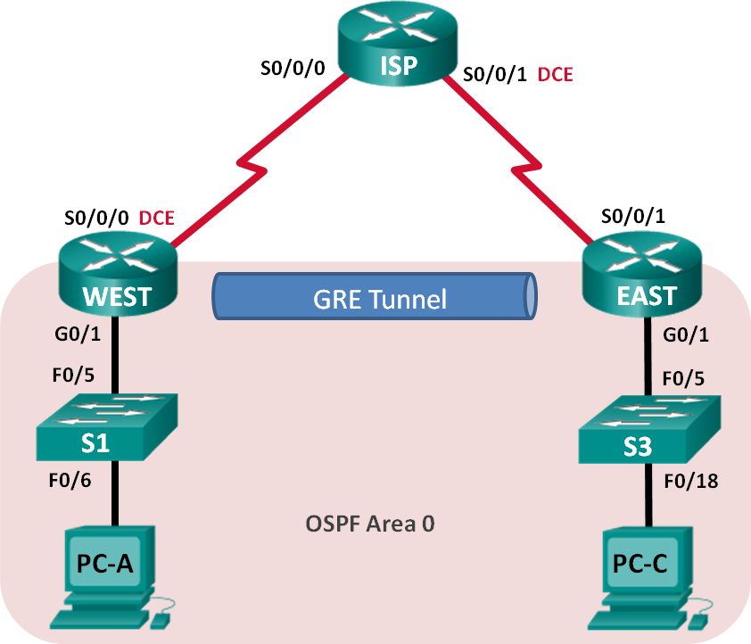

**Addressing Table**

|  |  |  |  |  |
| --- | --- | --- | --- | --- |
| **Device** | **Interface** | **IP Address** | **Subnet Mask** | **Default Gateway** |
| WEST | G0/1 | 172.16.1.1 | 255.255.255.0 | N/A |
| S0/0/0 (DCE) | 10.1.1.1 | 255.255.255.252 | N/A |
| Tunnel0 | 172.16.12.1 | 255.255.255.252 | N/A |
| ISP | S0/0/0 | 10.1.1.2 | 255.255.255.252 | N/A |
| S0/0/1 (DCE) | 10.2.2.2 | 255.255.255.252 | N/A |
| EAST | G0/1 | 172.16.2.1 | 255.255.255.0 | N/A |
| S0/0/1 | 10.2.2.1 | 255.255.255.252 | N/A |
| Tunnel0 | 172.16.12.2 | 255.255.255.252 | N/A |
| PC-A | NIC | 172.16.1.3 | 255.255.255.0 | 172.16.1.1 |
| PC-C | NIC | 172.16.2.3 | 255.255.255.0 | 172.16.2.1 |

**Objectives**

##### Part 1: Configure Basic Device Settings Part 2: Configure a GRE Tunnel

**Part 3: Enable Routing over the GRE Tunnel**

**Background / Scenario**

Generic Routing Encapsulation (GRE) is a tunneling protocol that can encapsulate a variety of network layer protocols between two locations over a public network, such as the Internet.

GRE can be used with:

* Connecting IPv6 networks over IPv4 networks
* Multicast packets, such as OSPF, EIGRP, and streaming applications

In this lab, you will configure an unencrypted point-to-point GRE VPN tunnel and verify that network traffic is using the tunnel. You will also configure the OSPF routing protocol inside the GRE VPN tunnel. The GRE tunnel is between the WEST and EAST routers in OSPF area 0. The ISP has no knowledge of the GRE tunnel. Communication between the WEST and EAST routers and the ISP is accomplished using default static routes.

**Note**: The routers used with CCNA hands-on labs are Cisco 1941 Integrated Services Routers (ISRs) with Cisco IOS Release 15.2(4)M3 (universalk9 image). The switches used are Cisco Catalyst 2960s with Cisco IOS Release 15.0(2) (lanbasek9 image). Other routers, switches, and Cisco IOS versions can be used.

Depending on the model and Cisco IOS version, the commands available and output produced might vary from what is shown in the labs. Refer to the Router Interface Summary Table at the end of this lab for the correct interface identifiers.

**Note**: Make sure that the routers and switches have been erased and have no startup configurations. If you are unsure, contact your instructor.

### Required Resources

* + - * + 3 Routers (Cisco 1941 with Cisco IOS Release 15.2(4)M3 universal image or comparable)
        + 2 Switches (Cisco 2960 with Cisco IOS Release 15.0(2) lanbasek9 image or comparable)
        + 2 PCs (Windows with terminal emulation program, such as Tera Term)
        + Console cables to configure the Cisco IOS devices via the console ports
        + Ethernet and serial cables as shown in the topology

## Part 1: Configure Basic Device Settings

In Part 1, you will set up the network topology and configure basic router settings, such as the interface IP addresses, routing, device access, and passwords.

#### Step 1: Cable the network as shown in the topology. Step 2: Initialize and reload the routers and switches.

**Step 3: Configure basic settings for each router.**

1. Disable DNS lookup.
2. Configure the device names.
3. Encrypt plain text passwords.
4. Create a message of the day (MOTD) banner warning users that unauthorized access is prohibited.
5. Assign **class** as the encrypted privileged EXEC mode password.
6. Assign **cisco** as the console and vty password and enable login.
7. Set console logging to synchronous mode.
8. Apply IP addresses to Serial and Gigabit Ethernet interfaces according to the Addressing Table and activate the physical interfaces. Do NOT configure the Tunnel0 interfaces at this time.
9. Set the clock rate to **128000** for DCE serial interfaces.

#### Step 4: Configure default routes to the ISP router.

WEST(config)# **ip route 0.0.0.0 0.0.0.0 10.1.1.2**

EAST(config)# **ip route 0.0.0.0 0.0.0.0 10.2.2.2**

#### Step 5: Configure the PCs.

Assign IP addresses and default gateways to the PCs according to the Addressing Table.

#### Step 6: Verify connectivity.

At this point, the PCs are unable to ping each other. Each PC should be able to ping its default gateway. The routers are able to ping the serial interfaces of the other routers in the topology. If not, troubleshoot until you can verify connectivity.

#### Step 7: Save your running configuration.

**Part 2: Configure a GRE Tunnel**

In Part 2, you will configure a GRE tunnel between the WEST and EAST routers.

#### Step 1: Configure the GRE tunnel interface.

1. Configure the tunnel interface on the WEST router. Use S0/0/0 on WEST as the tunnel source interface and 10.2.2.1 as the tunnel destination on the EAST router.

WEST(config)# **interface tunnel 0**

WEST(config-if)# **ip address 172.16.12.1 255.255.255.252**

WEST(config-if)# **tunnel source s0/0/0**

WEST(config-if)# **tunnel destination 10.2.2.1**

1. Configure the tunnel interface on the EAST router. Use S0/0/1 on EAST as the tunnel source interface and 10.1.1.1 as the tunnel destination on the WEST router.

EAST(config)# **interface tunnel 0**

EAST(config-if)# **ip address 172.16.12.2 255.255.255.252**

EAST(config-if)# **tunnel source 10.2.2.1**

EAST(config-if)# **tunnel destination 10.1.1.1**

**Note**: For the **tunnel source** command, either the interface name or the IP address can be used as the source.

#### Step 2: Verify that the GRE tunnel is functional.

1. Verify the status of the tunnel interface on the WEST and EAST routers.

WEST# **show ip interface brief**

Interface IP-Address OK? Method Status Protocol Embedded-Service-Engine0/0 unassigned YES unset administratively down down GigabitEthernet0/0 unassigned YES unset administratively down down GigabitEthernet0/1 172.16.1.1 YES manual up up

Serial0/0/0 10.1.1.1 YES manual up up

Serial0/0/1 unassigned YES unset administratively down down

Tunnel0 172.16.12.1 YES manual up up

EAST# **show ip interface brief**

Interface IP-Address OK? Method Status Protocol Embedded-Service-Engine0/0 unassigned YES unset administratively down down GigabitEthernet0/0 unassigned YES unset administratively down down GigabitEthernet0/1 172.16.2.1 YES manual up up Serial0/0/0 unassigned YES unset administratively down down

Serial0/0/1 10.2.2.1 YES manual up up

Tunnel0 172.16.12.2 YES manual up up

1. Issue the **show interfaces tunnel 0** command to verify the tunneling protocol, tunnel source, and tunnel destination used in this tunnel.

What is the tunneling protocol used? What are the tunnel source and destination IP addresses associated with GRE tunnel on each router?

El protocolo usado es GRE, para realizar un tunnel de envio de datos seguro mediante la red WEST y EAST, Para el WEST, la fuente del túnel es 10.1.1.1 (Serial0/0/0), y

El destino es 10.2.2.1.Para el EAST, el túnel de la fuente es 10.2.2.1 y el destino es

10.1.1.1

1. Ping across the tunnel from the WEST router to the EAST router using the IP address of the tunnel interface.

WEST# **ping 172.16.12.2**

Type escape sequence to abort.

Sending 5, 100-byte ICMP Echos to 172.16.12.2, timeout is 2 seconds:

!!!!!

Success rate is 100 percent (5/5), round-trip min/avg/max = 32/34/36 ms

1. Use the **traceroute** command on the WEST to determine the path to the tunnel interface on the EAST router. What is the path to the EAST router?

Mediate el tunnel gre, 172.16.12.1 ------------------🡪 172.16.12.2

1. Ping and trace the route across the tunnel from the EAST router to the WEST router using the IP address of the tunnel interface.

What is the path to the WEST router from the EAST router? Mediate el tunnel gre, 172.16.12.1 🡨--------------- 172.16.12.2

With which interfaces are these IP addresses associated? Explain.

El trafico viaja por la interfaz tunnel que tiene asignada una ip que la identifica.

1. The **ping** and **traceroute** commands should be successful. If not, troubleshoot before continuing to the next part.

## Part 3: Enable Routing over the GRE Tunnel

In Part 3, you will configure OSPF routing so that the LANs on the WEST and EAST routers can communicate using the GRE tunnel.

After the GRE tunnel is set up, the routing protocol can be implemented. For GRE tunneling, a network statement will include the IP network of the tunnel, instead of the network associated with the serial interface. just like you would with other interfaces, such as Serial and Ethernet. Remember that the ISP router is not participating in this routing process.

#### Step 1: Configure OSPF routing for area 0 over the tunnel.

1. Configure OSPF process ID 1 using area 0 on the WEST router for the 172.16.1.0/24 and 172.16.12.0/24 networks.

WEST(config)# **router ospf 1**

WEST(config-router)# **network 172.16.1.0 0.0.0.255 area 0**

WEST(config-router)# **network 172.16.12.0 0.0.0.3 area 0**

1. Configure OSPF process ID 1 using area 0 on the EAST router for the 172.16.2.0/24 and 172.16.12.0/24 networks.

EAST(config)# **router ospf 1**

EAST(config-router)# **network 172.16.2.0 0.0.0.255 area 0**

EAST(config-router)# **network 172.16.12.0 0.0.0.3 area 0**

#### Step 2: Verify OSPF routing.

1. From the WEST router, issue the **show ip route** command to verify the route to 172.16.2.0/24 LAN on the EAST router.

WEST# **show ip route**

Codes: L - local, C - connected, S - static, R - RIP, M - mobile, B - BGP D - EIGRP, EX - EIGRP external, O - OSPF, IA - OSPF inter area

N1 - OSPF NSSA external type 1, N2 - OSPF NSSA external type 2 E1 - OSPF external type 1, E2 - OSPF external type 2

i - IS-IS, su - IS-IS summary, L1 - IS-IS level-1, L2 - IS-IS level-2

ia - IS-IS inter area, * - candidate default, U - per-user static route o - ODR, P - periodic downloaded static route, H - NHRP, l - LISP

+ - replicated route, % - next hop override Gateway of last resort is 10.1.1.2 to network 0.0.0.0

S* 0.0.0.0/0 [1/0] via 10.1.1.2

10.0.0.0/8 is variably subnetted, 2 subnets, 2 masks C 10.1.1.0/30 is directly connected, Serial0/0/0

L 10.1.1.1/32 is directly connected, Serial0/0/0 172.16.0.0/16 is variably subnetted, 5 subnets, 3 masks

C 172.16.1.0/24 is directly connected, GigabitEthernet0/1 L 172.16.1.1/32 is directly connected, GigabitEthernet0/1

O 172.16.2.0/24 [110/1001] via 172.16.12.2, 00:00:07, Tunnel0

C 172.16.12.0/30 is directly connected, Tunnel0 L 172.16.12.1/32 is directly connected, Tunnel0

What is the exit interface and IP address to reach the 172.16.2.0/24 network?

la interfaz tunnel con la ip 172.16.12.2 se usa para alcanzar la red 172.16.2.0/24

1. From the EAST router issue the command to verify the route to 172.16.1.0/24 LAN on the WEST router. What is the exit interface and IP address to reach the 172.16.1.0/24 network?

La interfaz tunnel con la ip 172.16.12.1 se usa para alcanzar la red 172.16.1.0/24

#### Step 3: Verify end-to-end connectivity.

1. Ping from PC-A to PC-C. It should be successful. If not, troubleshoot until you have end-to-end connectivity.

**Note**: It may be necessary to disable the PC firewall to ping between PCs.

1. Traceroute from PC-A to PC-C. What is the path from PC-A to PC-C?

desde el pc-a hasta pc-c se pasa por su puerta de enlace después por el tunnel gre para llegar al destino, a la red del pc c.

**Reflection**

1. What other configurations are needed to create a secured GRE tunnel?

se le puede añadir una encriptación al tunnel, mediante el protocolo ipsec, con este protocolo se obtiene una tunnel seguro (VPN)

1. If you added more LANs to the WEST or EAST router, what would you need to do so that the network will use the GRE tunnel for traffic?

Añadiendo las redes nuevas al protocolo de enrutamiento y indicarle una ruta de tunnel para que se uso.

### Router Interface Summary Table

|  |  |  |  |  |
| --- | --- | --- | --- | --- |
| **Router Interface Summary** | | | | |
| **Router Model** | **Ethernet Interface #1** | **Ethernet Interface #2** | **Serial Interface #1** | **Serial Interface #2** |
| 1800 | Fast Ethernet 0/0 (F0/0) | Fast Ethernet 0/1 (F0/1) | Serial 0/0/0 (S0/0/0) | Serial 0/0/1 (S0/0/1) |
| 1900 | Gigabit Ethernet 0/0 (G0/0) | Gigabit Ethernet 0/1 (G0/1) | Serial 0/0/0 (S0/0/0) | Serial 0/0/1 (S0/0/1) |
| 2801 | Fast Ethernet 0/0 (F0/0) | Fast Ethernet 0/1 (F0/1) | Serial 0/1/0 (S0/1/0) | Serial 0/1/1 (S0/1/1) |
| 2811 | Fast Ethernet 0/0 (F0/0) | Fast Ethernet 0/1 (F0/1) | Serial 0/0/0 (S0/0/0) | Serial 0/0/1 (S0/0/1) |
| 2900 | Gigabit Ethernet 0/0 (G0/0) | Gigabit Ethernet 0/1 (G0/1) | Serial 0/0/0 (S0/0/0) | Serial 0/0/1 (S0/0/1) |
| **Note**: To find out how the router is configured, look at the interfaces to identify the type of router and how many interfaces the router has. There is no way to effectively list all the combinations of configurations for each router class. This table includes identifiers for the possible combinations of Ethernet and Serial interfaces in the device. The table does not include any other type of interface, even though a specific router may contain one. An example of this might be an ISDN BRI interface. The string in parenthesis is the legal abbreviation that can be used in Cisco IOS commands to represent the interface. | | | | |



* + - 1. **Lab - Configure and Verify eBGP**

**Topology**

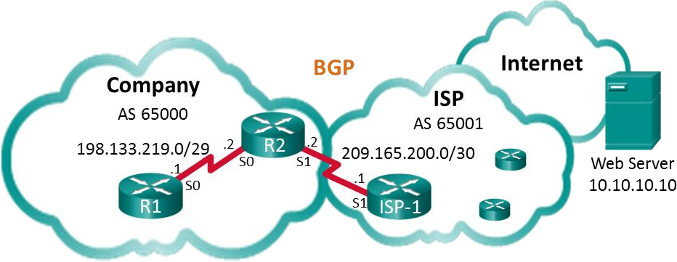

**Addressing Table**

|  |  |  |  |
| --- | --- | --- | --- |
| **Device** | **Interface** | **IP Address** | **Subnet Mask** |
| R1 | S0/0/0 (DCE) | 198.133.219.1 | 255.255.255.248 |
| R2 | S0/0/0 | 198.133.219.2 | 255.255.255.248 |
| S0/0/1 (DCE) | 209.165.200.2 | 255.255.255.252 |
| ISP-1 | S0/0/1 | 209.165.200.1 | 255.255.255.252 |
| Web Server |  | 10.10.10.10 | 255.255.255.255 |

**Objectives**

##### Part 1: Build the Network and Configure Basic Device Settings Part 2: Configure eBGP on R1

**Part 3: Verify eBGP Configuration**

**Background / Scenario**

In this lab you will configure eBGP for the Company. The ISP will provide the default route to the Internet. Once configuration is complete you will use various **show** commands to verify that the eBGP configuration is working as expected.

### Required Resources

* + - * + 3 Routers (Cisco 1941 with Cisco IOS Release 15.2(4)M3 universal image or comparable)
        + Console cables to configure the Cisco IOS devices via the console ports
        + Serial cables as shown in the topology

## Part 1: Build the Network and Configure Basic Device Settings

In Part 1, you will set up the network topology and configure basic settings on R1 and R2 routers. You will also copy the provided configuration for ISP-1 on to that router.

#### Step 1: Cable the network as shown in the topology.

**Step 2: Initialize and reload the network devices as necessary. Step 3: Configure basic settings on R1 and R2.**

1. Disable DNS lookup to prevent the routers from attempting to translate incorrectly entered commands as though they were host names.
2. Configure the hostnames according to the topology.
3. Configure interfaces according to the Addressing Table.
4. Save the running configuration to the startup configuration file.

#### Step 4: Copy configuration to ISP-1.

Copy and paste the following configuration to ISP-1.

hostname ISP-1

no ip domain-lookup interface Loopback0

ip address 10.10.10.10 255.255.255.255

interface Serial0/0/1

ip address 209.165.200.1 255.255.255.252

no shut

ip route 0.0.0.0 0.0.0.0 lo0

router bgp 65001

bgp log-neighbor-changes network 0.0.0.0

neighbor 209.165.200.2 remote-as 65000 end

## Part 2: Configure eBGP on R2

Configure R2 to become an eBGP peer with ISP-1. Refer to the Topology for BGP AS number information.

#### Step 1: Enable BGP and identify the AS number for the Company.

R2(config)# **router bgp 65000**

#### Step 2: Use the neighbor command to identify ISP-1 as the BGP peer.

R2(config-router)# **neighbor 209.165.200.1 remote-as 65001**

#### Step 3: Add the Company’s network to the BGP table so it is advertised to ISP-1.

R2(config-router)# **network 198.133.219.0 mask 255.255.255.248**

## Part 3: Verify eBGP Configuration

In Part 3, use the BGP verifications commands to verify that the BGP configuration is working as expected.

#### Step 1: Display the IPv4 routing table on R2.

R2# **show ip route**

Codes: L - local, C - connected, S - static, R - RIP, M - mobile, B - BGP D - EIGRP, EX - EIGRP external, O - OSPF, IA - OSPF inter area

N1 - OSPF NSSA external type 1, N2 - OSPF NSSA external type 2 E1 - OSPF external type 1, E2 - OSPF external type 2

i - IS-IS, su - IS-IS summary, L1 - IS-IS level-1, L2 - IS-IS level-2 ia - IS-IS inter area, * - candidate default, U - per-user static route o - ODR, P - periodic downloaded static route, H - NHRP, l - LISP

a - application route

+ - replicated route, % - next hop override

Gateway of last resort is 209.165.200.1 to network 0.0.0.0

B* 0.0.0.0/0 [20/0] via 209.165.200.1, 00:00:07

198.133.219.0/24 is variably subnetted, 2 subnets, 2 masks C 198.133.219.0/29 is directly connected, Serial0/0/0

L 198.133.219.2/32 is directly connected, Serial0/0/0 209.165.200.0/24 is variably subnetted, 2 subnets, 2 masks

C 209.165.200.0/30 is directly connected, Serial0/0/1 L 209.165.200.2/32 is directly connected, Serial0/0/1

#### Step 2: Display the BGP table on R2.

R2# **show ip bgp**

BGP table version is 4, local router ID is 209.165.200.2

Status codes: s suppressed, d damped, h history, * valid, > best, i - internal, r RIB-failure, S Stale, m multipath, b backup-path, f RT-Filter, x best-external, a additional-path, c RIB-compressed,

Origin codes: i - IGP, e - EGP, ? - incomplete

RPKI validation codes: V valid, I invalid, N Not found

Network Next Hop Metric LocPrf Weight Path

*> 0.0.0.0 209.165.200.1 0 0 65001 i

*> 198.133.219.0/29 0.0.0.0 0 32768 i

#### Step 3: Display the BGP connection status on R2.

##### R2# show ip bgp summary

BGP router identifier 209.165.200.2, local AS number 65000 BGP table version is 4, main routing table version 4

2 network entries using 288 bytes of memory

2 path entries using 160 bytes of memory

2/2 BGP path/bestpath attribute entries using 320 bytes of memory

1 BGP AS-PATH entries using 24 bytes of memory

0 BGP route-map cache entries using 0 bytes of memory

0 BGP filter-list cache entries using 0 bytes of memory BGP using 792 total bytes of memory

BGP activity 2/0 prefixes, 2/0 paths, scan interval 60 secs

|  |  |  |  |  |  |
| --- | --- | --- | --- | --- | --- |
| Neighbor | V | AS | MsgRcvd MsgSent | TblVer InQ OutQ | Up/Down State/PfxRcd |
| 209.165.200.1 | 4 | 65001 | 12 11 | 4 0 0 | 00:06:56 1 |

#### Step 4: Display the IPv4 routing table on ISP-1.

Verify that the 198.133.218.0/29 network is being advertised to the ISP-1 router.

ISP-1# **show ip route**

Codes: L - local, C - connected, S - static, R - RIP, M - mobile, B - BGP D - EIGRP, EX - EIGRP external, O - OSPF, IA - OSPF inter area

N1 - OSPF NSSA external type 1, N2 - OSPF NSSA external type 2 E1 - OSPF external type 1, E2 - OSPF external type 2

i - IS-IS, su - IS-IS summary, L1 - IS-IS level-1, L2 - IS-IS level-2 ia - IS-IS inter area, * - candidate default, U - per-user static route o - ODR, P - periodic downloaded static route, H - NHRP, l - LISP

a - application route

+ - replicated route, % - next hop override Gateway of last resort is 0.0.0.0 to network 0.0.0.0

S* 0.0.0.0/0 is directly connected, Loopback0 10.0.0.0/32 is subnetted, 1 subnets

C 10.10.10.10 is directly connected, Loopback0 198.133.219.0/29 is subnetted, 1 subnets

B 198.133.219.0 [20/0] via 209.165.200.2, 00:00:25

209.165.200.0/24 is variably subnetted, 2 subnets, 2 masks C 209.165.200.0/30 is directly connected, Serial0/0/1

L 209.165.200.1/32 is directly connected, Serial0/0/1

Ping the Web Server from R1. Were the pings successful?

sí después de configurar una ruta estatica

**Reflection**

The topology used in this lab was created to demonstrate how to configure the BGP routing protocol. However, the BGP protocol would not normally be configured for a topology like this in the real world. Explain.

BGP se configura en lado de los ISP, ya que son los que se encargan de las traducciones y enrutamientos de redes.

### Router Interface Summary Table

|  |  |  |  |  |
| --- | --- | --- | --- | --- |
| **Router Interface Summary** | | | | |
| **Router Model** | **Ethernet Interface #1** | **Ethernet Interface #2** | **Serial Interface #1** | **Serial Interface #2** |
| 1800 | Fast Ethernet 0/0 (F0/0) | Fast Ethernet 0/1 (F0/1) | Serial 0/0/0 (S0/0/0) | Serial 0/0/1 (S0/0/1) |
| 1900 | Gigabit Ethernet 0/0 (G0/0) | Gigabit Ethernet 0/1 (G0/1) | Serial 0/0/0 (S0/0/0) | Serial 0/0/1 (S0/0/1) |
| 2801 | Fast Ethernet 0/0 (F0/0) | Fast Ethernet 0/1 (F0/1) | Serial 0/1/0 (S0/1/0) | Serial 0/1/1 (S0/1/1) |
| 2811 | Fast Ethernet 0/0 (F0/0) | Fast Ethernet 0/1 (F0/1) | Serial 0/0/0 (S0/0/0) | Serial 0/0/1 (S0/0/1) |
| 2900 | Gigabit Ethernet 0/0 (G0/0) | Gigabit Ethernet 0/1 (G0/1) | Serial 0/0/0 (S0/0/0) | Serial 0/0/1 (S0/0/1) |
| **Note**: To find out how the router is configured, look at the interfaces to identify the type of router and how many interfaces the router has. There is no way to effectively list all the combinations of configurations for each router class. This table includes identifiers for the possible combinations of Ethernet and Serial interfaces in the device. The table does not include any other type of interface, even though a specific router may contain one. An example of this might be an ISDN BRI interface. The string in parenthesis is the legal abbreviation that can be used in Cisco IOS commands to represent the interface. | | | | |



* + - 1. **Lab – Configure a Branch Connection**

**Topology**

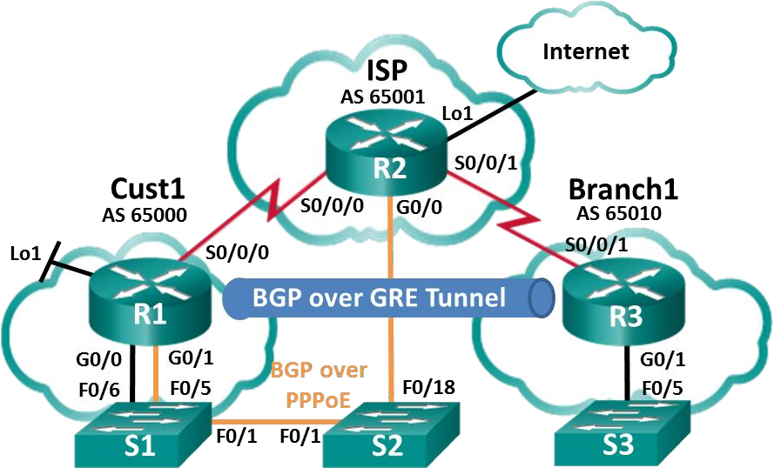

**Addressing Table**

|  |  |  |  |
| --- | --- | --- | --- |
| **Device** | **Interface** | **IP Address** | **Subnet Mask** |
| R1 | G0/0 | 192.168.1.1 | 255.255.255.0 |
| G0/1 | PPPoE Client |  |
| Lo1 | 209.165.200.49 | 255.255.255.240 |
| S0/0/0 (DCE) | 209.165.200.81 | 255.255.255.252 |
| R2 | G0/0 | PPPoE Provider |  |
| Lo1 | 209.165.200.65 | 255.255.255.240 |
| S0/0/0 | 209.165.200.82 | 255.255.255.252 |
| S0/0/1 (DCE) | 209.165.200.85 | 255.255.255.252 |
| R3 | G0/1 | 192.168.3.1 | 255.255.255.0 |
| S0/0/1 (DCE) | 209.165.200.86 | 255.255.255.252 |

**Objectives**

##### Part 1: Build the Network and Load Device Configurations

**Part 2: Configure a PPPoE Client Connection Part 3: Configure a GRE Tunnel**

**Part 4: Configure BGP over PPPoE and BGP over a GRE Tunnel**

**Background / Scenario**

In this lab, you will configure two separate WAN connections, a BGP route over a PPPoE connection, and a BGP route over a GRE tunnel. This lab is a test case scenario and does not represent a realistic BGP implementation.

**Note**: The routers used with CCNA hands-on labs are Cisco 1941 Integrated Services Routers (ISRs) with Cisco IOS, Release 15.2(4)M3 (universalk9 image). Other routers and Cisco IOS versions can be used.

Depending on the model and Cisco IOS version, the commands available and output produced might vary from what is shown in the labs. Refer to the Router Interface Summary Table at the end of this lab for the correct interface identifiers.

**Note**: Ensure that the routers have been erased and have no startup configurations. If you are unsure, contact your instructor.

### Required Resources

* + - * + 3 Routers (Cisco 1941 with Cisco IOS Release 15.2(4)M3 universal image or comparable)
        + 3 Switches (Cisco 2960 with Cisco IOS Release 15.0(2) lanbasek9 image or comparable)
        + Console cables to configure the Cisco IOS devices via the console ports
        + Ethernet cables and Serial cables as shown in the topology

## Part 1: Build the Network and Load Device Configurations

#### Step 1: Cable the network as shown in the topology. Step 2: Load router configurations.

Copy and paste the following configurations into the appropriate routers and switch.

##### Cust 1 (R1) Configuration:

conf t hostname Cust1 no cdp run

interface Loopback1

ip address 209.165.200.49 255.255.255.240

interface GigabitEthernet0/0

ip address 192.168.1.1 255.255.255.0

no shut

interface Serial0/0/0

ip address 209.165.200.81 255.255.255.252

no shut

ip route 0.0.0.0 0.0.0.0 s0/0/0 25 end

**Note:** In the Cust1 configuration above, CDP is disabled with the **no cdp run** command. The static default route with an administrative distance is manually configured to 25 instead of the default 1. The significance of these configurations will be explained later in the lab.

##### ISP (R2) Configuration:

conf t hostname ISP

username Cust1 password 0 ciscopppoe bba-group pppoe global

virtual-template 1

interface Loopback 1

ip address 209.165.200.65 255.255.255.240

interface GigabitEthernet0/0 ip tcp adjust-mss 1452 pppoe enable group global no shut

interface Serial0/0/0

ip address 209.165.200.82 255.255.255.252

no shut

interface Serial0/0/1

ip address 209.165.200.85 255.255.255.252

no shut

interface Virtual-Template1 mtu 1492

ip address 209.165.200.30 255.255.255.224

peer default ip address pool PPPoEPOOL ppp authentication chap callin

router bgp 65001

network 0.0.0.0

neighbor 209.165.200.1 remote-as 65000

ip local pool PPPoEPOOL 209.165.200.1 209.165.200.20

ip route 0.0.0.0 0.0.0.0 Loopback1 end

##### Branch1 (R3) Configuration:

conf t

hostname Branch1

interface GigabitEthernet0/1

ip address 192.168.3.1 255.255.255.0

no shut

interface Serial0/0/1

ip address 209.165.200.86 255.255.255.252

no shut

ip route 0.0.0.0 0.0.0.0 Serial0/0/1 end

##### S1 Configuration:

conf t hostname S1 vlan 111 interface f0/6

switchport mode access switchport access vlan 111

end

**Note**: Because S1 connects to two separate networks, G0/0 and G0/1 on Cust1, it is necessary to segment the switch into two separate VLANs, in this case VLAN111, and VLAN1.

#### Step 3: Save the configuration on all configured routers and switches.

**Part 2: Configure a PPPoE Client Connection**

In Part 2, following the PPPoE requirements listed below, you will configure Cust1 as the PPPoE client. The ISP router configuration is already complete.

##### PPPoE requirements for the Cust1 router:

* + - * + Configure an **interface Dialer1** with the following settings:

##### a negotiated ip address

**mtu 1492**

**ppp encapsulation**

**dialer pool 1**

**ppp chap callin authentication**

**ppp chap hostname Cust1**

**ppp chap password ciscopppoe (unencrypted)**

* + - * + Configure **G0/1** with the following settings:

##### enable global pppoe

**adjust the TCP maximum segment size to 1452**

**set the pppoe-client to dialer pool 1**

List the commands used to configure Cust1 as the PPPoE Client:

Int dialer1

Ip addresss negotiated

Mtu 1492

Encapsulation ppp

Dialer pool 1

Ppp encapsulation chap callin

Ppp chap hostname Cust1

Ppp chap password ciscopppoe

Int g0/1

Pppoe enable group global

Ip tcp adjust-mss

Pppoe-client dial-pool-number 1

No shutdown

If the Cust1 router is configured correctly, it should receive an IP address from the ISP router. What IP address did Cust1 receive and on what interface? What command did you use to check for the IP address and interface?

Show ip interface brief

Nos muestra un resumen del dialer con la ip recibida y mediante IPCP.

**Note**: If Cust1 had CDP running on interface dialer1, it could produce the following repeating log message:

*PPP: Outbound cdp packet dropped, NCP not negotiated*. To prevent this, CDP was globally turned off.

## Part 3: Configure a GRE Tunnel

In Part 3, following the GRE requirements listed below, you will configure a GRE tunnel between Cust1 and Branch1.

##### GRE tunnel requirements:

* + - * + On Cust1 and Branch1, configure **interface Tunnel 0** with the following settings:

##### o IP address 192.168.2.1/24 and 192.168.2.2/24 respectively

**Tunnel mode GRE over IP**

**Tunnel source interface and destination address using serial interfaces**

List the commands used to configure a GRE tunnel between Cust1 and Branch1:

Cust1

Int tunnel 0

Ip address 192.168.2.1 255.255.255.0

Tunnel mode gre ip

Tunnel source s0/0/0

Tunnel destination 209.165.200.86

Branch1

Int tunnel 0

Ip address 192.168.2.2 255.255.255.0

Tunnel source s0/0/1

Tunnel destination 209.165.200.81

How can you tell if the tunnel was created successfully? What command could you use to test the tunnel?

Podemos visualizar que ha cambiado de estado la interfaz, a parte podemos hacer tracert para ver el camino hasta el destino mediante el tunnel 0.

Para ver el estado de las interfaces (Tunnrl)

Show ip interface brief

What would happen if Cust1 did not have a static default route? Test it by removing the static default route. What was the result? Make sure to replace the static default route, as shown in the Cust1 configuration in Part 1 Step2, before moving on.

En caso de no haya una ruta estatica la interfaz tunnel vuelve al estado down, cuando se agrega la ruta estatica vuelva a estar en up

## Part 4: Configure BGP over PPPoE and BGP over a GRE Tunnel

In Part 4, following the BGP requirements listed below, you will configure BGP on Cust1 and Branch1. The ISP router configuration is already complete.

##### BGP requirements:

* + - * + On Cust1:

##### Create a BGP routing process AS 65000

**Advertise networks attached to Loopback 1 and G0/0**

**Configure BGP neighbors to the ISP and Branch1 routers**

* + - * + On Branch1:

##### Create a BGP routing process AS 65010

**Advertise the network attached to G0/1**

**Configure BGP neighbor to Cust1 only**

List the commands used to configure BGP on Cust1 and Branch1:

Cust1

Router bgp 6500

Network 209.165.200.48 mask 255.255.255.240

Network 192.168.1.0 mask 255.255.255.0

Neighbor 209.165.200.30 remote-as 65001

Neighbor 192.168.2.2 remote-as 65010

Branch1

Router bgp 65010

Network 192.168.3.0 mask 255.255.255.0

Neighbor 192.168.2.1 remote-as 65000

On Cust1, did you receive console messages regarding BGP neighbor relationships to ISP and Branch1?

Recibe el mensaje con nueva adyacencia up.

On Cust1, can you ping the ISP at 209.165.200.30 over PPPoE? Can you ping the Branch1 local network at 192.168.3.1?

Si, el ping success.

Check the routing table of Cust1. What routes were learned by BGP? There should be a route learned from both ISP and Branch1.

Do Show ip route

Examine the two routes learned by BGP in the Cust1 routing table. What do they show about routes in the network now?

**Router Interface Summary Table**

|  |  |  |  |  |
| --- | --- | --- | --- | --- |
| **Router Interface Summary** | | | | |
| **Router Model** | **Ethernet Interface #1** | **Ethernet Interface #2** | **Serial Interface #1** | **Serial Interface #2** |
| 1800 | Fast Ethernet 0/0 (F0/0) | Fast Ethernet 0/1 (F0/1) | Serial 0/0/0 (S0/0/0) | Serial 0/0/1 (S0/0/1) |
| 1900 | Gigabit Ethernet 0/0 (G0/0) | Gigabit Ethernet 0/1 (G0/1) | Serial 0/0/0 (S0/0/0) | Serial 0/0/1 (S0/0/1) |
| 2801 | Fast Ethernet 0/0 (F0/0) | Fast Ethernet 0/1 (F0/1) | Serial 0/1/0 (S0/1/0) | Serial 0/1/1 (S0/1/1) |
| 2811 | Fast Ethernet 0/0 (F0/0) | Fast Ethernet 0/1 (F0/1) | Serial 0/0/0 (S0/0/0) | Serial 0/0/1 (S0/0/1) |
| 2900 | Gigabit Ethernet 0/0 (G0/0) | Gigabit Ethernet 0/1 (G0/1) | Serial 0/0/0 (S0/0/0) | Serial 0/0/1 (S0/0/1) |
| **Note**: To find out how the router is configured, look at the interfaces to identify the type of router and how many interfaces the router has. There is no way to effectively list all the combinations of configurations for each router class. This table includes identifiers for the possible combinations of Ethernet and Serial interfaces in the device. The table does not include any other type of interface, even though a specific router may contain one. An example of this might be an ISDN BRI interface. The string in parenthesis is the legal abbreviation that can be used in Cisco IOS commands to represent the interface. | | | | |



* + - 1. **Lab – Configuring and Verifying Extended ACLs**

**Topology**

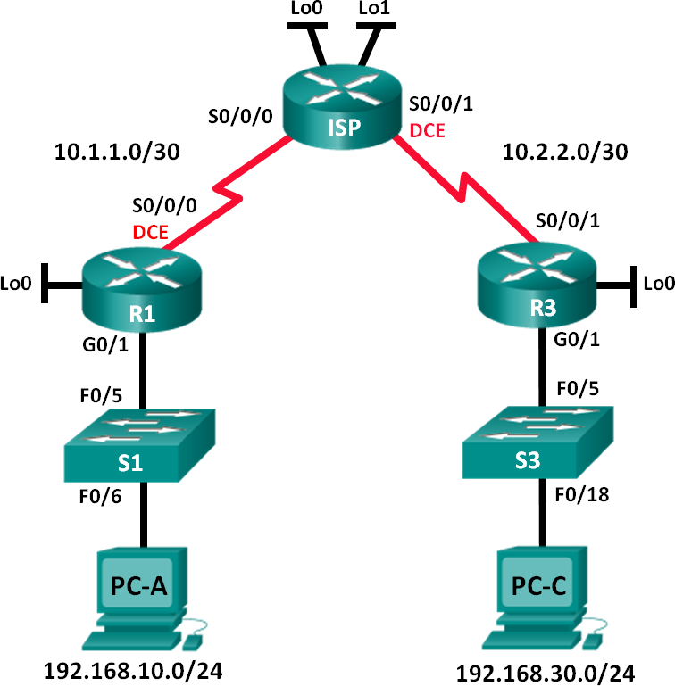

**Addressing Table**

|  |  |  |  |  |
| --- | --- | --- | --- | --- |
| **Device** | **Interface** | **IP Address** | **Subnet Mask** | **Default Gateway** |
| R1 | G0/1 | 192.168.10.1 | 255.255.255.0 | N/A |
|  | Lo0 | 192.168.20.1 | 255.255.255.0 | N/A |
|  | S0/0/0 (DCE) | 10.1.1.1 | 255.255.255.252 | N/A |
| ISP | S0/0/0 | 10.1.1.2 | 255.255.255.252 | N/A |
|  | S0/0/1 (DCE) | 10.2.2.2 | 255.255.255.252 | N/A |
|  | Lo0 | 209.165.200.225 | 255.255.255.224 | N/A |
|  | Lo1 | 209.165.201.1 | 255.255.255.224 | N/A |
| R3 | G0/1 | 192.168.30.1 | 255.255.255.0 | N/A |
|  | Lo0 | 192.168.40.1 | 255.255.255.0 | N/A |
|  | S0/0/1 | 10.2.2.1 | 255.255.255.252 | N/A |
| S1 | VLAN 1 | 192.168.10.11 | 255.255.255.0 | 192.168.10.1 |
| S3 | VLAN 1 | 192.168.30.11 | 255.255.255.0 | 192.168.30.1 |
| PC-A | NIC | 192.168.10.3 | 255.255.255.0 | 192.168.10.1 |
| PC-C | NIC | 192.168.30.3 | 255.255.255.0 | 192.168.30.1 |

**Objectives**

##### Part 1: Set Up the Topology and Initialize Devices Part 2: Configure Devices and Verify Connectivity

* + - * + Configure basic settings on PCs, routers, and switches.
        + Configure OSPF routing on R1, ISP, and R3.

##### Part 3: Configure and Verify Extended Numbered and Named ACLs

* + - * + Configure, apply, and verify a numbered extended ACL.
        + Configure, apply, and verify a named extended ACL.

##### Part 4: Modify and Verify Extended ACLs

**Background / Scenario**

Extended access control lists (ACLs) are extremely powerful. They offer a much greater degree of control than standard ACLs as to the types of traffic that can be filtered, as well as where the traffic originated and where it is going.

In this lab, you will set up filtering rules for two offices represented by R1 and R3. Management has established some access policies between the LANs located at R1 and R3, which you must implement. The ISP router between R1 and R3 does not have any ACLs placed on it. You would not be allowed any administrative access to an ISP router as you can only control and manage your own equipment.

**Note**: The routers used with CCNA hands-on labs are Cisco 1941 Integrated Services Routers (ISRs) with Cisco IOS Release 15.2(4)M3 (universalk9 image). The switches used are Cisco Catalyst 2960s with Cisco IOS Release 15.0(2) (lanbasek9 image). Other routers, switches, and Cisco IOS versions can be used.

Depending on the model and Cisco IOS version, the commands available and output produced might vary from what is shown in the labs. Refer to the Router Interface Summary Table at the end of the lab for the correct interface identifiers.

**Note**: Make sure that the routers and switches have been erased and have no startup configurations. If you are unsure, contact your instructor.

### Required Resources

* + - * + 3 Routers (Cisco 1941 with Cisco IOS Release 15.2(4)M3 universal image or comparable)
        + 2 Switches (Cisco 2960 with Cisco IOS Release 15.0(2) lanbasek9 image or comparable)
        + 2 PCs (Windows 7, Vista, or XP with terminal emulation program, such as Tera Term)
        + Console cables to configure the Cisco IOS devices via the console ports
        + Ethernet and serial cables as shown in the topology

## Part 1: Set Up the Topology and Initialize Devices

In Part 1, you will set up the network topology and clear any configurations if necessary.

#### Step 1: Cable the network as shown in the topology. Step 2: Initialize and reload the routers and switches.

**Part 2: Configure Devices and Verify Connectivity**

In Part 2, you will configure basic settings on the routers, switches, and PCs. Refer to the Topology and Addressing Table for device names and address information.

#### Step 1: Configure IP addresses on PC-A and PC-C. Step 2: Configure basic settings on R1.

1. Disable DNS lookup.
2. Configure the device name as shown in the topology.
3. Create a loopback interface on R1.
4. Configure interface IP addresses as shown in the Topology and Addressing Table.
5. Configure a privileged EXEC mode password of **class**.
6. Assign a clock rate of **128000** to the S0/0/0 interface.
7. Assign **cisco** as the console and vty password and enable Telnet access. Configure **logging synchronous** for both the console and vty lines.
8. Enable web access on R1 to simulate a web server with local authentication for user **admin**.

R1(config)# **ip http server**

R1(config)# **ip http authentication local**

R1(config)# **username admin privilege 15 secret class**

#### Step 3: Configure basic settings on ISP.

1. Configure the device name as shown in the topology.
2. Create the loopback interfaces on ISP.
3. Configure interface IP addresses as shown in the Topology and Addressing Table.
4. Disable DNS lookup.
5. Assign **class** as the privileged EXEC mode password.
6. Assign a clock rate of **128000** to the S0/0/1 interface.
7. Assign **cisco** as the console and vty password and enable Telnet access. Configure **logging synchronous** for both console and vty lines.
8. Enable web access on the ISP. Use the same parameters as in Step 2h.

#### Step 4: Configure basic settings on R3.

1. Configure the device name as shown in the topology.
2. Create a loopback interface on R3.
3. Configure interface IP addresses as shown in the Topology and Addressing Table.
4. Disable DNS lookup.
5. Assign **class** as the privileged EXEC mode password.
6. Assign **cisco** as the console password and configure **logging synchronous** on the console line.
7. Enable SSH on R3.

R3(config)# **ip domain-name cisco.com**

R3(config)# **crypto key generate rsa modulus 1024**

R3(config)# **line vty 0 4**

R3(config-line)# **login local**

R3(config-line)# **transport input ssh**

1. Enable web access on R3. Use the same parameters as in Step 2h.

#### Step 5: (Optional) Configure basic settings on S1 and S3.

1. Configure the hostnames as shown in the topology.
2. Configure the management interface IP addresses as shown in the Topology and Addressing Table.
3. Disable DNS lookup.
4. Configure a privileged EXEC mode password of **class**.
5. Configure a default gateway address.

#### Step 6: Configure OSPF routing on R1, ISP, and R3.

1. Assign 1 as the OSPF process ID and advertise all networks on R1, ISP, and R3. The OSPF configuration for R1 is included for reference.

R1(config)# **router ospf 1**

R1(config-router)# **network 192.168.10.0 0.0.0.255 area 0**

R1(config-router)# **network 192.168.20.0 0.0.0.255 area 0**

R1(config-router)# **network 10.1.1.0 0.0.0.3 area 0**

1. After configuring OSPF on R1, ISP, and R3, verify that all routers have complete routing tables listing all networks. Troubleshoot if this is not the case.

#### Step 7: Verify connectivity between devices.

**Note**: It is very important to verify connectivity **before** you configure and apply ACLs! Ensure that your network is properly functioning before you start to filter out traffic.

1. From PC-A, ping PC-C and the loopback and serial interfaces on R3.

Were your pings successful? si

1. From R1, ping PC-C and the loopback and serial interface on R3.

Were your pings successful? si

1. From PC-C, ping PC-A and the loopback and serial interface on R1.

Were your pings successful? si

1. From R3, ping PC-A and the loopback and serial interface on R1.

Were your pings successful? si

1. From PC-A, ping the loopback interfaces on the ISP router.

Were your pings successful? si

1. From PC-C, ping the loopback interfaces on the ISP router.

Were your pings successful? si

1. Open a web browser on PC-A and go to [http://209.165.200.225](http://209.165.200.225/) on ISP. You will be prompted for a username and password. Use **admin** for the username and **class** for the password. If you are prompted to accept a signature, accept it. The router will load the Cisco Configuration Professional (CCP) Express in a separate window. You may be prompted for a username and password. Use **admin** for the username and **class** for the password.
2. Open a web browser on PC-C and go to [http://10.1.1.1](http://10.1.1.1/) on R1. You will be prompted for a username and password. Use **admin** for username and **class** for the password. If you are prompted to accept a signature, accept it. The router will load CCP Express in a separate window. You may be prompted for a username and password. Use **admin** for the username and **class** for the password.

## Part 3: Configure and Verify Extended Numbered and Named ACLs

Extended ACLs can filter traffic in many different ways. Extended ACLs can filter on source IP addresses, source ports, destination IP addresses, destination ports, as well as various protocols and services.

Security policies are as follows:

1. Allow web traffic originating from the 192.168.10.0/24 network to go to any network.
2. Allow an SSH connection to the R3 serial interface from PC-A.
3. Allow users on 192.168.10.0/24 network access to 192.168.20.0/24 network.
4. Allow web traffic originating from the 192.168.30.0/24 network to access R1 via the web interface and the 209.165.200.224/27 network on ISP. The 192.168.30.0/24 network should NOT be allowed to access any other network via the web.

In looking at the security policies listed above, you will need at least two ACLs to fulfill the security policies. A best practice is to place extended ACLs as close to the source as possible. We will follow this practice for these policies.

#### Step 1: Configure a numbered extended ACL on R1 for security policy numbers 1 and 2.

You will use a numbered extended ACL on R1. What are the ranges for extended ACLs?

100 a 199 y 2000 a 2699

1. Configure the ACL on R1. Use 100 for the ACL number.

R1(config)# **access-list 100 remark Allow Web & SSH Access**

##### R1(config)# access-list 100 permit tcp host 192.168.10.3 host 10.2.2.1 eq 22

R1(config)# **access-list 100 permit tcp any any eq 80**

What does the 80 signify in the command output listed above?

Puerto destino, 80 es para la web no segura http.

To what interface should ACL 100 be applied?

En la interfaz serial del router para no afectar a otras redes s0/0/0

In what direction should ACL 100 be applied?

En sentido de salida, ya que entro al router y debe salir, asi se le aplica la acl

1. Apply ACL 100 to the S0/0/0 interface.

R1(config)# **interface s0/0/0**

R1(config-if)# **ip access-group 100 out**

1. Verify ACL 100.
   1. Open up a web browser on PC-A, and access [http://209.165.200.225](http://209.165.200.225/) (the ISP router). It should be successful; troubleshoot, if not.
   2. Establish an SSH connection from PC-A to R3 using 10.2.2.1 for the IP address. Log in with **admin**

and **class** for your credentials. It should be successful; troubleshoot, if not.

* 1. From privileged EXEC mode prompt on R1, issue the **show access-lists** command.

##### R1# show access-lists

Extended IP access list 100

10 permit tcp host 192.168.10.3 host 10.2.2.1 eq 22 (22 matches)

20 permit tcp any any eq www (111 matches)

* 1. From the PC-A command prompt, issue a ping to 10.2.2.1. Explain your results.

sin respuesta debido a la acl 100, solo permite ssh y web.

_

#### Step 2: Configure a named extended ACL on R3 for security policy number 3.

1. Configure the policy on R3. Name the ACL WEB-POLICY.

R3(config)# **ip access-list extended WEB-POLICY**

R3(config-ext-nacl)# **permit tcp 192.168.30.0 0.0.0.255 host 10.1.1.1 eq 80**

R3(config-ext-nacl)# **permit tcp 192.168.30.0 0.0.0.255 209.165.200.224**

##### 0.0.0.31 eq 80

1. Apply ACL WEB-POLICY to the S0/0/1 interface.

R3(config-ext-nacl)# **interface S0/0/1**

R3(config-if)# **ip access-group WEB-POLICY out**

1. Verify the ACL WEB-POLICY.
   1. From R3 privileged EXEC mode command prompt, issue the **show ip interface s0/0/1** command. What, if any, is the name of the ACL? El que se le asignó antes, WEB-POLICY

In what direction is the ACL applied? En la salida

* 1. Open up a web browser on PC-C and access [http://209.165.200.225](http://209.165.200.225/) (the ISP router). It should be successful; troubleshoot, if not.
  2. From PC-C, open a web session to [http://10.1.1.1](http://10.1.1.1/) (R1). It should be successful; troubleshoot, if not.
  3. From PC-C, open a web session to [http://209.165.201.1](http://209.165.201.1/) (ISP router). It should fail; troubleshoot, if not.
  4. From a PC-C command prompt, ping PC-A. What was your result and why?

falló, solo se permiten salida de trafico web.

## Part 4: Modify and Verify Extended ACLs

Because of the ACLs applied on R1 and R3, no pings or any other kind of traffic is allowed between the LAN networks on R1 and R3. Management has decided that all traffic between the 192.168.10.0/24 and 192.168.30.0/24 networks should be allowed. You must modify both ACLs on R1 and R3.

#### Step 1: Modify ACL 100 on R1.

1. From R1 privileged EXEC mode, issue the **show access-lists** command.

How many lines are there in this access list? 2

1. Enter global configuration mode and modify the ACL on R1.

R1(config)# **ip access-list extended 100**

R1(config-ext-nacl)# **30 permit ip 192.168.10.0 0.0.0.255 192.168.30.0**

##### 0.0.0.255

R1(config-ext-nacl)# **end**

c. Issue the **show access-lists** command.

Where did the new line that you just added appear in ACL 100?

En la ultima posición de la lista

#### Step 2: Modify ACL WEB-POLICY on R3.

1. From R3 privileged EXEC mode, issue the **show access-lists** command.

How many lines are there in this access list? 2

1. Enter global configuration mode and modify the ACL on R3.

R3(config)# **ip access-list extended WEB-POLICY**

R3(config-ext-nacl)# **30 permit ip 192.168.30.0 0.0.0.255 192.168.10.0**

##### 0.0.0.255

R3(config-ext-nacl)# **end**

c. Issue the **show access-lists** command to verify that the new line was added at the end of the ACL.

#### Step 3: Verify modified ACLs.

1. From PC-A, ping the IP address of PC-C. Were the pings successful? si
2. From PC-C, ping the IP address of PC-A. Were the pings successful? si

Why did the ACLs work immediately for the pings after you changed them?

Porque las acls ya están aplicadas a las interfaces, los cambios se aplicacan a la ACL y automáticamente se ejecuta la acl actualizada

**Reflection**

1. Why is careful planning and testing of ACLs required?

Poruqe es muy fácil equevocarse y evitar que el trafico de una red no circule correctamente, puede provocar problemas a la hora de aplicar varias acls de salida y entrada ya que el orden importa a la hora de la aplicación.

1. Which type of ACL is better: standard or extended?

Las extendidas son más útiles, ya que pueden hacer todo lo que hacen las estándares y más, trabajar por puertos, redes específicas. La desventaja que tienen las extendidas es por su complejidad y por tanto pueden provocar bloqueos de red innecesario y inadecuado.

1. Why are OSPF hello packets and routing updates not blocked by the implicit **deny any** access control entry (ACE) or ACL statement of the ACLs applied to R1 and R3?

no afecta la acl porque ese trafico ya se encuentra dentro del router y no va hacia las interfaces g0/X, sino entre las serial por tanto no esta la acl en la interfaz serial.

### Router Interface Summary Table

|  |  |  |  |  |
| --- | --- | --- | --- | --- |
| **Router Interface Summary** | | | | |
| **Router Model** | **Ethernet Interface #1** | **Ethernet Interface #2** | **Serial Interface #1** | **Serial Interface #2** |
| 1800 | Fast Ethernet 0/0 (F0/0) | Fast Ethernet 0/1 (F0/1) | Serial 0/0/0 (S0/0/0) | Serial 0/0/1 (S0/0/1) |
| 1900 | Gigabit Ethernet 0/0 (G0/0) | Gigabit Ethernet 0/1 (G0/1) | Serial 0/0/0 (S0/0/0) | Serial 0/0/1 (S0/0/1) |
| 2801 | Fast Ethernet 0/0 (F0/0) | Fast Ethernet 0/1 (F0/1) | Serial 0/1/0 (S0/1/0) | Serial 0/1/1 (S0/1/1) |
| 2811 | Fast Ethernet 0/0 (F0/0) | Fast Ethernet 0/1 (F0/1) | Serial 0/0/0 (S0/0/0) | Serial 0/0/1 (S0/0/1) |
| 2900 | Gigabit Ethernet 0/0 (G0/0) | Gigabit Ethernet 0/1 (G0/1) | Serial 0/0/0 (S0/0/0) | Serial 0/0/1 (S0/0/1) |
| **Note**: To find out how the router is configured, look at the interfaces to identify the type of router and how many interfaces the router has. There is no way to effectively list all the combinations of configurations for each router class. This table includes identifiers for the possible combinations of Ethernet and Serial interfaces in the device. The table does not include any other type of interface, even though a specific router may contain one. An example of this might be an ISDN BRI interface. The string in parenthesis is the legal abbreviation that can be used in Cisco IOS commands to represent the interface. | | | | |



* + - 1. **Lab – Configuring and Verifying IPv6 ACLs**

**Topology**

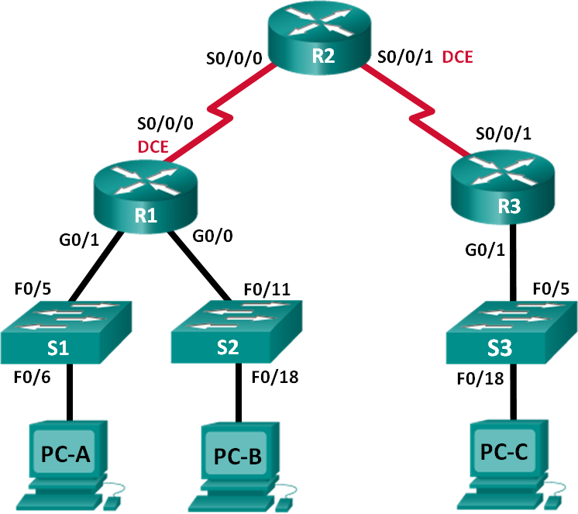

**Addressing Table**

|  |  |  |  |
| --- | --- | --- | --- |
| **Device** | **Interface** | **IP Address** | **Default Gateway** |
| R1 | G0/0 | 2001:DB8:ACAD:B::1/64 | N/A |
|  | G0/1 | 2001:DB8:ACAD:A::1/64 | N/A |
|  | S0/0/0 (DCE) | 2001:DB8:AAAA:1::1/64 | N/A |
| R2 | S0/0/0 | 2001:DB8:AAAA:1::2/64 | N/A |
|  | S0/0/1 (DCE) | 2001:DB8:AAAA:2::2/64 | N/A |
| R3 | G0/1 | 2001:DB8:CAFE:C::1/64 | N/A |
|  | S0/0/1 | 2001:DB8:AAAA:2::1/64 | N/A |
| S1 | VLAN1 | 2001:DB8:ACAD:A::A/64 | N/A |
| S2 | VLAN1 | 2001:DB8:ACAD:B::A/64 | N/A |
| S3 | VLAN1 | 2001:DB8:CAFE:C::A/64 | N/A |
| PC-A | NIC | 2001:DB8:ACAD:A::3/64 | FE80::1 |
| PC-B | NIC | 2001:DB8:ACAD:B::3/64 | FE80::1 |
| PC-C | NIC | 2001:DB8:CAFE:C::3/64 | FE80::1 |

**Objectives**

##### Part 1: Set Up the Topology and Initialize Devices Part 2: Configure Devices and Verify Connectivity Part 3: Configure and Verify IPv6 ACLs

**Part 4: Edit IPv6 ACLs**

**Background / Scenario**

You can filter IPv6 traffic by creating IPv6 access control lists (ACLs) and applying them to interfaces similarly to the way that you create IPv4 named ACLs. IPv6 ACL types are extended and named. Standard and numbered ACLs are no longer used with IPv6. To apply an IPv6 ACL to a vty interface, you use the new **ipv6 access-class** command. The **ipv6 traffic-filter** command is still used to apply an IPv6 ACL to interfaces.

In this lab, you will apply IPv6 filtering rules and then verify that they are restricting access as expected. You will also edit an IPv6 ACL and clear the match counters.

**Note**: The routers used with CCNA hands-on labs are Cisco 1941 Integrated Services Routers (ISRs) with Cisco IOS Release 15.2(4)M3 (universalk9 image). The switches used are Cisco Catalyst 2960s with Cisco IOS Release 15.0(2) (lanbasek9 image). Other routers, switches and Cisco IOS versions can be used.

Depending on the model and Cisco IOS version, the commands available and output produced might vary from what is shown in the labs. Refer to the Router Interface Summary Table at the end of the lab for the correct interface identifiers.

**Note**: Make sure that the routers and switches have been erased and have no startup configurations. If you are unsure, contact your instructor.

### Required Resources

* + - * + 3 Routers (Cisco 1941 with Cisco IOS Release 15.2(4)M3 universal image or comparable)
        + 3 Switches (Cisco 2960 with Cisco IOS Release 15.0(2) lanbasek9 image or comparable)
        + 3 PCs (Windows 7, Vista, or XP with terminal emulation program, such as Tera Term)
        + Console cables to configure the Cisco IOS devices via the console ports
        + Ethernet and serial cables as shown in the topology

## Part 1: Set Up the Topology and Initialize Devices

In Part 1, you set up the network topology and clear any configurations if necessary.

#### Step 1: Cable the network as shown in the topology. Step 2: Initialize and reload the routers and switches.

**Part 2: Configure Devices and Verify Connectivity**

In Part 2, you configure basic settings on the routers, switches and PCs. Refer to the Topology and Addressing Table at the beginning of this lab for device names and address information.

#### Step 1: Configure IPv6 addresses on all PCs.

Configure IPv6 global unicast addresses according to the Addressing Table. Use the link-local address of

**FE80::1** for the default-gateway on all PCs.

#### Step 2: Configure the switches.

1. Disable DNS lookup.
2. Assign the hostname.
3. Assign a domain-name of **ccna-lab.com**.
4. Encrypt plain text passwords.
5. Create a MOTD banner warning users that unauthorized access is prohibited.
6. Create a local user database with a username of **admin** and password as **classadm**.
7. Assign **class** as the privileged EXEC encrypted password.
8. Assign **cisco** as the console password and enable login.
9. Enable login on the VTY lines using the local database.
10. Generate a crypto rsa key for ssh using a modulus size of 1024 bits.
11. Change the transport input VTY lines to all for SSH and Telnet only.
12. Assign an IPv6 address to VLAN 1 according to the Addressing Table.
13. Administratively disable all inactive interfaces.

#### Step 3: Configure basic settings on all routers.

1. Disable DNS lookup.
2. Assign the hostname.
3. Assign a domain-name of **ccna-lab.com**.
4. Encrypt plain text passwords.
5. Create a MOTD banner warning users that unauthorized access is prohibited.
6. Create a local user database with a username of **admin** and password as **classadm**.
7. Assign **class** as the privileged EXEC encrypted password.
8. Assign **cisco** as the console password and enable login.
9. Enable login on the VTY lines using the local database.
10. Generate a crypto rsa key for ssh using a modulus size of 1024 bits.
11. Change the transport input VTY lines to all for SSH and Telnet only.

#### Step 4: Configure IPv6 settings on R1.

1. Configure the IPv6 unicast address on interface G0/0, G0/1, and S0/0/0.
2. Configure the IPv6 link-local address on interface G0/0, G0/1, and S0/0/0. Use **FE80::1** for the link-local address on all three interfaces.
3. Set the clock rate on S0/0/0 to 128000.
4. Enable the interfaces.
5. Enable IPv6 unicast routing.
6. Configure an IPv6 default route to use interface S0/0/0.

R1(config)# **ipv6 route ::/0 s0/0/0**

#### Step 5: Configure IPv6 settings on R2.

1. Configure the IPv6 unicast address on interface S0/0/0 and S0/0/1.
2. Configure the IPv6 link-local address on interface S0/0/0 and S0/0/1. Use **FE80::2** for the link-local address on both interfaces.
3. Set the clock rate on S0/0/1 to 128000.
4. Enable the interfaces.
5. Enable IPv6 unicast routing.
6. Configure static IPv6 routes for traffic handling of R1 and R3 LAN subnets.

R2(config)# **ipv6 route 2001:db8:acad::/48 s0/0/0**

R2(config)# **ipv6 route 2001:db8:cafe:c::/64 s0/0/1**

#### Step 6: Configure IPv6 settings on R3.

1. Configure the IPv6 unicast address on interface G0/1 and S0/0/1.
2. Configure the IPv6 link-local address on interface G0/1 and S0/0/1. Use **FE80::1** for the link-local address on both interfaces.
3. Enable the interfaces.
4. Enable IPv6 unicast routing.
5. Configure an IPv6 default route to use interface S0/0/1.

R3(config)# **ipv6 route ::/0 s0/0/1**

#### Step 7: Verify connectivity.

1. Each PC should be able to ping the other PCs in the topology.
2. Telnet to R1 from all PCs in the Topology.
3. SSH to R1 from all PCs in the Topology.
4. Telnet to S1 from all PCs in the Topology.
5. SSH to S1 from all PCs in the Topology.
6. Troubleshoot connectivity issues now because the ACLs that you create in Part 3 of this lab will restrict access to some areas of the network.

**Note**: Tera Term requires the target IPv6 address to be enclosed in brackets. Enter the IPv6 address as shown, click **OK** and then click **Continue** to accept the security warning and connect to the router.

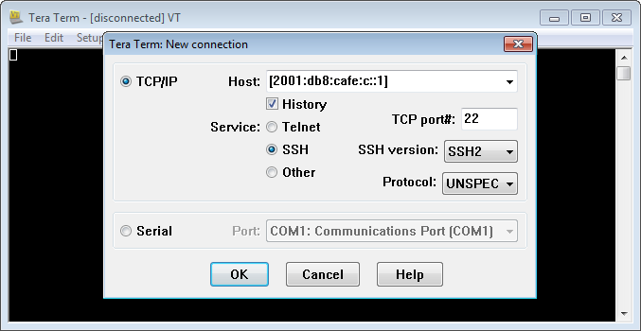

Input the user credentials configured (username **admin** and password **classadm**) and select the **Use plain password to log in** in the SSH Authentication dialogue box. Click **OK** to continue.

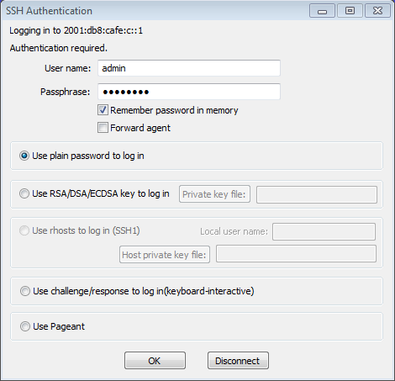

## Part 3: Configure and Verify IPv6 ACLs

#### Step 1: Configure and verify VTY restrictions on R1.

1. Create an ACL to only allow hosts from the 2001:db8:acad:a::/64 network to telnet to R1. All hosts should only be able to ssh to R1.

R1(config)# **ipv6 access-list RESTRICT-VTY**

R1(config-ipv6-acl)# **permit tcp 2001:db8:acad:a::/64 any eq 23**

R1(config-ipv6-acl)# **permit tcp any any eq 22**

1. Apply the RESTRICT-VTY ACL to R1’s VTY lines.

R1(config-ipv6-acl)# **line vty 0 4**

R1(config-line)# **ipv6 access-class RESTRICT-VTY in**

R1(config-line)# **end**

R1#

1. Show the new ACL.

##### R1# show access-lists

IPv6 access list RESTRICT-VTY

permit tcp 2001:DB8:ACAD:A::/64 any sequence 10 permit tcp any any eq 22 sequence 20

1. Verify that the RESTRICT-VTY ACL is only allowing Telnet traffic from the 2001:db8:acad:a::/64 network.

How does the RESTRICT-VTY ACL only allow hosts from the 2001:db8:acad:a::/64 network to telnet to R1?

What does the second permit statement in the RESTRICT-VTY ACL do?

#### Step 2: Restrict Telnet access to the 2001:db8:acad:a::/64 network.

1. Create an ACL called RESTRICTED-LAN that will block Telnet access to the 2001:db8:acad:a::/64 network.

R1(config)# **ipv6 access-list RESTRICTED-LAN**

R1(config-ipv6-acl)# **remark Block Telnet from outside**

R1(config-ipv6-acl)# **deny tcp any 2001:db8:acad:a::/64 eq telnet**

R1(config-ipv6-acl)# **permit ipv6 any any**

1. Apply the RESTRICTED-LAN ACL to interface G0/1 for all outbound traffic.

R1(config-ipv6-acl)# **int g0/1**

R1(config-if)# **ipv6 traffic-filter RESTRICTED-LAN out**

R1(config-if)# **end**

1. Telnet to S1 from PC-B and PC-C to verify that Telnet has been restricted. SSH to S1 from PC-B to verify that it can still be reached using SSH. Troubleshoot if necessary.
2. Use the **show ipv6 access-list** command to view the RESTRICTED-LAN ACL.

##### R1# show ipv6 access-lists RESTRICTED-LAN

IPv6 access list RESTRICTED-LAN

deny tcp any 2001:DB8:ACAD:A::/64 eq telnet (6 matches) sequence 20 permit ipv6 any any (45 matches) sequence 30

Notice that each statement identifies the number of hits or matches that have occurred since the ACL was applied to the interface.

1. Use the **clear ipv6 access-list** to reset the match counters for the RESRICTED-LAN ACL.

##### R1# clear ipv6 access-list RESTRICTED-LAN

1. Redisplay the ACL with the **show access-lists** command to confirm that the counters were cleared.

##### R1# show access-lists RESTRICTED-LAN

IPv6 access list RESTRICTED-LAN

deny tcp any 2001:DB8:ACAD:A::/64 eq telnet sequence 20 permit ipv6 any any sequence 30

## Part 4: Edit IPv6 ACLs

In Part 4, you will edit the RESTRICTED-LAN ACL that you created in Part 3. It is always a good idea to remove the ACL from the interface to which it is applied before editing it. After you complete your edits, then reapply the ACL to the interface.

**Note**: Many network administrators will make a copy of the ACL and edit the copy. When editing is complete, the administrator will remove the old ACL and apply the newly edited ACL to the interface. This method keeps the ACL in place until you are ready to apply the edited copy of the ACL.

#### Step 1: Remove the ACL from the interface.

R1(config)# **int g0/1**

R1(config-if)# **no ipv6 traffic-filter RESTRICTED-LAN out**

R1(config-if)# **end**

#### Step 2: Use the show access-lists command to view the ACL.

##### R1# show access-lists

IPv6 access list RESTRICT-VTY

permit tcp 2001:DB8:ACAD:A::/64 any (4 matches) sequence 10 permit tcp any any eq 22 (6 matches) sequence 20

IPv6 access list RESTRICTED-LAN

deny tcp any 2001:DB8:ACAD:A::/64 eq telnet sequence 20 permit ipv6 any any (36 matches) sequence 30

#### Step 3: Insert a new ACL statement using sequence numbering.

R1(config)# **ipv6 access-list RESTRICTED-LAN**

R1(config-ipv6-acl)# **permit tcp 2001:db8:acad:b::/64 host 2001:db8:acad:a::a eq 23 sequence 15**

What does this new permit statement do?

#### Step 4: Insert a new ACL statement at the end of the ACL.

R1(config-ipv6-acl)# **permit tcp any host 2001:db8:acad:a::3 eq www**

**Note**: This permit statement is only used to show how to add a statement to the end of an ACL. This ACL line would never be matched because the previous permit statement is matching on everything.

#### Step 5: Use the do show access-lists command to view the ACL change.

R1(config-ipv6-acl)# **do show access-list**

IPv6 access list RESTRICT-VTY

permit tcp 2001:DB8:ACAD:A::/64 any (2 matches) sequence 10 permit tcp any any eq 22 (6 matches) sequence 20

IPv6 access list RESTRICTED-LAN

permit tcp 2001:DB8:ACAD:B::/64 host 2001:DB8:ACAD:A::A eq telnet sequence 15 deny tcp any 2001:DB8:ACAD:A::/64 eq telnet sequence 20

permit ipv6 any any (124 matches) sequence 30

permit tcp any host 2001:DB8:ACAD:A::3 eq www sequence 40

**Note**: The **do** command can be used to execute any privileged EXEC command while in global configuration mode or a submode.

#### Step 6: Delete an ACL statement.

Use the **no** command to delete the permit statement that you just added.

R1(config-ipv6-acl)# **no permit tcp any host 2001:DB8:ACAD:A::3 eq www**

#### Step 7: Use the do show access-list RESTRICTED-LAN command to view the ACL.

R1(config-ipv6-acl)# **do show access-list RESTRICTED-LAN**

IPv6 access list RESTRICTED-LAN

permit tcp 2001:DB8:ACAD:B::/64 host 2001:DB8:ACAD:A::A eq telnet sequence 15 deny tcp any 2001:DB8:ACAD:A::/64 eq telnet sequence 20

permit ipv6 any any (214 matches) sequence 30

#### Step 8: Re-apply the RESTRICTED-LAN ACL to the interface G0/1.

R1(config-ipv6-acl)# **int g0/1**

R1(config-if)# **ipv6 traffic-filter RESTRICTED-LAN out**

R1(config-if)# **end**

#### Step 9: Test ACL changes.

Telnet to S1 from PC-B. Troubleshoot if necessary.

**Reflection**

1. What is causing the match count on the RESTRICTED-LAN **permit ipv6 any any** statement to continue to increase?
2. What command would you use to reset the counters for the ACL on the VTY lines?

### Router Interface Summary Table

|  |  |  |  |  |
| --- | --- | --- | --- | --- |
| **Router Interface Summary** | | | | |
| **Router Model** | **Ethernet Interface #1** | **Ethernet Interface #2** | **Serial Interface #1** | **Serial Interface #2** |
| 1800 | Fast Ethernet 0/0 (F0/0) | Fast Ethernet 0/1 (F0/1) | Serial 0/0/0 (S0/0/0) | Serial 0/0/1 (S0/0/1) |
| 1900 | Gigabit Ethernet 0/0 (G0/0) | Gigabit Ethernet 0/1 (G0/1) | Serial 0/0/0 (S0/0/0) | Serial 0/0/1 (S0/0/1) |
| 2801 | Fast Ethernet 0/0 (F0/0) | Fast Ethernet 0/1 (F0/1) | Serial 0/1/0 (S0/1/0) | Serial 0/1/1 (S0/1/1) |
| 2811 | Fast Ethernet 0/0 (F0/0) | Fast Ethernet 0/1 (F0/1) | Serial 0/0/0 (S0/0/0) | Serial 0/0/1 (S0/0/1) |
| 2900 | Gigabit Ethernet 0/0 (G0/0) | Gigabit Ethernet 0/1 (G0/1) | Serial 0/0/0 (S0/0/0) | Serial 0/0/1 (S0/0/1) |
| **Note**: To find out how the router is configured, look at the interfaces to identify the type of router and how many interfaces the router has. There is no way to effectively list all the combinations of configurations for each router class. This table includes identifiers for the possible combinations of Ethernet and Serial interfaces in the device. The table does not include any other type of interface, even though a specific router may contain one. An example of this might be an ISDN BRI interface. The string in parenthesis is the legal abbreviation that can be used in Cisco IOS commands to represent the interface. | | | | |



* + - 1. **Lab - Troubleshooting ACL Configuration and Placement**

**Topology**

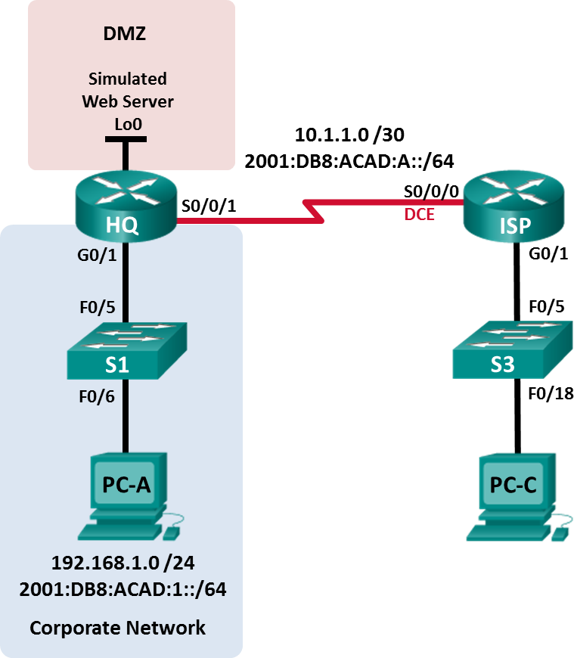

**Addressing Table**

|  |  |  |  |  |
| --- | --- | --- | --- | --- |
| **Device** | **Interface** | **IP Address** | **Subnet Mask** | **Default Gateway** |
| **IPv6 Address / Prefix** | |
| **Link Local Address** | |
| HQ | G0/1 | 192.168.1.1 | 255.255.255.0 | N/A |
| 2001:DB8:ACAD:1::1/64 | |
| FE80::1 | |
| S0/0/1 | 10.1.1.2 | 255.255.255.252 | N/A |
| 2001:DB8:ACAD:A::2/64 | |
| FE80::2 | |
| Lo0 | 192.168.4.1 | 255.255.255.0 | N/A |
| 2001:DB8:ACAD:4::1/64 | |
| FE80::1 | |
| ISP | G0/1 | 192.168.3.1 | 255.255.255.0 | N/A |
| 2001:DB8:ACAD:3::1/64 | |
| FE80::1 | |
| S0/0/0 (DCE) | 10.1.1.1 | 255.255.255.252 | N/A |
| 2001:DB8:ACAD:A::1/64 | |
| FE80::1 | |
| S1 | VLAN 1 | 192.168.1.11 | 255.255.255.0 | 192.168.1.1 |
| S3 | VLAN 1 | 192.168.3.11 | 255.255.255.0 | 192.168.3.1 |
| PC-A | NIC | 192.168.1.3 | 255.255.255.0 | 192.168.1.1 |
| 2001:DB8:ACAD:1::3/64 | | FE80::1 |
| FE80::3 | |
| PC-C | NIC | 192.168.3.3 | 255.255.255.0 | 192.168.3.1 |
| 2001:DB8:ACAD:3::3/64 | | FE80::1 |
| FE80::3 | |

**Objectives**

##### Part 1: Build the Network and Configure Basic Device Settings Part 2: Troubleshoot Internal Access

**Part 3: Troubleshoot Remote Access**

**Background / Scenario**

An access control list (ACL) is a series of IOS commands that provide basic traffic filtering on a Cisco router. ACLs are used to select the types of traffic to be processed.

A single ACL statement is called an access control entry (ACE). The ACEs in the ACL are evaluated from top to bottom with an implicit deny all ACE at the end of the list. ACLs can also control the types of traffic into or out of a network by the source and destination hosts or network. To process the desired traffic correctly, the placement of the ACLs is critical.

In this lab, a small company has just added a web server to the network to allow customers to access confidential information. The company IPv4 and IPv6 network is divided into two zones: Corporate network zone and Demilitarized Zone (DMZ). The corporate network zone houses private servers and internal clients. The DMZ houses the externally accessible web server (simulated by Lo0 on HQ).

To secure access to the corporate and DMZ networks, several ACLs were configured on the HQ router. However, there are problems with the configured ACLs. In this lab, you will examine what the ACLs are doing and take corrective actions to implement them properly.

When troubleshooting ACLs, it is important that its purpose and desired outcome is well understood. For this reason, the following describes the ACLs configured on HQ:

* + - * + **ACL 101** is implemented to limit the traffic leaving the corporate network zone. This zone is often referred to as the private or internal network because it houses the private servers and internal clients. In this topology, this zone is assigned network address 192.168.1.0/24. Therefore, only traffic from that network should be permitted to leave the internal network.
        + **ACL 102** is used to limit the traffic into the corporate network. Only responses to requests that originated from within the corporate network are allowed back into that network. This includes TCP-based requests from internal hosts such as Web and FTP. ICMP is allowed into the network for troubleshooting purposes so that incoming ICMP messages generated in response to pings can be received by internal hosts. No other network should be able to access the corporate zone.
        + **ACL 121** controls outside traffic to the DMZ and corporate network. Only HTTP traffic is allowed to the DMZ web server (simulated by Lo0 on HQ). Other network related traffic, such as EIGRP, is allowed from outside networks. Furthermore, valid internal private addresses, such as 192.168.1.0, loopback address such as 127.0.0.1 and multicast addresses are denied entrance to the corporate network to prevent malicious network attacks from outside users.
        + **IPv6 ACL** named NO-ICMP denies ICMP traffic to the DMZ and corporate network originated from the outside. ICMP response is allowed into the network that is responding to the requests from the internet hosts. Other network related traffic, such as EIGRP, is allowed from outside networks. Furthermore, the outside network is allowed to access the DMZ web server (simulated by Lo0 on HQ).

**Note**: The routers used with CCNA hands-on labs are Cisco 1941 Integrated Services Routers (ISRs) with Cisco IOS Release 15.4(3) (universalk9 image). The switches used are Cisco Catalyst 2960s with Cisco IOS Release 15.0(2) (lanbasek9 image). Other routers, switches and Cisco IOS versions can be used. Depending on the model and Cisco IOS version, the commands available and output produced might vary from what is shown in the labs. Refer to the Router Interface Summary Table at the end of the lab for the correct interface identifiers.

**Note**: Make sure that the routers and switches have been erased and have no startup configurations. If you are unsure, contact your instructor.

### Required Resources

* + - * + 2 Routers (Cisco 1941 with Cisco IOS Release 15.4(3) universal image or comparable)
        + 2 Switches (Cisco 2960 with Cisco IOS Release 15.0(2) lanbasek9 image or comparable)
        + 2 PCs (Windows with terminal emulation program, such as Tera Term)
        + Console cables to configure the Cisco IOS devices via the console ports
        + Ethernet and serial cables as shown in the topology

## Part 1: Build the Network and Configure Basic Device Settings

In Part 1, you will set up the network topology and configure the routers and switches with basic settings such as passwords and IP addresses. Preset configurations are also provided for you for the initial router configurations. You will also configure the IP settings for the PCs in the topology.

#### Step 1: Cable the network as shown in the topology.

**Step 2: Configure PC hosts according to the Addressing Table**

**Step 3: Initialize and reload the routers and switches as necessary. Step 4: (Optional) Configure basic settings for each switch.**

1. Disable DNS lookup.
2. Configure host names as shown in the Topology.
3. Configure IP addresses and default gateways as shown in the Addressing Table.
4. Assign **cisco** as the console and vty passwords.
5. Assign **class** as the privileged EXEC password.
6. Configure **logging synchronous** to prevent console messages from interrupting command entry.

#### Step 5: Configure basic settings for each router.

1. Disable DNS lookup.
2. Configure host names as shown in the topology.
3. Assign **class** as the privileged EXEC password.
4. Assign **cisco** as the console and vty passwords.
5. Configure **logging synchronous** to prevent console messages from interrupting command entry.

#### Step 6: Configure HTTP access and user credentials on HQ router.

Local user credentials are configured to access the simulated web server (192.168.4.1).

HQ(config)# **ip http server**

HQ(config)# **username admin privilege 15 secret adminpass**

HQ(config)# **ip http authentication local**

#### Step 7: Load router configurations.

The configurations for the routers ISP and HQ are provided for you. There are errors within these configurations, and it is your task to correct them.

##### Router ISP

hostname ISP

ipv6 unicast-routing

ipv6 router eigrp 1

eigrp router-id 10.1.1.1 no shutdown

interface GigabitEthernet0/1

ip address 192.168.3.1 255.255.255.0

ipv6 address FE80::1 link-local ipv6 address 2001:DB8:ACAD:3::1/64 ipv6 eigrp 1

no shutdown interface Serial0/0/0

ip address 10.1.1.1 255.255.255.252

clock rate 128000

ipv6 address FE80::1 link-local ipv6 address 2001:DB8:ACAD:A::1/64 ipv6 eigrp 1

no shutdown router eigrp 1

network 10.1.1.0 0.0.0.3

network 192.168.3.0 no auto-summary

end

##### Router HQ

hostname HQ

ipv6 unicast-routing ipv6 router eigrp 1

eigrp router-id 10.1.1.2 no shutdown

interface Loopback0

ip address 192.168.4.1 255.255.255.0

ipv6 address FE80::1 link-local ipv6 address 2001:DB8:ACAD:4::1/64 ipv6 eigrp 1

interface GigabitEthernet0/1

ip address 192.168.1.1 255.255.255.0

ipv6 address FE80::1 link-local ipv6 address 2001:DB8:ACAD:1::1/64 ip access-group 101 out

ip access-group 102 in ipv6 eigrp 1

no shutdown interface Serial0/0/1

ip address 10.1.1.2 255.255.255.252

ip access-group 121 in

ipv6 address FE80::2 link-local ipv6 address 2001:DB8:ACAD:A::2/64 ipv6 eigrp 1

ipv6 traffic-filter NO-ICMP out no shutdown

router eigrp 1

network 10.1.1.0 0.0.0.3

network 192.168.1.0

network 192.168.4.0 no auto-summary

ip http server

access-list 101 permit ip 192.168.11.0 0.0.0.255 any access-list 101 deny ip any any

access-list 102 permit tcp any any established access-list 102 permit icmp any any echo-reply access-list 102 permit icmp any any unreachable access-list 102 deny ip any any

access-list 121 permit tcp any host 192.168.4.1 eq 89 access-list 121 deny icmp any host 192.168.4.11 access-list 121 deny ip 192.168.1.0 0.0.0.255 any

access-list 121 deny ip 127.0.0.0 0.255.255.255 any

access-list 121 deny ip 224.0.0.0 31.255.255.255 any access-list 121 permit ip any any

access-list 121 deny ip any any ipv6 access-list NO-ICMP

deny icmp any any echo-request permit ipv6 any any

end

## Part 2: Troubleshoot Internal Access

In Part 2, the ACLs on router HQ are examined to determine if they are configured correctly.

#### Step 1: Troubleshoot ACL 101

ACL 101 is implemented to limit the traffic leaving the corporate network zone. This zone houses only internal clients and private servers. Only 192.168.1.0/24 network can exit this corporate network zone.

1. Can PC-A ping its default gateway? no
2. After verifying that PC-A was configured correctly, examine the HQ router to find possible configuration errors by viewing the summary of ACL 101. Enter the command **show access-lists 101**.

##### HQ# show access-lists 101

Extended IP access list 101

10 permit ip 192.168.11.0 0.0.0.255 any

20 deny ip any any

1. Are there any problems with ACL 101?

La ACL 101 permite la red 192.168.11.0 en lugar de la red 192.168.1.0

1. Correct ACL 101. Record the commands used to correct the errors.

no access-list 101

access-list 101 permit ip 192.168.1.0 0.0.0.255 any

access-list 101 deny ip any any

1. Can PC-A ping its default gateway? no
2. PC-A still cannot ping its default gateway, therefore verify that ACL 101 is applied in the correct direction on the G0/1 interface. Enter the **show ip interface g0/1** command.

##### HQ# show ip interface g0/1

GigabitEthernet0/1 is up, line protocol is up Internet address is 192.168.1.1/24 Broadcast address is 255.255.255.255 Address determined by setup command

MTU is 1500 bytes

Helper address is not set

Directed broadcast forwarding is disabled Multicast reserved groups joined: 224.0.0.10 Outgoing access list is 101

Inbound access list is 102

Is the direction for interface G0/1 configured correctly for ACL 101?

No esta correcto.

1. Correct the direction of ACL 101 on the G0/1 interface. Record the commands used to correct the errors.

interface g0/1

ip access-group 101 in

1. Verify the traffic from network 192.168.1.0 /24 can exit the corporate network. PC-A should now be able to ping its default gateway interface.

#### Step 2: Troubleshoot ACL 102

ACL 102 is implemented to limit traffic going into the corporate network. Traffic originating from the outside network is not allowed onto the corporate network. Remote traffic is allowed into the corporate network if the established traffic originated from the internal network. ICMP reply messages are allowed for troubleshooting purposes.

1. Can PC-A ping PC-C? no
2. Examine the HQ router to find possible configuration errors by viewing the summary of ACL 102. Enter the command **show access-lists 102**.

##### HQ# show access-lists 102

Extended IP access list 102

10 permit tcp any any established

20 permit icmp any any echo-reply

30 permit icmp any any unreachable

40 deny ip any any (57 matches)

1. Are there any problems with ACL 102? no
2. Verify that the ACL 102 is applied in the correct direction on G0/1 interface. Enter the **show ip interface g0/1** command.

##### HQ# show ip interface g0/1

GigabitEthernet0/1 is up, line protocol is up Internet address is 192.168.1.1/24 Broadcast address is 255.255.255.255 Address determined by setup command

MTU is 1500 bytes

Helper address is not set

Directed broadcast forwarding is disabled Multicast reserved groups joined: 224.0.0.10 Outgoing access list is 101

Inbound access list is 101

1. Are there any problems with the application of ACL 102 to interface G0/1?

el problema esque se esta aplicando otra acl en esa interfaz, debe ser la ACL120

1. Correct any errors found regarding ACL 102. Record the commands used to correct the errors.

interface g0/1

no ip access-group 101

ip access-group 102 out

1. Can PC-A ping PC-C now? si

## Part 3: Troubleshoot Remote Access

In Part 3, ACL 121 is configured to prevent spoofing attacks from the outside networks and allow only remote HTTP access to the web server (192.168.4.1) in the DMZ.

1. Verify ACL 121 has been configured correctly. Enter the **show ip access-list 121** command.

##### HQ# show ip access-lists 121

Extended IP access list 121

10 permit tcp any host 192.168.4.1 eq 89

20 deny icmp any host 192.168.4.11 30 deny ip 192.168.1.0 0.0.0.255 any

|  |  |  |
| --- | --- | --- |
| 40 | deny ip 127.0.0.0 | 0.255.255.255 any |
| 50 | deny ip 224.0.0.0 | 31.255.255.255 any |
| 60 | permit ip any any | (354 matches) |
| 70 | deny ip any any |  |

Are there any problems with this ACL?

El puerto 89 no es correcto, debe ser 80. La ip 192.168.4.11 no es correcta, debe ser 192.168.4.1 para el servidor web.

1. Make and record the necessary configuration changes to ACL 121.

no access-list 121

access-list 121 permit tcp any host 192.168.4.1 eq 80

access-list 121 deny icmp any host 192.168.4.1

access-list 121 deny ip 192.168.1.0 0.0.0.255 any

access-list 121 deny ip 127.0.0.0 0.255.255.255 any

access-list 121 deny ip 224.0.0.0 31.255.255.255 any

access-list 121 permit ip any any

access-list 121 deny ip any any

1. Verify that the ACL 121 is applied in the correct direction on the HQ S0/0/1 interface. Enter the **show ip interface s0/0/1** command.

##### HQ# show ip interface s0/0/1

Serial0/0/1 is up, line protocol is up Internet address is 10.1.1.2/30 Broadcast address is 255.255.255.255

<output omitted>

Multicast reserved groups joined: 224.0.0.10 Outgoing access list is not set

Inbound access list is 121

Are there any problems with the application of this ACL?

no

1. Verify that PC-C can only access the simulated web server on HQ by using the web browser. Provide the username **admin** and password **adminpass** to access the web server (192.168.4.1).

## Part 4: Troubleshoot IPv6 ACL

In Part 4, an IPv6 ACL named NO-ICMP denies ICMP traffic to the DMZ and corporate network originating from the outside. ICMP response to the internal hosts, EIGRP packets, and network related traffic are allowed from outside networks. Furthermore, the outside network is allowed to access the DMZ web server (simulated by Lo0 on HQ).

1. Verify ACL **NO-ICMP** has been configured correctly. Enter the **show ipv6 access-list NO-ICMP**

command.

##### HQ# show ipv6 access-list NO-ICMP

IPv6 access list NO-ICMP

deny icmp any any echo-request sequence 10 permit ipv6 any any sequence 20

Are there any problems with this ACL?

1. Verify that the ACL NO-ICMP is applied in the correct direction on the HQ S0/0/1 interface. Enter the

**show ipv6 interface s0/0/1** command.

##### HQ# show ipv6 interface s0/0/1

Serial0/0/1 is up, line protocol is up

IPv6 is enabled, link-local address is FE80::2 No Virtual link-local address(es):

Global unicast address(es):

2001:DB8:ACAD:A::1, subnet is 2001:DB8:ACAD:A::/64

Joined group address(es): FF02::1

FF02::2 FF02::A FF02::1:FF00:1 FF02::1:FF00:2

MTU is 1500 bytes

ICMP error messages limited to one every 100 milliseconds ICMP redirects are enabled

ICMP unreachables are sent Output features: Access List Outgoing access list NO-ICMP

ND DAD is enabled, number of DAD attempts: 1

ND reachable time is 30000 milliseconds (using 30000) ND RAs are suppressed (periodic)

Hosts use stateless autoconfig for addresses.

Are there any problems with the application of this ACL?

1. Make and record the necessary configuration changes to ACL NO-ICMP.

**Reflection**

1. How should the ACL statement be ordered? From general to specific or vice versa?

cuando se ejecuta una acl y encuentra condición correcta se detiene su ejecución, por tanto deben estar ordenadas de más especifico e ir escalando a lo general o las que más engloban el trafico.

1. If you delete an ACL by using the **no access-list** command and the ACL is still applied to the interface, what happens?

Deniega todo el trafico, por tanto hay que eliminarla de la interfaz para evitar problemas de conectividad.

### Router Interface Summary Table

|  |  |  |  |  |
| --- | --- | --- | --- | --- |
| **Router Interface Summary** | | | | |
| **Router Model** | **Ethernet Interface #1** | **Ethernet Interface #2** | **Serial Interface #1** | **Serial Interface #2** |
| 1800 | Fast Ethernet 0/0 (F0/0) | Fast Ethernet 0/1 (F0/1) | Serial 0/0/0 (S0/0/0) | Serial 0/0/1 (S0/0/1) |
| 1900 | Gigabit Ethernet 0/0 (G0/0) | Gigabit Ethernet 0/1 (G0/1) | Serial 0/0/0 (S0/0/0) | Serial 0/0/1 (S0/0/1) |
| 2801 | Fast Ethernet 0/0 (F0/0) | Fast Ethernet 0/1 (F0/1) | Serial 0/1/0 (S0/1/0) | Serial 0/1/1 (S0/1/1) |
| 2811 | Fast Ethernet 0/0 (F0/0) | Fast Ethernet 0/1 (F0/1) | Serial 0/0/0 (S0/0/0) | Serial 0/0/1 (S0/0/1) |
| 2900 | Gigabit Ethernet 0/0 (G0/0) | Gigabit Ethernet 0/1 (G0/1) | Serial 0/0/0 (S0/0/0) | Serial 0/0/1 (S0/0/1) |
| **Note**: To find out how the router is configured, look at the interfaces to identify the type of router and how many interfaces the router has. There is no way to effectively list all the combinations of configurations for each router class. This table includes identifiers for the possible combinations of Ethernet and Serial interfaces in the device. The table does not include any other type of interface, even though a specific router may contain one. An example of this might be an ISDN BRI interface. The string in parenthesis is the legal abbreviation that can be used in Cisco IOS commands to represent the interface. | | | | |



* + - 1. **Lab – Researching Network Monitoring Software**

**Objectives**

##### Part 1: Survey Your Understanding of Network Monitoring Part 2: Research Network Monitoring Tools

**Part 3: Select a Network Monitoring Tool**

**Background / Scenario**

Network monitoring is needed for any sized network. Proactively monitoring the network infrastructure can assist network administrators with their day-to-day duties. The wide variety of networking tools available vary in cost, depending on the features, number of network locations and number of nodes supported.

In this lab, you will conduct research on available network monitoring software. You will gather information on software products and features of those products. You will investigate one product in greater detail and list some of the key features available.

### Required Resources

* + - * + PC with Internet access

## Part 1: Survey Your Understanding of Network Monitoring

Describe network monitoring as you understand it. Give an example of how it might be used in a production network.

## Part 2: Research Network Monitoring Tools

#### Step 1: Research and find three network monitoring tools.

List the three tools that you found.

#### Step 2: Complete the following form for the network monitoring tools selected.

|  |  |  |
| --- | --- | --- |
| **Vendor** | **Product Name** | **Features** |
|  |  |  |
|  |  |  |
|  |  |  |

**Part 3: Select a Network Monitoring Tool**

**Step 1: Select one or more monitoring tools from your research.**

From your research, identify one or more tools you would choose for monitoring your network. List the tools and explain your reasons for choosing them, including specific features that you consider important.

#### Step 2: Investigate the PRTG network monitoring tool.

Navigate to [www.paessler.com/prtg.](http://www.paessler.com/prtg)

Give examples of some of the features that you found for PRTG in the space provided below.

**Reflection**

Based on your research, what conclusions have you reached regarding network monitoring software?



# Lab – Configuring SNMP

### Topology

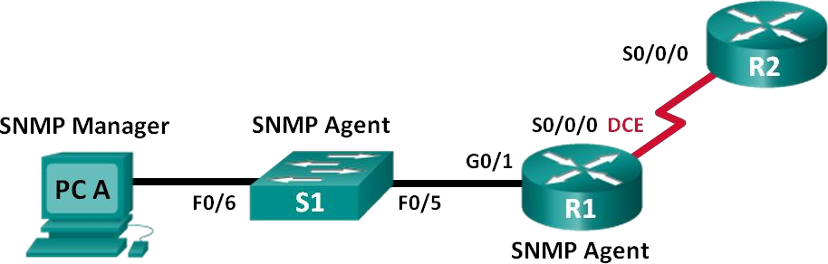

**Addressing Table**

|  |  |  |  |  |
| --- | --- | --- | --- | --- |
| **Device** | **Interface** | **IP Address** | **Subnet Mask** | **Default Gateway** |
| R1 | G0/1 | 192.168.1.1 | 255.255.255.0 | N/A |
| S0/0/0 | 192.168.2.1 | 255.255.255.252 | N/A |
| R2 | S0/0/0 | 192.168.2.2 | 255.255.255.252 | N/A |
| S1 | VLAN 1 | 192.168.1.2 | 255.255.255.0 | N/A |
| PC-A | NIC | 192.168.1.3 | 255.255.255.0 | 192.168.1.1 |

**Objectives**

##### Part 1: Build the Network and Configure Basic Device Settings Part 2: Configure an SNMPv2 Manager and Agent

**Part 3: Configure an SNMPv3 Manager and Agent**

**Background / Scenario**

Simple Network Management Protocol (SNMP) is a network management protocol and an IETF standard which can be used to both monitor and control clients on the network. SNMP can be used to get and set variables related to the status and configuration of network hosts like routers and switches, as well as network client computers. The SNMP manager can poll SNMP agents for data, or data can be automatically sent to the SNMP manager by configuring traps on the SNMP agents.

In this lab, you will download, install, and configure SNMP management software on PC-A. You will also configure a Cisco router and Cisco switch as SNMP agents. After capturing SNMP notification messages from the SNMP agent, you will convert the MIB/Object ID codes to learn the details of the messages using the Cisco SNMP Object Navigator.

**Note**: The routers used with CCNA hands-on labs are Cisco 1941 Integrated Services Routers (ISRs) with Cisco IOS Release 15.4(3) (universalk9 image). The switches used are Cisco Catalyst 2960s with Cisco IOS Release 15.0(2) (lanbasek9 image). Other routers, switches and Cisco IOS versions can be used. Depending on the model and Cisco IOS version, the commands available and output produced might vary from what is

shown in the labs. Refer to the Router Interface Summary Table at the end of the lab for the correct interface identifiers.

**Note**: Make sure that the routers and switches have been erased and have no startup configurations. If you are unsure, contact your instructor.

**Note**: The **snmp-server** commands in this lab will cause the Cisco 2960 switch to issue a warning message when saving the configuration file to NVRAM. To avoid this warning message verify that the switch is using the **lanbase-routing** template. The IOS template is controlled by the Switch Database Manager (SDM).

When changing the preferred template, the new template will be used after reboot even if the configuration is not saved.

S1# **show sdm prefer**

Use the following commands to assign the **lanbase-routing** template as the default SDM template.

##### S1# configure terminal

S1(config)# **sdm prefer lanbase-routing**

S1(config)# **end**

S1# **reload**

### Required Resources

* + - * + 2 Routers (Cisco 1941 with Cisco IOS, Release 15.4(3) universal image or comparable)
        + 1 Switch (Cisco 2960 with Cisco IOS Release 15.0(2) lanbasek9 image or comparable)
        + 1 PC (Windows with terminal emulation program, such as Tera Term, SNMP manager, such as SNMP MIB Browser by ManageEngine, and Wireshark)
        + Console cables to configure the Cisco IOS devices via the console ports
        + Ethernet and serial cables as shown in the topology
        + SNMP Management Software (SNMP MIB Browser by ManageEngine)

**Part 1: Build the Network and Configure Basic Device Settings**

In Part 1, you will set up the network topology and configure the devices with basic settings.

#### Step 1: Cable the network as shown in the topology. Step 2: Configure the PC host.

**Step 3: Initialize and reload the switch and routers as necessary.**

**Step 4: Configure basic settings for the routers and switch.**

1. Disable DNS lookup.
2. Configure device names as shown in the topology.
3. Configure IP addresses as shown in the Addressing Table. (Do not configure or enable the VLAN 1 interface on S1 at this time.)
4. Assign **cisco** as the console and vty password and enable login.
5. Assign **class** as the encrypted privileged EXEC mode password.
6. Configure **logging synchronous** to prevent console messages from interrupting command entry.
7. Verify successful connectivity between PC-A and R1 and between the routers by issuing the **ping**

command.

1. Copy the running configuration to the startup configuration.

## Part 2: Configure SNMPv2 Manager and Agent

In Part 2, SNMP management software will be installed and configured on PC-A, and R1 and S1 will be configured as SNMP agents.

#### Step 1: Install an SNMP management program.

1. Download and install the SNMP MIB Browser by ManageEngine from the following URL: [https://www.manageengine.com/products/mibbrowser-free-tool/download.html.](https://www.manageengine.com/products/mibbrowser-free-tool/download.html) You will be asked to provide an email address to download the software.
2. Launch the ManageEngine MibBrowser program.
   1. If you receive an error message regarding the failure to load MIBs. Navigate to the MibBrowser Free Tool folder:

32bit: C:\Program Files (x86)\ManageEngine\MibBrowser Free Tool 64bit: C:\Program Files\ManageEngine\MibBrowser Free Tool

* 1. Right-click the **mibs** folder, Properties, and select the **Security** tab. Click **Edit**. Select **Users**. Check the **Modify** under **Allow** column. Click **OK** to change the permission.
  2. Repeat the previous step with the **conf** folder.
  3. Launch the ManageEngine MibBrowser program again.

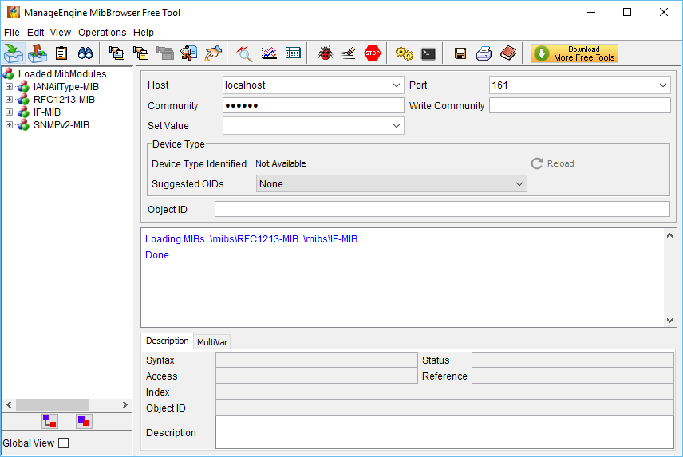

#### Step 2: Configure a SNMPv2 agent.

On S1, enter the following commands from the global configuration mode to configure the switch as an SNMP agent. In line 1 below, the SNMP community string is **ciscolab**, with read-only privileges, and the named access list SNMP_ACL defines which hosts are allowed to get SNMP information from S1. In lines 2 and 3,

the SNMP manager location and contact commands provide descriptive contact information. Line 4 specifies the IP address of the host that will receive SNMP notifications, the SNMP version, and the community string. Line 5 enables all default SNMP traps, and lines 6 and 7 create the named access list, to control which hosts are permitted to get SNMP information from the switch.

S1(config)# **snmp-server community ciscolab ro SNMP_ACL** S1(config)# **snmp-server location Company_HQ** S1(config)# **snmp-server contact** [**admin@company.com**](mailto:admin@company.com)

##### S1(config)# snmp-server host 192.168.1.3 version 2c ciscolab

S1(config)# **snmp-server enable traps** S1(config)# **ip access-list standard SNMP_ACL** S1(config-std-nacl)# **permit 192.168.1.3**

#### Step 3: Verify the SNMPv2 settings.

Use the **show** commands to verify the SNMPv2 settings.

S1# **show snmp**

Chassis: FCQ1628Y5MG Contact: [admin@company.com](mailto:admin@company.com) Location: Company_HQ

0 SNMP packets input

0 Bad SNMP version errors

0 Unknown community name

0 Illegal operation for community name supplied

0 Encoding errors

0 Number of requested variables

0 Number of altered variables

0 Get-request PDUs

0 Get-next PDUs

0 Set-request PDUs

0 Input queue packet drops (Maximum queue size 1000)

0 SNMP packets output

0 Too big errors (Maximum packet size 1500)

0 No such name errors

0 Bad values errors

0 General errors

0 Response PDUs

0 Trap PDUs

SNMP global trap: enabled

SNMP logging: enabled

Logging to 192.168.1.3.162, 0/10, 0 sent, 0 dropped.

SNMP agent enabled

##### S1# show snmp community

Community name: ciscolab Community Index: ciscolab

Community SecurityName: ciscolab

storage-type: nonvolatile active access-list: SNMP_ACL

<output omitted>

What is the configured SNMP community?

#### Step 4: Enable SNMP trap.

In this step, you will start the SNMP trap and observe the messages when you configure and enable SVI on VLAN 1 for S1.

1. In the MibBrowser, click **Edit** > **Settings**. Verify that **v2c** is selected as the SNMP Version. Click **OK** to continue.
2. Click **Trap Viewer UI** ( ).
3. Verify **162** is the Port number and configure **ciscolab** as the Community.

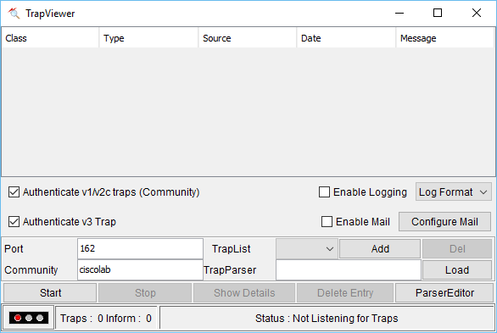

1. Click **Start** after you have verified the settings. The TrapList field displays **162:ciscolab**.
2. To generate SNMP messages, configure and enable SVI on S1. Use the IP address **192.168.1.2 /24** for VLAN 1 and disable and enable the interface.
3. Enter the **show snmp** command to verify the SNMP messages were sent.

S1# **show snmp**

Chassis: FCQ1628Y5MG Contact: [admin@company.com](mailto:admin@company.com) Location: Company_HQ

0 SNMP packets input

0 Bad SNMP version errors

0 Unknown community name

0 Illegal operation for community name supplied

0 Encoding errors

0 Number of requested variables

0 Number of altered variables

0 Get-request PDUs

0 Get-next PDUs

0 Set-request PDUs

0 Input queue packet drops (Maximum queue size 1000)

2 SNMP packets output

0 Too big errors (Maximum packet size 1500)

0 No such name errors

0 Bad values errors

0 General errors

0 Response PDUs

2 Trap PDUs

SNMP global trap: enabled

SNMP logging: enabled

Logging to 192.168.1.3.162, 0/10, 2 sent, 0 dropped.

SNMP agent enabled SNMP agent enabled

1. Navigate to the **TrapViewer**. View the messages that have been trapped by MibBrowser. To see the details of each message, click **Show Details**.

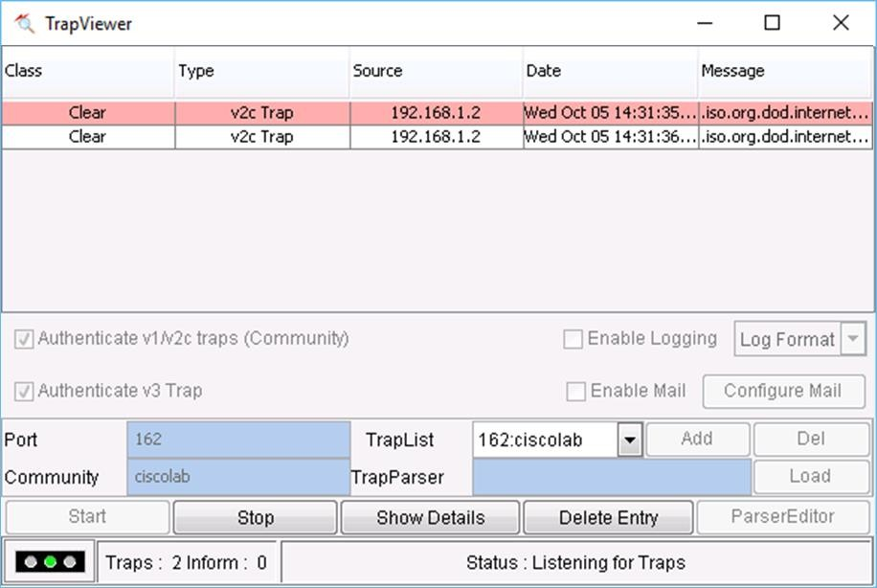

## Part 3: Configure SNMPv3 Manager and Agent

#### Step 1: Configure a SNMPv3 agent on R1.

On R1, enter the following commands from the global configuration mode to configure the router as an SNMP agent. In lines 1 – 3 below, a standard ACL named PERMIT-ADMIN permits only the hosts of the network 192.168.1.0 /24 to access the SNMP agent running on R1. Line 4 configures an SNMP view, SNMP-RO, and

it includes the iso tree from the MIB. In line 5, an SNMP group is configured with the name ADMIN, is set to SNMPv3 with authentication and encryption required, and only allows access limit to hosts permitted in the PERMIT-ADMIN ACL. Line 5 defines a user named USER1 with the group ADMIN. Authentication is set to use SHA with the password cisco12345 and encryption is set for AES 128 with cisco54321 as the configured password.

R1(config)# **ip access-list standard PERMIT-ADMIN** R1(config-std-nacl)# **permit 192.168.1.0 0.0.0.255** R1(config-std-nacl)# **exit**

R1(config)# **snmp-server view SNMP-RO iso included**

##### R1(config)# snmp-server group ADMIN v3 priv read SNMP-RO access PERMIT-ADMIN

R1(config)# **snmp-server user USER1 ADMIN v3 auth sha cisco12345 pri aes 128 cisco54321**

R1(config)#

*Aug 5 02:52:50.715: Configuring snmpv3 USM user, persisting snmpEngineBoots. Please Wait...

#### Step 2: Verify a SNMPv3 configuration on R1.

Use the **show** commands to verify the SNMPv3 settings.

##### R1# show run | include snmp

snmp-server group ADMIN v3 priv read SNMP-RO access PERMIT-ADMIN snmp-server view SNMP-RO iso included

R1# **show snmp user**

User name: USER1

Engine ID: 800000090300D48CB5CEA0C0

storage-type: nonvolatile active Authentication Protocol: SHA

Privacy Protocol: AES128 Group-name: ADMIN

#### Step 3: Configure SNMP manager access to the SNMPv3 agent.

1. Navigate to PC-A Open **Wireshark**. Start a live capture on the appropriate interface.
2. Enter **snmp** in the Filter field.
3. In the MibBrowser, click **Edit** > **Settings**. Select **v3** for SNMP Version. Then click **Add**.
4. Enter the SNMPv3 settings that were configured on R1. Click **OK** to continue.

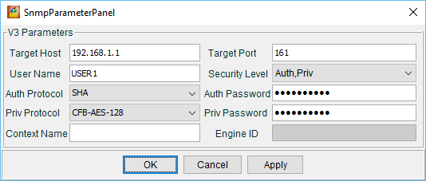

|  |  |
| --- | --- |
| **SNMPv3 Parameters** | **Settings** |
| Target Host | 192.168.1.1 |
| User Name | USER1 |
| Auth Protocol | SHA |
| Priv Protocol | CFB-AES-128 |
| Target Port | 161 |
| Security Level | Auth,Priv |
| Auth Password | cisco12345 |
| Priv Password | cisco54321 |

1. Click **Edit** > **Find Node**. Enter **ipAddrTable** in the Find What field and click **Close**. Verify **ipAddrTable** is selected in the left panel and **.iso.org.dod.internet.mgmt.mib-2.ip.ipAddrTable** is listed in the ObjectID field.
2. Click **Operation** > **GET** to get all the objects under the select MIB object, **ipAddrTable** in this instance.

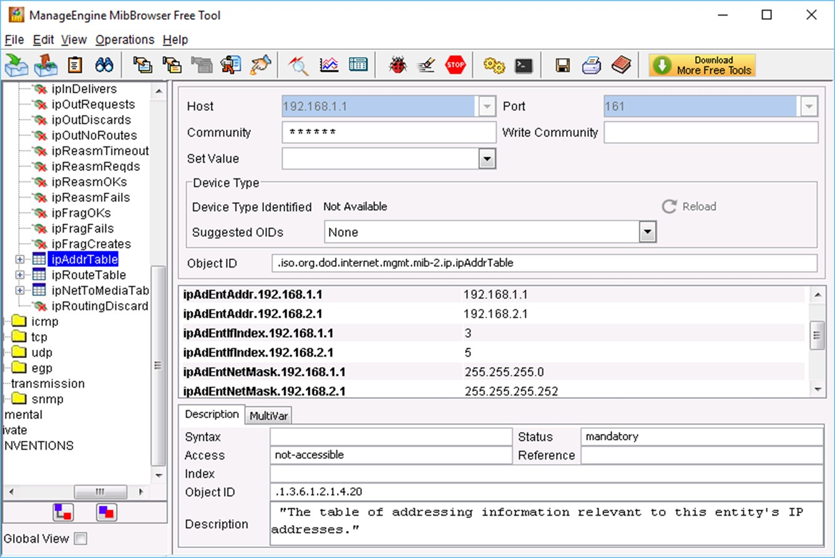

1. Navigate back to the Wireshark screen. Stop the live capture.
2. In the Results panel, right-click one of the results. Select **Protocol Preferences > Open Simple Network Management Protocol Preferences**.

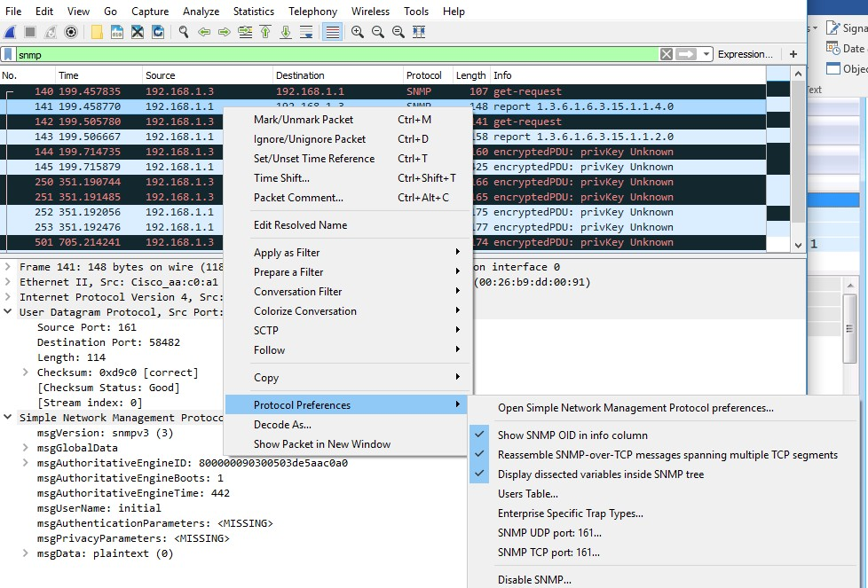

1. Click **Edit** for the Users Table. Click **New** and enter user information in Step 1. Click **OK**.

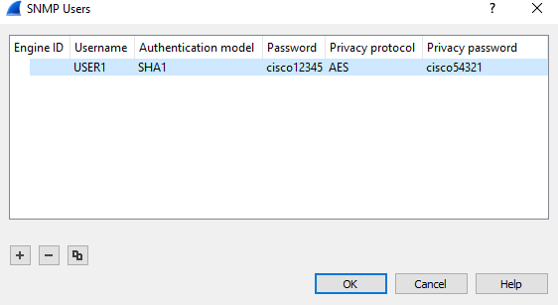

1. Click **OK** to accept the user information. Click **OK** again to exit the Wireshark Preferences window.
2. Select one of the lines. Expand the SNMP result and view the decrypted messages.

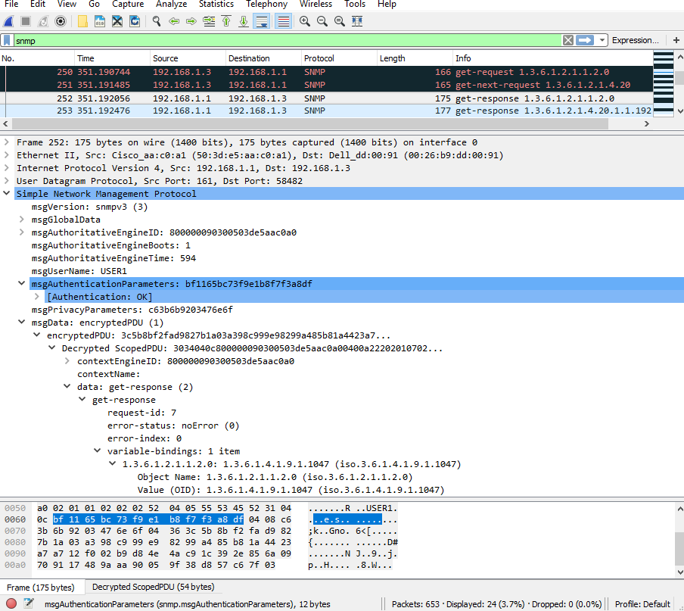

#### Step 4: Review your results.

What are the IP addresses configured on R1 in the SNMPv3 results?

192.168.1.1

Compare the Wireshark decrypted SNMP packets and MIB Browser results. Record your observations.

**Reflection**

1. What are some of the potential benefits of monitoring a network with SNMP?

Es un protocolo potente, muy flixible a la hora de implementarlo, es multiplataforma, se encuentra disponible para varias versiones OS, se puede implementar para administrar una red, monitorear estados de equipos de un espacio.

1. Why is it preferable to solely use read-only access when working with SNMPv2?

esta versión solo suporta envíos en texto plano, no encripta datos, por el riesgo de seguridad.

1. What are the benefits of using SNMPv3 over SNMPv2?

la principal mejora que se obtiene al usar v3 en vez de v2 es la seguridad, v3 incluyo una capa de seguridad que encripta datos.

### Router Interface Summary Table

|  |  |  |  |  |
| --- | --- | --- | --- | --- |
| **Router Interface Summary** | | | | |
| **Router Model** | **Ethernet Interface #1** | **Ethernet Interface #2** | **Serial Interface #1** | **Serial Interface #2** |
| 1800 | Fast Ethernet 0/0 (F0/0) | Fast Ethernet 0/1 (F0/1) | Serial 0/0/0 (S0/0/0) | Serial 0/0/1 (S0/0/1) |
| 1900 | Gigabit Ethernet 0/0 (G0/0) | Gigabit Ethernet 0/1 (G0/1) | Serial 0/0/0 (S0/0/0) | Serial 0/0/1 (S0/0/1) |
| 2801 | Fast Ethernet 0/0 (F0/0) | Fast Ethernet 0/1 (F0/1) | Serial 0/1/0 (S0/1/0) | Serial 0/1/1 (S0/1/1) |
| 2811 | Fast Ethernet 0/0 (F0/0) | Fast Ethernet 0/1 (F0/1) | Serial 0/0/0 (S0/0/0) | Serial 0/0/1 (S0/0/1) |
| 2900 | Gigabit Ethernet 0/0 (G0/0) | Gigabit Ethernet 0/1 (G0/1) | Serial 0/0/0 (S0/0/0) | Serial 0/0/1 (S0/0/1) |
| **Note**: To find out how the router is configured, look at the interfaces to identify the type of router and how many interfaces the router has. There is no way to effectively list all the combinations of configurations for each router class. This table includes identifiers for the possible combinations of Ethernet and serial interfaces in the device. The table does not include any other type of interface, even though a specific router may contain one. An example of this might be an ISDN BRI interface. The string in parenthesis is the legal abbreviation that can be used in Cisco IOS commands to represent the interface. | | | | |



* + - 1. **Lab – Implement Local SPAN**

**Topology**

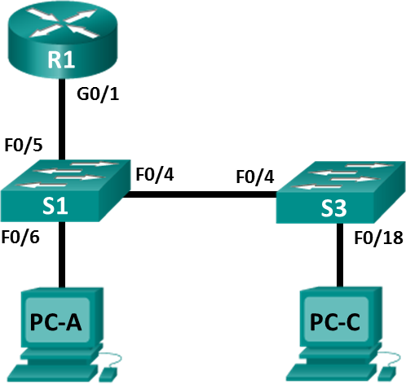

**Addressing Table**

|  |  |  |  |  |
| --- | --- | --- | --- | --- |
| **Device** | **Interface** | **IP Address** | **Subnet Mask** | **Default Gateway** |
| R1 | G0/1 | 192.168.1.1 | 255.255.255.0 | N/A |
| S1 | VLAN 1 | 192.168.1.2 | 255.255.255.0 | 192.168.1.1 |
| S3 | VLAN 1 | 192.168.1.3 | 255.255.255.0 | 192.168.1.1 |
| PC-A | NIC | 192.168.1.254 | 255.255.255.0 | 192.168.1.1 |
| PC-C | NIC | 192.168.1.10 | 255.255.255.0 | 192.168.1.1 |

**Objectives**

##### Part 1: Build the Network and Verify Connectivity

**Part 2: Configure Local SPAN and Capture Copied Traffic with Wireshark**

**Background / Scenario**

As the network administrator you want to analyze traffic entering and exiting the local network. To do this, you will set up port mirroring on the switch port connected to the router and mirror all traffic to another switch port. The goal is to send all mirrored traffic to an intrusion detection system (IDS) for analysis. In this initial implementation, you will send all mirrored traffic to a PC which will capture the traffic for analysis using a port sniffing program. To set up port mirroring you will use the Switched Port Analyzer (SPAN) feature on the Cisco switch. SPAN is a type of port mirroring that sends copies of a frame entering a port, out another port on the same switch. It is common to find a device running a packet sniffer or intrusion detection system (IDS) connected to the mirrored port.

**Note**: The routers used with CCNA hands-on labs are Cisco 1941 Integrated Services Routers (ISRs) with Cisco IOS Release 15.4(3) (universalk9 image). The switches used are Cisco Catalyst 2960s with Cisco IOS Release 15.0(2) (lanbasek9 image). Other routers, switches, and Cisco IOS versions can be used. Depending on the model and Cisco IOS version, the commands available and output produced might vary from what is shown in the labs. Refer to the Router Interface Summary Table at the end of this lab for the correct interface identifiers.

**Note**: Make sure that the routers and switches have been erased and have no startup configurations. If you are unsure, contact your instructor.

### Required Resources

* + - * + 1 Router (Cisco 1941 with Cisco IOS Release 15.4(3) universal image or comparable)
        + 2 Switches (Cisco 2960 with Cisco IOS Release 15.0(2) lanbasek9 image or comparable)
        + 2 PCs (Windows with terminal emulation program, such as Tera Term)
        + Console cables to configure the Cisco IOS devices via the console ports
        + Ethernet and serial cables as shown in the topology

## Part 1: Build the Network and Verify Connectivity

In Part 1, you will set up the network topology and configure basic settings, such as the interface IP addresses, static routing, device access, and passwords.

#### Step 1: Cable the network as shown in the topology.

Attach the devices as shown in the topology diagram, and cable as necessary.

#### Step 2: Configure PC hosts.

**Step 3: Initialize and reload the routers and switches as necessary. Step 4: Configure basic settings for the router.**

1. Disable DNS lookup.
2. Configure the device name as shown in the topology.
3. Configure an IP address for the router as listed in the Addressing Table.
4. Assign **class** as the encrypted privileged EXEC mode password.
5. Assign **cisco** for the console and vty password, enable login.
6. Set the vty lines to **transport input telnet**.
7. Configure **logging synchronous** to prevent console messages from interrupting command entry.
8. Copy the running configuration to the startup configuration.

#### Step 5: Configure basic settings for each switch.

1. Disable DNS lookup.
2. Configure the device name as shown in the topology.
3. Assign **class** as the encrypted privileged EXEC mode password.
4. Configure IP addresses for the switches as listed in the Addressing Table.
5. Configure the default gateway on each switch.
6. Assign **cisco** for the console and vty password and enable login.
7. Configure **logging synchronous** to prevent console messages from interrupting command entry.
8. Copy the running configuration to the startup configuration.

#### Step 6: Verify connectivity.

1. From PC-A, you should be able to ping the interface on R1, S1, S3, and PC-C. Were all pings successful? si

If the pings are not successful, troubleshoot the basic device configurations before continuing.

1. From PC-C, you should be able to ping the interface on R1, S1, S3, and PC-A. Were all pings successful? si

If the pings are not successful, troubleshoot the basic device configurations before continuing.

## Part 2: Configure Local SPAN and Capture Copied Traffic with Wireshark

To configure Local SPAN you need to configure one or more source ports called monitored ports and a single destination port also called a monitored port for copied or mirrored traffic to be sent out from. SPAN source ports can be configured to monitor traffic in either ingress or egress, or both directions (default).

The SPAN source port will need to be configured on the port that connects to the router on S1 switch port F0/5. This way all traffic entering or exiting the LAN will be monitored. The SPAN destination port will be configured on S1 switch port F0/6 which is connected to PC-A running Wireshark.

#### Step 1: Configure SPAN on S1.

a. Console into S1 and configure the source and destination monitor ports on S1. Now all traffic entering or leaving F0/5 will be copied and forwarded out of F0/6

S1(config)# **monitor session 1 source interface f0/5**

S1(config)# **monitor session 1 destination interface f0/6**

#### Step 2: Start a Wireshark Capture on PC-A.

1. Open Wireshark on PC-A, set the capture interface to **Ethernet**.

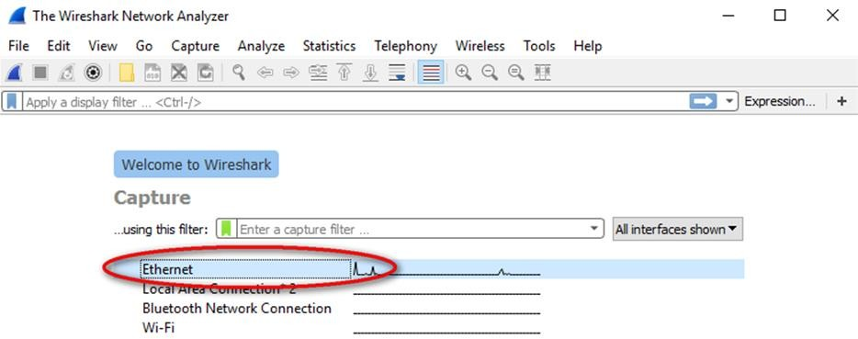

1. Click the **Wireshark** icon to start capture.

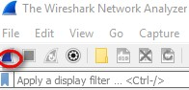

#### Step 3: Telnet into R1 and create ICMP traffic on the LAN.

1. Telnet from S1 to R1.

##### S1# Telnet 192.168.1.1

Trying 192.168.1.1 . . . Open

User Access Verification Password:

R1>

1. From privileged mode, ping PC-C, S1 and S3.

R1> **enable**

Password:

##### R1# ping 192.168.1.10

Type escape sequence to abort.

Sending 5, 100-byte ICMP Echos to 192.168.1.10, timeout is 2 seconds:

!!!!!

Success rate is 100 percent (5/5), round-trip min/avg/max = 1/1/4 ms R1# **ping 192.168.1.2**

<Output omitted>

##### R1# ping 192.168.1.3

<Output omitted>

#### Step 4: Stop the Wireshark Capture on PC-A and Filter for ICMP.

1. Return to PC-A and stop the running Wireshark capture on PC-A.

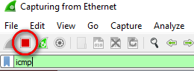

1. Filter the Wireshark capture for ICMP packets. Type in icmp and press **Enter**.

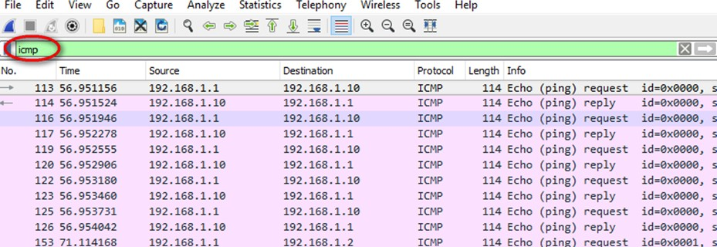

1. Examine the Wireshark capture filtered for ICMP packets.

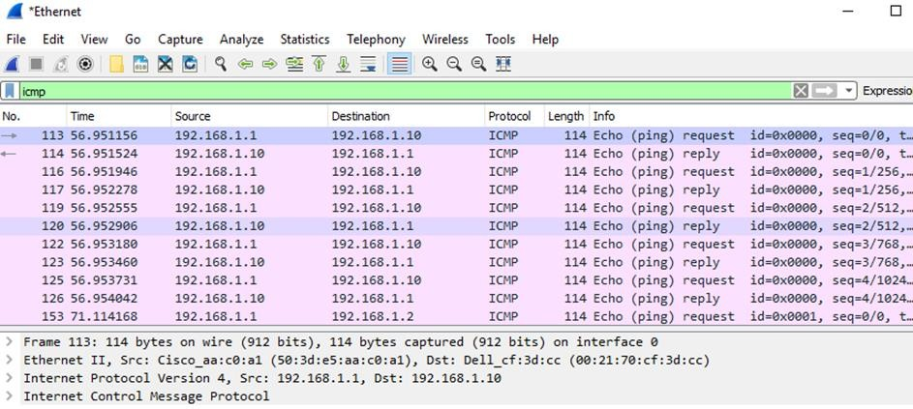

1. Were the pings from R1 to PC-C, S1 and S3 successfully copied and forwarded out f0/6 to PC-A?

si, success

1. Was the traffic monitored and copied in both directions? Si, en ambos sentidos, 1.10 <->1.1

**Reflection**

In this scenario, instead of using PC-A, and a packet sniffer, would an IDS or an IPS be more appropriate?

Si, para una buena implementación, seria mejor con un IDS o IPS ya que contará que la seguridad y la prevención.

### Router Interface Summary Table

|  |  |  |  |  |
| --- | --- | --- | --- | --- |
| **Router Interface Summary** | | | | |
| **Router Model** | **Ethernet Interface #1** | **Ethernet Interface #2** | **Serial Interface #1** | **Serial Interface #2** |
| 1800 | Fast Ethernet 0/0 (F0/0) | Fast Ethernet 0/1 (F0/1) | Serial 0/0/0 (S0/0/0) | Serial 0/0/1 (S0/0/1) |
| 1900 | Gigabit Ethernet 0/0 (G0/0) | Gigabit Ethernet 0/1 (G0/1) | Serial 0/0/0 (S0/0/0) | Serial 0/0/1 (S0/0/1) |
| 2801 | Fast Ethernet 0/0 (F0/0) | Fast Ethernet 0/1 (F0/1) | Serial 0/1/0 (S0/1/0) | Serial 0/1/1 (S0/1/1) |
| 2811 | Fast Ethernet 0/0 (F0/0) | Fast Ethernet 0/1 (F0/1) | Serial 0/0/0 (S0/0/0) | Serial 0/0/1 (S0/0/1) |
| 2900 | Gigabit Ethernet 0/0 (G0/0) | Gigabit Ethernet 0/1 (G0/1) | Serial 0/0/0 (S0/0/0) | Serial 0/0/1 (S0/0/1) |
| **Note**: To find out how the router is configured, look at the interfaces to identify the type of router and how many interfaces the router has. There is no way to effectively list all the combinations of configurations for each router class. This table includes identifiers for the possible combinations of Ethernet and Serial interfaces in the device. The table does not include any other type of interface, even though a specific router may contain one. An example of this might be an ISDN BRI interface. The string in parenthesis is the legal abbreviation that can be used in Cisco IOS commands to represent the interface. | | | | |



* + - 1. **Lab – Troubleshoot LAN Traffic Using SPAN**

**Topology**



**Addressing Table**

|  |  |  |  |  |
| --- | --- | --- | --- | --- |
| **Device** | **Interface** | **IP Address** | **Subnet Mask** | **Default Gateway** |
| R1 | G0/1 | 192.168.1.1 | 255.255.255.0 | N/A |
| S1 | VLAN 1 | 192.168.1.2 | 255.255.255.0 | 192.168.1.1 |
| S3 | VLAN 1 | 192.168.1.3 | 255.255.255.0 | 192.168.1.1 |
| PC-A | NIC | 192.168.1.254 | 255.255.255.0 | 192.168.1.1 |
| PC-C | NIC | 192.168.1.10 | 255.255.255.0 | 192.168.1.1 |

**Objectives**

##### Part 1: Build the Network and Verify Connectivity

**Part 2: Configure Local SPAN and Capture Copied Traffic with Wireshark**

**Background / Scenario**

As the network administrator you decide to analyze the internal local area network for suspicious network traffic and possible DoS or reconnaissance attacks. To do this, you will set up port mirroring on all active switch ports and mirror/copy all traffic to a designated switch port where a PC running Wireshark can analyze the captured traffic. The goal is to identify the source of suspicious traffic. To set up port mirroring you will use the Switched Port Analyzer (SPAN) feature on the Cisco switch. It is common to find a device running a packet sniffer or intrusion detection system (IDS) connected to the mirrored port.

**Note**: The routers used with CCNA hands-on labs are Cisco 1941 Integrated Services Routers (ISRs) with Cisco IOS Release 15.4(3) (universalk9 image). The switches used are Cisco Catalyst 2960s with Cisco IOS

Release 15.0(2) (lanbasek9 image). Other routers, switches, and Cisco IOS versions can be used. Depending on the model and Cisco IOS version, the commands available and output produced might vary from what is shown in the labs. Refer to the Router Interface Summary Table at the end of this lab for the correct interface identifiers.

**Note**: Make sure that the routers and switches have been erased and have no startup configurations. If you are unsure, contact your instructor.

### Required Resources

* + - * + 1 Router (Cisco 1941 with Cisco IOS Release 15.4(3) universal image or comparable)
        + 2 Switches (Cisco 2960 with Cisco IOS Release 15.0(2) lanbasek9 image or comparable)
        + 2 PCs (Windows with a terminal emulation program, such as Tera Term or PuTTY, Wireshark, and Zenmap)
        + Console cables to configure the Cisco IOS devices via the console ports
        + Ethernet and serial cables as shown in the topology

## Part 1: Build the Network and Verify Connectivity

In Part 1, you will set up the network topology and configure basic settings, such as the interface IP addresses, static routing, device access, and passwords.

#### Step 1: Cable the network as shown in the topology.

Attach the devices as shown in the topology diagram, and cable as necessary.

#### Step 2: Configure PC hosts.

**Step 3: Initialize and reload the routers and switches as necessary. Step 4: Configure basic settings for the router.**

1. Disable DNS lookup.
2. Configure the device name as shown in the topology.
3. Configure an IP address for the router as listed in the Addressing Table.
4. Assign **class** as the encrypted privileged EXEC mode password.
5. Assign **cisco** for the console and vty password, enable login.
6. Set the vty lines to **transport input telnet**
7. Configure **logging synchronous** to prevent console messages from interrupting command entry.
8. Copy the running configuration to the startup configuration.

#### Step 5: Configure basic settings for each switch.

1. Disable DNS lookup.
2. Configure the device name as shown in the topology.
3. Assign **class** as the encrypted privileged EXEC mode password.
4. Configure IP addresses for the switches as listed in the Addressing Table.
5. Configure the default gateway on each switch.
6. Assign **cisco** for the console and vty password and enable login.
7. Configure **logging synchronous** to prevent console messages from interrupting command entry.
8. Copy the running configuration to the startup configuration.

#### Step 6: Verify connectivity.

1. From PC-A, you should be able to ping the interface on R1, S1, S3, and PC-C. Were all pings successful? no

If the pings are not successful, troubleshoot the basic device configurations before continuing.

1. From PC-C, you should be able to ping the interface on R1, S1, S3, and PC-A. Were all pings successful? no

If the pings are not successful, troubleshoot the basic device configurations before continuing.

## Part 2: Configure Local SPAN and Capture Copied Traffic with Wireshark

To configure Local SPAN, you need to configure one or more source ports called monitored ports, and a single destination port, also called a monitored port, for copied or mirrored traffic to be sent out of. SPAN source ports can be configured to monitor traffic in either ingress, or egress, or both directions (default).

#### Step 1: Configure SPAN on S1.

1. Locate the switch ports that are up on S1

##### S1# show ip interface brief

Which switch ports are physically up and logically up? S1 f0/4-6

1. On S1, F0/6 connects to PC-A, which will be used for analyzing traffic with Wireshark. F0/6 will be the SPAN destination monitor port for duplicated packets. F0/4 and F0/5 will be the source monitor ports for intercepted packets. You can configure multiple source monitor ports but only one destination monitor port.

S1(config)# **monitor session 1 source interface fa0/4 - 5**

S1(config)# **monitor session 1 destination interface fa0/6**

#### Step 2: Start a Wireshark Capture on PC-A.

1. Open Wireshark on PC-A, set the capture interface to **Ethernet**.

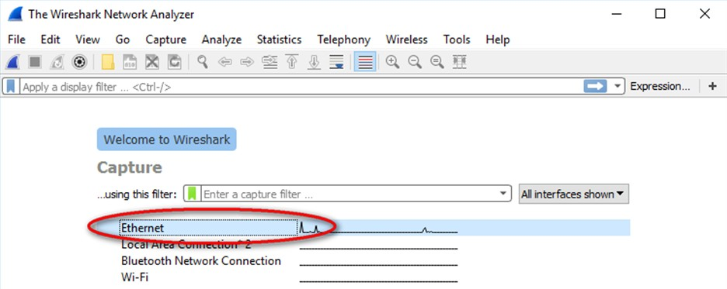

1. Click the **Wireshark** icon to start capture.



#### Step 3: From PC-C, Use NMAP to Generate Suspicious Traffic.

1. If necessary, navigate to [NMAP.org](https://nmap.org/download.html) to download Zenmap. Scroll down the page to find the latest stable release for PC-C. Then follow the on-screen instructions to install Zenmap with default settings.
2. Open Zenmap on PC-C and run a ping scan to scan for available hosts (*nmap –sn –PU 192.168.1-6*). The scan result identifies 3 hosts on the network R1, S1, and S2 at 192.168.1.1, 192.168.1.2 and 192.168.1.3. Notice that Zenmap has also identified the MAC addresses of the three hosts as Cisco Systems interfaces. If this were a real network reconnaissance attack the scan might involve the entire range of network hosts as well as ports and OS fingerprinting.

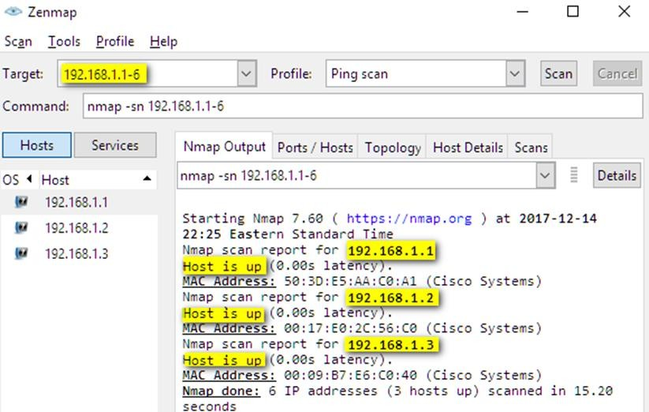

1. The hypothetical attacker can now issue an intense scan on R1 at 192.168.1.1 (nmap –T4 –A –v 192.168.1.1). The scan result identifies an open port 23/Telnet.

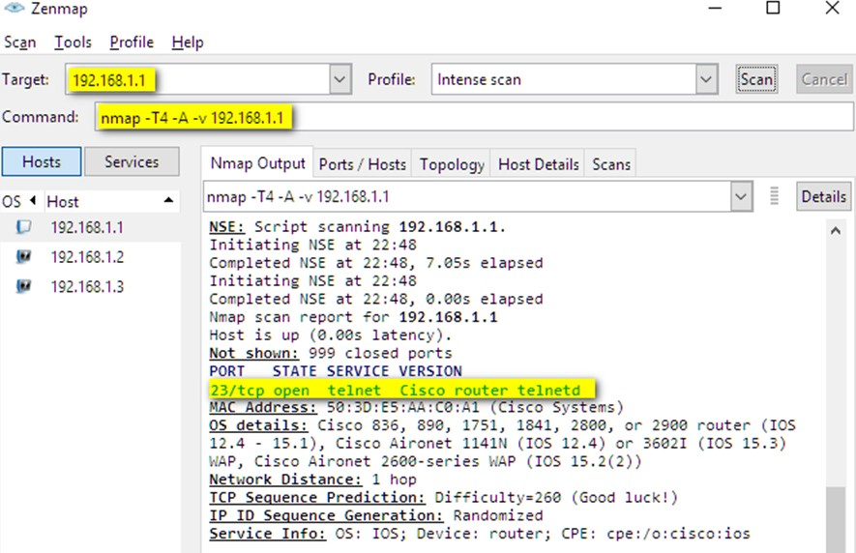

#### Step 4: From PC-A Stop the Wireshark Capture and Examine the Captured SPAN Packets.

1. Return to PC-A, and stop the Wireshark capture. Notice the non-standard traffic patterns between PC-C at 192.168.1.10 and R1 at 192.168.1.1. It is filled with Out-Of-Order segments and Connection resets (RST). This packet capture identifies PC-C as sending suspicious traffic to router R1.

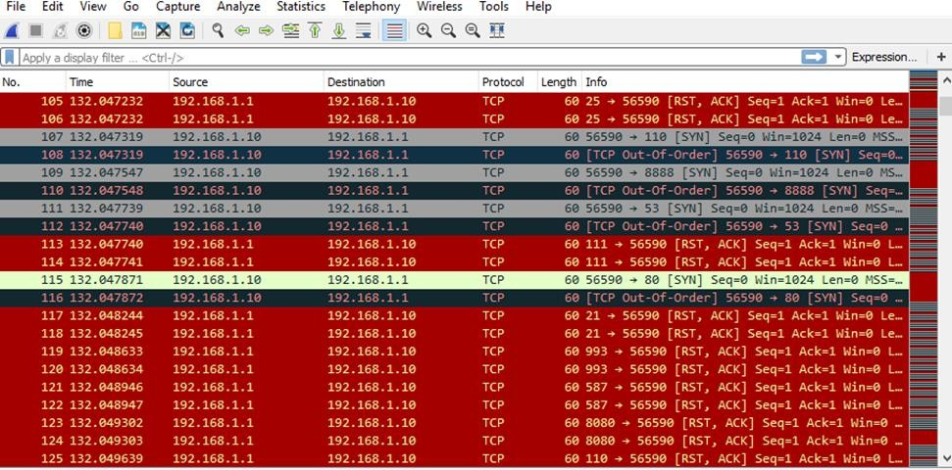

1. The attacker on PC-C knowing that the router has an open port on 23 could attempt an additional brute force attack or DoS style attack, like a LAND attack. A LAND attack is a TCP SYN packet with the same source and destination IP address and port number. Using Zenmap, the command **nmap –sS 192.168.1.1 –S 192.168.1.1 –p23 –g23 –e eth0** is an example. Notice how the LAND attack sets both the source and destination IP addresses to 192.168.1.1 and both the source and destination port numbers to the open port at 23. Although R1 with IOS15 is not vulnerable to this older type of DoS attack, many older systems and servers are still vulnerable. This attack will crash vulnerable systems, by setting them into an infinite loop.

**Reflection**

In this scenario, SPAN was used to troubleshoot and identify the source of suspicious activity on the network? What other troubleshooting scenarios might SPAN be useful for?

Por ejemplo, cuando haya un ataque y inficción por malware, ayuda a identificar que dispositivos están afectados.

### Router Interface Summary Table

|  |  |  |  |  |
| --- | --- | --- | --- | --- |
| **Router Interface Summary** | | | | |
| **Router Model** | **Ethernet Interface #1** | **Ethernet Interface #2** | **Serial Interface #1** | **Serial Interface #2** |
| 1800 | Fast Ethernet 0/0 (F0/0) | Fast Ethernet 0/1 (F0/1) | Serial 0/0/0 (S0/0/0) | Serial 0/0/1 (S0/0/1) |
| 1900 | Gigabit Ethernet 0/0 (G0/0) | Gigabit Ethernet 0/1 (G0/1) | Serial 0/0/0 (S0/0/0) | Serial 0/0/1 (S0/0/1) |
| 2801 | Fast Ethernet 0/0 (F0/0) | Fast Ethernet 0/1 (F0/1) | Serial 0/1/0 (S0/1/0) | Serial 0/1/1 (S0/1/1) |
| 2811 | Fast Ethernet 0/0 (F0/0) | Fast Ethernet 0/1 (F0/1) | Serial 0/0/0 (S0/0/0) | Serial 0/0/1 (S0/0/1) |
| 2900 | Gigabit Ethernet 0/0 (G0/0) | Gigabit Ethernet 0/1 (G0/1) | Serial 0/0/0 (S0/0/0) | Serial 0/0/1 (S0/0/1) |
| **Note**: To find out how the router is configured, look at the interfaces to identify the type of router and how many interfaces the router has. There is no way to effectively list all the combinations of configurations for each router class. This table includes identifiers for the possible combinations of Ethernet and serial interfaces in the device. The table does not include any other type of interface, even though a specific router may contain one. An example of this might be an ISDN BRI interface. The string in parenthesis is the legal abbreviation that can be used in Cisco IOS commands to represent the interface. | | | | |



* + - 1. **Lab – Configure IP SLA ICMP Echo**

**Topology**

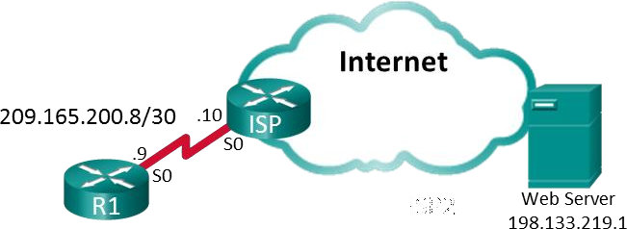

**Addressing Table**

|  |  |  |  |  |
| --- | --- | --- | --- | --- |
| **Device** | **Interface** | **IP Address** | **Subnet Mask** | **Default Gateway** |
| R1 | S0/0/0 | 209.165.200.9 | 255.255.255.252 | N/A |
| ISP | S0/0/0 | 209.165.200.10 | 255.255.255.252 | N/A |
| Lo0 | 198.133.219.1 | 255.255.255.255 | N/A |

**Objectives**

##### Part 1: Build the Network and Verify Connectivity Part 2: Configure IP SLA ICMP Echo on R1

**Part 3: Test and Monitor the IP SLA Operation**

**Background / Scenario**

An outside vendor has been contracted to provide web services for your company. As the network

administrator, you have been asked to monitor the vendor’s service. You decide to configure IP SLA to help with that task.

**Note**: The routers used with CCNA hands-on labs are Cisco 1941 Integrated Services Routers (ISRs) with Cisco IOS Release 15.2(4)M3 (universalk9 image). The switches used are Cisco Catalyst 2960s with Cisco IOS Release 15.0(2) (lanbasek9 image). Other routers, switches, and Cisco IOS versions can be used.

Depending on the model and Cisco IOS version, the commands available and output produced might vary from what is shown in the labs. Refer to the Router Interface Summary Table at the end of this lab for the correct interface identifiers.

**Note**: Make sure that the routers and switches have been erased and have no startup configurations. If you are unsure, contact your instructor.

### Required Resources

* + - * + 2 Router (Cisco 1941 with Cisco IOS Release 15.2(4)M3 universal image or comparable)
        + Console cables to configure the Cisco IOS devices via the console ports
        + Serial cable as shown in the topology

## Part 1: Build the Network and Verify Connectivity

In Part 1, you will set up the network topology and configure basic settings, such as the interface IP addresses, static routing, device access, and passwords.

#### Step 1: Cable the network as shown in the topology.

Attach the devices as shown in the topology diagram, and cable as necessary.

#### Step 2: Initialize and reload the routers as necessary. Step 3: Configure basic settings for R1.

1. Disable DNS lookup.
2. Configure the device name as shown in the topology.
3. Configure an IP address for the router as listed in the Addressing Table.
4. Assign **class** as the encrypted privileged EXEC mode password.
5. Assign **cisco** for the console and vty password, enable login.
6. Configure **logging synchronous** to prevent console messages from interrupting command entry.
7. Configure the default route for R1 to the ISP S0/0/0 IP address.
8. Copy the running configuration to the startup configuration.

#### Step 4: Copy and paste the configuration to the ISP router.

The ISP router configuration is provided below. Copy and paste this configuration into the ISP router. Loopback 0 is being used to simulate the Web server shown in the Topology.

hostname ISP

no ip domain lookup interface Loopback0

ip address 198.133.219.1 255.255.255.255

interface Serial0/0/0

ip address 209.165.200.10 255.255.255.252

no shut end

#### Step 5: Verify connectivity.

1. From R1, you should be able to ping the ISP Serial interface IP address. Were all pings successful?

si, success

If the pings are not successful, troubleshoot the basic device configurations before continuing.

1. From R1, you should be able to ping the Web Server IP address. Were all pings successful?

si, success

If the pings are not successful, troubleshoot the basic device configurations before continuing.

## Part 2: Configure IP SLA ICMP Echo on R1

In Part 2, you configure an IP SLA ICMP Echo operation on R1. Use the following parameters for this operation:

* + - * + Operation-number: **22**
        + ICMP Echo Destination Address: **198.133.219.1**
        + Frequency: **20 seconds**
        + Schedule Start: **Now**
        + Schedule Life time: **Forever**

#### Step 1: Create an IP SLA Operation.

**Step 2: Configure the ICMP Echo Operation. Step 3: Set the rate the IP SLA operation repeats.**

**Step 4: Schedule the IP SLA ICMP Echo operation.**

**Step 5: Use show command to verify the IP SLA configuration.**

**Part 3: Test and Monitor the IP SLA Operation**

In Part 3, you will simulate an outage of web services. This can be done by an administratively shutdown of the loopback 0 interface on the ISP router. You will then display the IP SLA operation statistics to monitorthe effect of this test.

#### Step 1: Shutdown the loopback 0 interface on the ISP router.

ISP(config)# **interface Lo0** ISP(config-if)# **shutdown** ISP(config-if)#

*Nov 28 14:00:52.823: %LINK-5-CHANGED: Interface Loopback0, changed state to administratively down

*Nov 28 14:00:53.823: %LINEPROTO-5-UPDOWN: Line protocol on Interface Loopback0, changed state to down

ISP(config-if)#

**Note**: Wait a few minutes before executing Step 2.

#### Step 2: Activate the loopback 0 interface on the ISP router.

R2(config-if)# **no shutdown**

R2(config-if)#

*Nov 28 14:04:23.263: %LINK-3-UPDOWN: Interface Loopback0, changed state to up

*Nov 28 14:04:24.263: %LINEPROTO-5-UPDOWN: Line protocol on Interface Loopback0, changed state to up

R2(config-if)#

#### Step 3: Issue the command used to display the IP SLA operation statistics on R1.

##### R1# show ip sla statistics

IPSLAs Latest Operation Statistics

IPSLA operation id: 22

Latest RTT: 1 milliseconds

Latest operation start time: 18:44:45 UTC Thu Jan 28 2016 Latest operation return code: OK

Number of successes: 103 Number of failures: 10

Operation time to live: Forever

**Note**: You should see a failure count greater than zero if you waited more than 20 seconds before re- activating the loopback 0 interface on the ISP router.

The IP SLA configured in Part 2 will run forever. How would you stop the IP SLA from running but still leave the IP SLA configured to use at a future time?

En modo configuración global:

No ip sla schedule (numero de operación)22

**Reflection**

Using the lab’s **show ip sla statistics** example, what does the failure count indicate about the Web Server?

Muestra la cantidad de veces que no ha llegado al destino web.

### Router Interface Summary Table

|  |  |  |  |  |
| --- | --- | --- | --- | --- |
| **Router Interface Summary** | | | | |
| **Router Model** | **Ethernet Interface #1** | **Ethernet Interface #2** | **Serial Interface #1** | **Serial Interface #2** |
| 1800 | Fast Ethernet 0/0 (F0/0) | Fast Ethernet 0/1 (F0/1) | Serial 0/0/0 (S0/0/0) | Serial 0/0/1 (S0/0/1) |
| 1900 | Gigabit Ethernet 0/0 (G0/0) | Gigabit Ethernet 0/1 (G0/1) | Serial 0/0/0 (S0/0/0) | Serial 0/0/1 (S0/0/1) |
| 2801 | Fast Ethernet 0/0 (F0/0) | Fast Ethernet 0/1 (F0/1) | Serial 0/1/0 (S0/1/0) | Serial 0/1/1 (S0/1/1) |
| 2811 | Fast Ethernet 0/0 (F0/0) | Fast Ethernet 0/1 (F0/1) | Serial 0/0/0 (S0/0/0) | Serial 0/0/1 (S0/0/1) |
| 2900 | Gigabit Ethernet 0/0 (G0/0) | Gigabit Ethernet 0/1 (G0/1) | Serial 0/0/0 (S0/0/0) | Serial 0/0/1 (S0/0/1) |
| **Note**: To find out how the router is configured, look at the interfaces to identify the type of router and how many interfaces the router has. There is no way to effectively list all the combinations of configurations for each router class. This table includes identifiers for the possible combinations of Ethernet and Serial interfaces in the device. The table does not include any other type of interface, even though a specific router may contain one. An example of this might be an ISDN BRI interface. The string in parenthesis is the legal abbreviation that can be used in Cisco IOS commands to represent the interface. | | | | |